|  |
| --- |
| Qualifications and Experience  Associate Director with 25 years of evaluation, technical assistance, and social science research experience  Ph.D. from the University of Pittsburgh  Extensive experience in evaluation techniques, survey methodology and design, data collection and analysis, project management, performance measurement, and implementation science |

1. **Donna Durant Atkinson, PhD - Project Director/Contract Manager Summary**

Dr. Donna Durant Atkinson is an evaluator and Westat Associate Director with more than 25 years of evaluation, technical assistance and social science research experience. She has designed and conducted evaluation studies at the national and local levels, including nationwide multisite evaluations. She has extensive experience in evaluation techniques, survey methodology and design, data collection and analysis, and project management, as

well as performance measurement. Dr. Atkinson has a background in substance abuse, HIV/AIDS, minority health, health professions training, and mentoring programs. She has also provided technical assistance in evaluation and program development, both on site and in workshop forums, to Federal grant and other programs, and has conducted numerous site visits, addressing programs serving specific ethnic and cultural groups.

# Education

Ph.D., Educational Research Methodology/Evaluation, University of Pittsburgh, 1984 M.S., Social Psychology, University of Pittsburgh, 1981

A.B., Psychology, Wellesley College, 1976

# Selected Project Experience

*Westat (2003 to Present)*

**CSAP Prevention Management Reporting and Training System (PMRTS) Client:** Substance Abuse and Mental Health Services Administration (SAMHSA)

Dr. Atkinson serves as Project Director responsible for functioning of the PMRTS; collecting, analyzing, and reporting high-quality data; and producing performance measures and results reports, the HIV Report to Congress, and ad hoc reports.

# Center for the Application of Prevention Technologies (CAPT)

**Client:** Center for Substance Abuse Prevention (CSAP), Substance Abuse and Mental Health Services Administration (SAMHSA)

Dr. Atkinson was the Project Director, leading the epidemiology portion of the project and providing direct training and technical assistance (TTA) in the Southeast resource area. As a subcontractor, Westat is providing state-of-the-science TTA to build the organizational capacity of substance abuse prevention grantees and their subrecipient grantees to implement SAMHSA’s data-driven Strategic Prevention Framework (SPF) efforts.

# CSAP Data Collection, Analyses, and Reporting (DCAR)

**Client:** Center for Substance Abuse Prevention (CSAP), Substance Abuse and Mental Health Services Administration (SAMHSA)

Dr. Atkinson was the Project Director, supporting CSAP in meeting its GPRA and National Outcome Measures (NOMs) reporting requirements.

**Patient-Centered Care Collaboration (PCCC) to Improve Minority Health Client:** U.S. Department of Health and Human Services (HHS)

As an Evaluator, Westat worked with partners to provide technical and management assistance to support HHS’s Office of Minority Health by developing, implementing, and testing strategies for increasing the adoption and dissemination of patient-centered outcomes research (PCOR) evidence for use with racial and ethnic minorities, implementing PCCC activities in Chicago and Houston.

# CSAT Division of Services Improvement (DSI) Clinical Technical Assistance Bridge Contract

**Client:** Center for Substance Abuse Treatment (CSAT), Substance Abuse and Mental Health Services Administration (SAMHSA)

Dr. Atkinson worked with Project Officers and DSI grantees to improve clinical services that provide substance abuse treatment services to individuals and families, especially clients with or at risk for HIV.

# Health Care Innovations Exchange

**Client:** Agency for Healthcare Research and Quality (AHRQ)

Westat operated and maintained this multipronged program, which promoted the adoption, implementation, and dissemination of novel care delivery methods. Dr. Atkinson worked with the Community Care Coordination Learning Network as an Evaluation Consultant.

# Evaluation of Adult Treatment Drug Courts

**Client:** Center for Substance Abuse Treatment (CSAT), Substance Abuse and Mental Health Services Administration (SAMHSA)

As Evaluation Lead, Dr. Atkinson conducted site visits to evidence-based grantee drug court programs in this multisite evaluation of 20 adult treatment drug courts receiving funding to enhance and/or expand their treatment services.

# Past Experience

ACS Federal Healthcare, Inc., Alexandria, VA (1991 to 2003)

Aspen Systems (formerly Applied Management Sciences), Rockville, MD (1987 to 1991)

# Recent Publications and Presentations

Rashid, J.R., Leath, B.A., Truman, B.I., Atkinson, D.D., Gary, L.C., and Manian, N. (2017). Translating comparative effectiveness research into practice: Effects of interventions on lifestyle, medication adherence, and self-care for type 2 diabetes, hypertension, and obesity among Black, Hispanic, and Asian residents of Chicago and Houston, 2010 to 2013. *Journal of Public Health Management and Practice*. [Advance online publication: March 1, 2017] doi: 10.1097/PHH.0000000000000525 PMID: 28257397

Kasat, S., Hagen, C., Vazquez, L., Clark, P., Stamatakos, K., Atkinson, D., Yamate, M., Love, C., and Giangrande, M. (2016, November). *Addressing challenges in assessing nonmedical use of prescription drug-involved deaths in the rural southeastern US states* (panel presentation). Annual Meeting of the American Public Health Association, Denver, CO.

Stamatakos, K., Vazquez, L., Hagen, C., Atkinson, D., Kasat, S., Yamate, M., Clark, P., Love, C., and Gia, C. (2016, October). *Non-medical use of prescription drugs with rural populations* (poster). Annual Meeting of the American Public Health Association, Denver, CO.

# Donna Durant Atkinson, Ph.D. - Statement of Availability

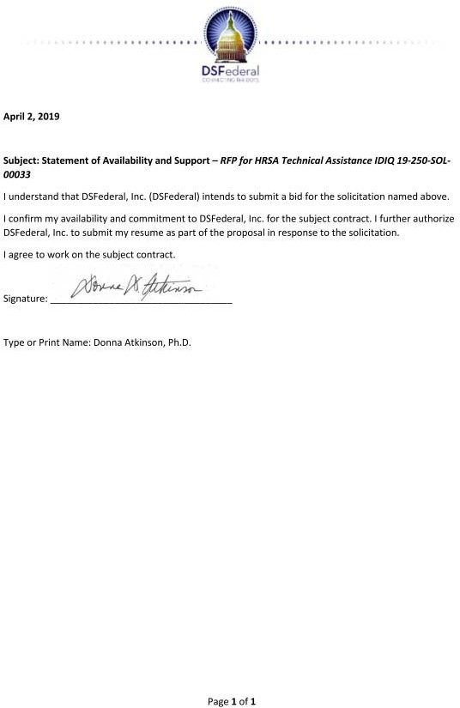

|  |
| --- |
| Qualifications and Experience  Health communications specialist with 4 years of experience planning, implementing, and evaluating research-driven communications solutions  M.P.H. from Emory University  Experience providing project oversight, strategic planning and implementation |

1. **Morenike Bello - Health Communications Specialist Summary**

Morenike (Reni) Bello is a health communications specialist with 4 years of experience planning, implementing, and evaluating research-driven communications solutions to common public health problems. At Westat, she is the project coordinator and the monitoring and reporting task lead for the CDC Act Against AIDS Doing It HIV Testing campaign. In her previous work at

the Georgia Campaign for Adolescent Power and Potential and the Rollins School of Public Health, Ms. Bello worked with a variety of community-based organizations and research institutions to develop her skills in qualitative and quantitative methods for research and evaluation, stakeholder and partner engagement, health education outreach, and materials development. Ms. Bello’s key projects included developing a statewide community of practice, conducting a needs and capacity assessment using an online survey, conducting a program evaluation using focus groups and provided technical assistance to community stakeholders for different program planning tasks.

# Education

M.P.H., Behavioral Sciences and Health Education, Rollins School of Public Health, Emory University, 2014

B.S. (summa cum laude), Community Health (with a minor in Human Development), University of Maryland, College Park, 2012

Certifications and Licensures: Certified Health Education Specialist, National Commission for Health Education Credentialing, Inc., 2014-2019

# Relevant Project Experience

*Westat (2014 to Present)*

# Health Marketing Support Services

**Client:** Office of the Associate Director for Communication, Centers for Disease Control and Prevention (CDC)

Westat provides expertise and support for CDC health communication programs covering a broad range of health topics and targeting a variety of audiences. Project staff conduct research to inform program planning, including concept and message testing, literature reviews, environmental scans and situational analyses, and audience identification and segmentation. Westat develops strategic communication plans and plans, implements, and evaluates social marketing campaigns. For the projects below, Ms. Bello has provided project oversight, strategic planning and implementation and monitored campaign implementation to ensure campaign goals and objectives were met. Ms. Bello has also planned and staffed community engagement events and national conferences and established partnerships with

community-based organizations, national nonprofits, digital media outlets, and online influencers. She also assisted in planning training and technical assistance activities.

# Development and Dissemination of a General Awareness Social Marketing Campaign for the Act Against AIDS Campaign

The National Center for HIV/AIDS, Viral Hepatitis, STD, and TB Prevention contracted with Westat to develop a national social marketing campaign to raise awareness of the importance of and to encourage universal HIV testing. Under this contract, Westat conducted formative research to inform campaign messages and materials, developed a strategic campaign implementation plan, and worked with CDC and its partners to launch a nationwide campaign.

# Health Marketing, Communications, and Technical Assistance Services for Multisectoral Partnerships

Westat supported the National Partnerships Team in the Division of HIV/AIDS Prevention, National Center for HIV/AIDS, Viral Hepatitis, STD, and TB Prevention, in identifying, recruiting, engaging, coordinating, and mobilizing multisectoral partnerships. Westat supported three tasks: development of a comprehensive project plan and strategy; identification, development, and engagement of strategic partnerships; and monitoring and evaluation of those partnerships and engagement efforts.

# Adaptation of AMIGAS for African American Women Never and Rarely Screened for Cervical Cancer

**Client:** Centers for Disease Control and Prevention (CDC)

Ayudando a las Mujeres con Información, Guía y Amor para su Salud (AMIGAS) is a community-based intervention program connecting researchers, healthcare workers, and program administrators to research, design, and implement methodologies for educating Hispanic women about cervical cancer screening. Under this contract, Westat is supporting CDC in evaluating the applicability and transferability of the AMIGAS intervention to modify the health behaviors and outcomes of African American women who have never had cervical cancer screening or have not been screened in the past 3 years. Ms. Bello conducted a literature review to identify the needs of the intervention’s new target audience, served as the liaison between the community advisory board and the project team, and prepared intervention components and materials.

# Publications

Cha, E., Kim, K.H., Umpierrez, G., Dawkins, C.R., Bello, M.K., Lerner, H.M., Narayan, K.M., and Dunbar, S.B. (2014). A feasibility study to develop a diabetes prevention program for young adults with prediabetes by using digital platforms and a handheld device. *Diabetes Educator*, 40(5). PMID: 24950683

Cha, E.S., Kim, K.H., Lerner, H.M., Dawkins, C.R., Bello, M.K., Umpierrez, U., and Dunbar, S. (2014). Health literacy, self-efficacy, food label use, and diet in young adults. *American Journal of Health Behavior*, 38(3), 331-339. PMID: 24636029 PMCID: PMC4039409

Cha, E.S., Umpierrez, G., Kim, K.H., Bello, M.K., and Dunbar, S. (2013). Characteristics of American young adults with increased risk for type 2 diabetes: A pilot study. *Diabetes Educator*, 39(4), 454-463. PMID: 23640300 PMCID: PMC3746506

# Morenike Bello - Statement of Availability

|  |
| --- |
| Qualifications and Experience  Senior Study Director with 15 years of experience in the design, development, implementation, and evaluation of information systems  Ph.D. from Claremont Graduate University |

1. **Nathan Botts, PhD - Rural TA Specialist/Research Analyst Summary**

Dr. Nathan Botts is a Westat Senior Study Director with more than 15 years of experience in the design, development, implementation, and evaluation of information systems. He analyzes gaps and develops training and technical assistance for community health centers within

privacy/security and patient engagement domains (HRSA); provides data analysis and dashboards across interoperability and nationwide health information exchange domains of performance evaluation for the Virtual Lifetime Electronic Record Health project (VA); serves as standards and interoperability analyst and establishing Westat’s direct exchange capacity (CDC); conducts requirements analysis and functional model development for the Model Electronic Health Record Format for Children project (AHRQ); and provides project management and evaluation of mobile health technologies to support veterans receiving substance abuse therapies (SAMHSA).

# Education

Ph.D., Information Systems and Technology, Claremont Graduate University, 2010 M.S., Information Systems and Technology, Claremont Graduate University, 2008 M.A., Educational Technology, San Diego State University, 2002

B.A., Political Science, University of California, Riverside, 1992

Certifications and Licensures: Graduate Certificate in Information Security, Purdue University Global, 2018; XML Professional Certificate, San Diego State University, 2003

# Relevant Project Experience

*Westat (2011 to Present)*

**Health Information Technology, Evaluation, and Quality Improvement (HITEQ) Center Client:** Bureau of Primary Health Care (BPHC), HRSA

Dr. Botts is leading learning system development and is the senior health IT analyst for privacy and security and for electronic patient engagement. The HITEQ center provides BPHC health center grantees and look-alikes with TTA to support them in adopting, optimizing, and implementing meaningful use of electronic health records and health IT.

**Mobile Patient Opportunities for Wellness, Engagement, and Recovery (mPOWER) Client:** Substance Abuse and Mental Health Services Administration (SAMHSA)

As a project manager, Dr. Botts managed evaluation design, survey development, assessment, and analysis of a mobile health tool in remote areas of New York. The project team investigated the use of personal health information tools, primarily mHealth, to bridge communication gaps between providers and rural veterans receiving substance abuse therapy.

# National Hospital Care Survey (NHCS)

**Client:** National Center for Health Statistics (NCHS)

Dr. Botts provides expertise on health information exchange standards and systems analysis for NHCS, which collects nationally representative data from participating hospitals including claims data, abstracted medical records data, EHR data, and an annual telephone survey.

# Network Resource Guide

**Client:** National Association of Community Health Centers (NACHC)

Dr. Botts was the project director and lead programmer for this project developing and deploying a web-based Network Resource Guide, a sustainable tool to enhance access to the NACHC support network knowledge base.

# Virtual Lifetime Electronic Records (VLER) Health Performance Evaluation and Health Communities Evaluation

**Client:** U.S. Department of Veterans Affairs (VA)

Dr. Botts was a senior data analyst and led interoperability evaluation of the electronic health information exchange (HIE) through the VLER Health Program that allows electronic HIE between VA, DOD, and private sector providers across the U.S. Dr. Botts supported evaluation design, data collection, and the study evaluation of VLER Health Communities pilot projects.

**Planning, Implementation, and Evaluation of a Knowledge Sharing Network (KSN) Client:** Agency for Healthcare Research and Quality (AHRQ)

As a Knowledge Integrator, Dr. Botts supported this Office of the National Coordinator for Health Information Technology (ONC) project funding 62 Regional Extension Centers (RECs) to support clinicians in implementing electronic health records.

# Developing a Health IT Policy Framework for Integrating Self-Management and Shared Management of Health and Care

**Client:** Office of the National Coordinator for Health Information Technology (ONC) As Senior Research Director, Dr. Botts created a model to integrate self-management and shared management into health and care using existing and emerging health IT strategies.

# Other Professional Experience

Kay Center for E-Health Research, Claremont, CA (2005 to 2011) HealthATM, Inc., Los Angeles, CA (2008 to 2011)

COPE Health Solutions, Los Angeles, CA (2008 to 2011) Migrant Education Program, San Diego, CA (2001 to 2009)

# Selected Publications and Technical Reports

Tao, D., Botts, N., Haruna, A., Ploeg, F., McKay, T., Datta, G., and Graham, M. (2018). *HL7 consumer mobile health application functional framework* (Release 1). Ann Arbor, MI: HL7 International. Available at: [http://www.hl7.org/implement/standards/product_brief.cfm?product_id=476.](http://www.hl7.org/implement/standards/product_brief.cfm?product_id=476)

Peterson, S., Hovick, S., Ba., F., Basen-Engquist, K., Fisch, M., Botts, N., Horan, T., Thoms, B., Stingo, F., Yzquierdo, R., Galvan, C., and Rieber, A. (2014). Preferences for eHealth technology in meeting the health information needs of underserved cancer survivors. *Psycho-Oncology*, 23, 73-74.

# Nathan Botts, PhD - Statement of Availability

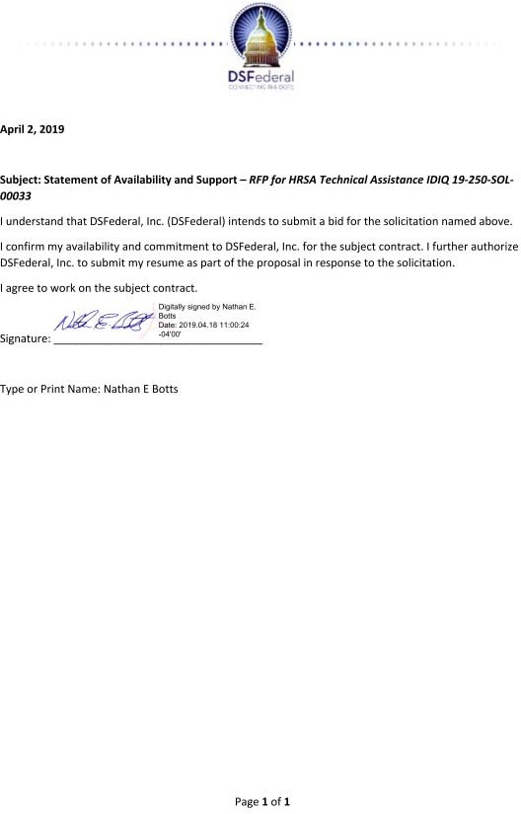

|  |
| --- |
| Qualifications and Experience  Senior Study Director and registered nurse with more than 30 years of experience in health care quality improvement  M.S.N. from the University of Alabama  Provides clinical and health care expertise on transitions of care issues and dissemination of research findings |

1. **Deborah J. Carpenter – Clinical Consultant Summary**

Deborah Carpenter is a Westat Senior Study Director and registered nurse with more than 30 years of experience in health care quality improvement and patient safety processes, dissemination of research products, and implementation of evidence-based practices. She maintains professional certifications in patient safety, health care quality, and project management.

# Education

M.S.N., University of Alabama in Birmingham, 1981

Residency, Health Services Administration, Miami Valley Hospital, 1980 B.S.N., University of North Carolina, 1974

Additional Training: Breakthrough Series College, Institute of Healthcare Improvement; Advanced Training Program in Health Care Delivery Improvement, Intermountain Healthcare

Certifications and Licensures: Certified Professional In-Patient Safety (CPPS), Certification Board for Professionals in Patient Safety, 2019; Project Management Professional (PMP), Project Management Institute, 2019; Certified Professional in Healthcare Quality (CPHQ), National Association of Healthcare Quality, 2019; Registered Nurse, North Carolina State Board of Nursing, 2019; Certification in Health Services Administration, Schools of Business and Allied Health, University of Alabama

# Relevant Project Experience

*Westat (2003 to Present)*

**Population Assessment of Tobacco and Health Study (PATH 1.0 and 2.0) Client:** National Institute on Drug Abuse (NIDA)

In support of NIDA and FDA, Westat is conducting a large national longitudinal cohort study of U.S. tobacco users and nonusers (aged 12+). Ms. Carpenter directs an ad hoc project to identify potential supplemental health measures. Ms. Carpenter managed a team developing the literature review and consulted with a technical expert panel of clinicians and researchers.

# Effectiveness of Transitional Care

**Client:** Patient-Centered Outcomes Research Institute (PCORI)

Westat is conducting research on the effectiveness of transitional care services aimed at improving patient discharge from hospital to home or other care settings and at reducing readmission rates. As project manager, Ms. Carpenter oversees all patient, caregiver, and provider survey operations and provides clinical and health care expertise on transitions of care issues and dissemination of research findings.

# Palliative Care Learning Network

**Client:** Patient-Centered Outcomes Research Institute (PCORI)

Project Overview: PCORI invested more than $80 million in 2017 to compare the effectiveness of different strategies for delivering palliative care in the community setting. Ms. Carpenter served as project director.

# User Network for Consumer Assessment of Healthcare Providers and Systems (CAHPS) and Patient Safety

**Client:** Agency for Healthcare Research and Quality (AHRQ)

Ms. Carpenter was a technical advisor for the Nursing Home Survey on Patient Safety Culture data collection, analysis, and dissemination. She also served as a clinical advisor for the development of the Medical Office Survey on Patient Safety Culture diagnostic safety supplemental item set.

# Health Care Innovations Exchange

**Client:** Agency for Healthcare Research and Quality (AHRQ)

Westat operated and maintained this multipronged program, which promoted the adoption, implementation, and dissemination of novel care delivery methods. As project director, Ms. Carpenter provided strategic and operational oversight and supported an editorial board and expert panel. Ms. Carpenter developed the approach for establishing and conducting communities of practice; led development of a dissemination plan, including social media strategies; and was an editorial content advisor.

**Guidance Document for State Perinatal Quality Collaboratives (PQCs) Client:** Centers for Disease Control and Prevention (CDC)

The project’s goal was to support states in their efforts to improve maternal and child health through quality improvement collaboratives. Ms. Carpenter provided expert facilitation and content related to how to start a collaborative, quality improvement models, and dissemination.

# Other Professional Experience

National Patient Safety Foundation, Chicago, IL (2002) Medstat Group, Inc., Washington, DC (1997 to 2002) VHA, Inc., Dallas, TX (1988 to 1997)

Our Lady of the Lake Regional Medical Center, Baton Rouge, LA (1983 to 1988)

# Selected Publications

Carpenter, D., Hassell, S., Mardon, R., Fair, S., Johnson, M., Siegel, S., and Nix, M. (2018).

Using learning communities to support adoption of health care innovations. *Joint Commission Journal on Quality and Patient Safety*, 44(10), 556-573. doi: 10:1016/j.jciq.3018.03.010 PMID: 30064957

Naylor, M.D., Shaid, E.C., Carpenter, D.C., Gass, B., Levine, C., Li, J., Malley, A., McCauley, K., Nguyen, H.Q., Watson, H., Brock, J., Mittman, B., Jack, B., Mitchell, S., Callicoatte, B., Schall, J., and Williams, M.V. (2017). Components of Comprehensive and Effective Transitional Care. *Journal of the American Geriatrics Society*, 65(6), 1119-1125. doi: 10.1111/jgs.14782 PMID: 28369722 PMCID: PMC5497308

# Deborah J. Carpenter - Statement of Availability

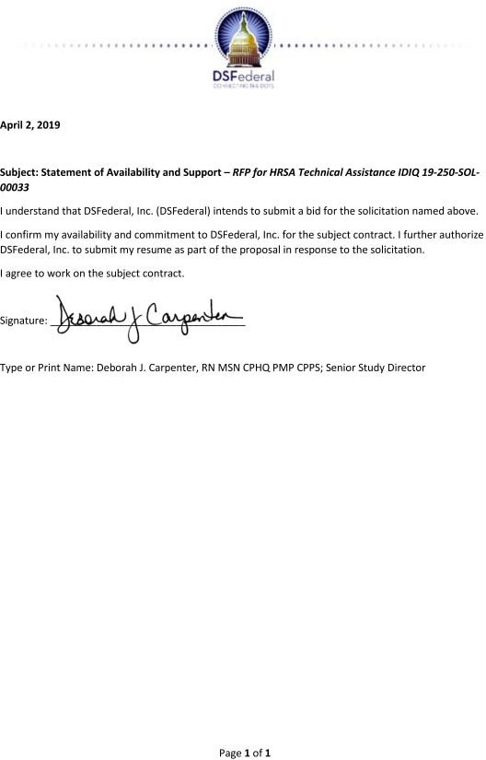

|  |
| --- |
| Qualifications and Experience  Senior Study Director with 13 years of experience in qualitative research design and methodologies  M.A.A. from the University of Maryland  Experience designing surveys, interview guides, and other data collection instruments |

1. **Melanie Chansky - TA Specialist Summary**

Melanie Chansky is a Westat Senior Study Director with 13 years of experience in qualitative research design and methodologies. At Westat, she leads health care research and writes project reports. In previous work, she conducted site visits, focus groups, and interviews for qualitative research projects at Battelle Health and Analytics. Ms. Chansky

served as task leader on an emergency preparedness evaluation for the National Association of City and County Health Officials and CDC. She was qualitative team lead on a large-scale evaluation of a national substance abuse prevention program and served as project manager for an effort to support the AHRQ Quality Indicators. She has also designed surveys, interview guides, and other data collection instruments for several projects, including evaluations of the Advanced Practice Centers Program at CDC and the Geriatric Education Centers Program at HRSA. Ms. Chansky has expertise conducting unstructured and structured interviews and has formal training and experience in conducting focus groups. In addition, she provided technical assistance to Federal, state, and local grantees on several projects.

# Education

M.A.A., Applied Anthropology (with a focus in Community Health and Development), University of Maryland, 2003

B.A. (with honors), Anthropology and French, Washington University, 2001

# Relevant Project Experience

*Westat (2013 to Present)*

**Improving Public Health Preparedness and Response to Drought Through the Assessment of Current Knowledge, Practices, and Gaps (Drought Assessment Delivery) Client:** Centers for Disease Control and Prevention (CDC)

Westat worked with the Emergency Management, Radiation, and Chemical Branch at the National Center for Environmental Health to develop an assessment on the inclusion of public health in drought preparedness and response activities. The assessment is intended for respondents at state, tribal, local, and territorial health departments. As the project director, Ms. Chansky’s activities included coordinating the development and programming of the assessment instrument, conducting cognitive and pilot testing, developing an analysis plan, and convening Federal, state, and academic subject matter experts to review the draft instrument. Westat is fielding the assessment, analyzing the data, and developing a final report.

# Health Marketing Support Services

**Client:** Office of the Associate Director for Communication, CDC

Westat provides expertise and support for CDC health communication programs covering a broad range of health topics and targeting a variety of audiences. Project staff conduct research to inform program planning, including concept and message testing, literature

reviews, environmental scans and situational analyses, and audience identification and segmentation. Westat develops strategic communication plans and plans, implements, and evaluates social marketing campaigns. For the projects below, Ms. Chansky conducted literature reviews, contributed to the development of a conceptual framework and logic models to inform future data collection and analysis. She also conducted focus groups and prepared reports.

# CDC Emergency Risk Communication Outcomes Measures Development and Assessment

Westat is assisting CDC by developing, operationalizing, and evaluating an evidence- informed set of quantifiable measures to assess the quality, effectiveness, and impact of emergency risk communication messages. Major activities include research to inform outcome measures and metrics, and recommendations for future data collection and analysis to assess the impact of CDC emergency risk communication.

# Promoting Childhood Immunization to Parents and Healthcare Professionals Using Communication and Social Marketing Strategies

Westat worked with CDC’s National Center for Immunization and Respiratory Diseases to develop and implement a social marketing campaign to promote childhood immunization to the parents of infants and young children and to child care and healthcare professionals.

Project staff conducted focus groups to inform development of public health communication strategies about pertussis.

# Evaluation of Comprehensive Community Mental Health Services for Children and Their Families Program: Children’s Mental Health Initiative (CMHI)

**Client:** Substance Abuse and Mental Health Services Administration (SAMHSA) Project Overview: Westat led the national evaluation of CMHI Systems of Care (SOC)

planning grants and implementation grants. In collaboration with family and youth advocacy organizations and academic research centers, Westat worked with SAMHSA to evaluate the impact of SOC grants in expanding, coordinating, and improving care. Westat collected grantee data at the jurisdiction/state, local service, and child and family levels to provide a complete picture of implementation outcomes and participant experiences. Ms. Chansky and the team collected data through stakeholder interviews, web-based surveys, network analysis, GIS analysis, and direct entry of client-level services and outcomes.

# Publications

Russo, A.R., Solis, A.C., Villanti, A.C., Wipfli, H.L., Kern, T.T., Lawley, R.K., Collins, L.K., Abudayyeh, H.S., Chansky, M.C., Glantz, S.A., Samet, J.M., and Benjamin, E.J. (2017). Mentoring for success in tobacco regulatory science: A qualitative study. *Tobacco Regulatory Science*, 3(3), 280-292.

Chansky, M.C., King, M.R., Bialkowski, W., Bryant, B.J., Kiss, J.E., D’Andrea, P., Cable, R.G., Spencer, B.R., and Mast, A.E. (2017). Qualitative assessment of pica experienced by frequent blood donors. *Transfusion*, 57, 946-951.

Chansky, M. (2005). Assessing the needs of the Northern Virginia Sierra Leonean community.

*Practicing Anthropology*, 27(2), 10-14.

# Melanie Chansky - Statement of Availability

|  |
| --- |
| Qualifications and Experience  Field manager with 13 years of experience collecting and reporting on data  M.A from the University of Maryland  Assesses grantee needs and provides resources |

1. **June Moore Crandall – TA Specialist / Research Analyst Summary**

June Crandall is a field manager, survey manager, and training materials developer with 13 years of experience collecting and reporting data on various subjects, including literacy skills and substance abuse trends. She is experienced in field operations as a field director and assistant evaluator. As the Adolescent and SBIRT Silo leader, Ms. Crandall oversaw and responded to technical requests from grantees and SAMHSA. She has experience with statistical software and spreadsheets (MS Excel and SPSS), mapping

software (ArcView), and database creation and management (MS Access), as well as an extensive background conducting literature searches and reviews using a variety of search engines, databases, and other Internet tools.

# Education

M.A., Criminology and Criminal Justice, University of Maryland, College Park, 2003 B.A., Criminology and Criminal Justice, University of Maryland, College Park, 2000

# Relevant Project Experience

*Westat (2003 to Present)*

# Children’s Mental Health Initiative (CMHI) National Evaluation

**Client:** Substance Abuse and Mental Health Services Administration (SAMHSA)

CMHI’s Systems of Care (SOC) approach involves collaboration across agencies to provide an array of effective, community-based, culturally and linguistically appropriate services and supports for children and youth with serious emotional disturbances and their families. Westat develops instrumentation, delivers training and technical assistance to grantee data collectors, develops and maintains a reporting system, analyzes and synthesizes data, and prepares reports to Congress and for other purposes. Ms. Crandall conducts regular communications with CMHI grantees about their evaluation data collections. She assesses grantee needs, provides resources, and identifies problems for quick resolution. She is responsible for monthly reporting on all activities. Ms. Crandall helps test data collection protocols and instruments. She also coordinates and synthesizes discussions into reports based on periodic CMHI Tribal Workgroup Meetings.

**Population Assessment of Tobacco and Health Study (PATH 1.0 and 2.0) Client:** National Institute on Drug Abuse (NIDA)

Westat is conducting a national longitudinal cohort study of U.S. tobacco users and nonusers (aged 12+). Westat is interviewing already-participating adults and youth (approximately 28,000 and 12,000, respectively) on a semi-annual basis and refreshing the sample with approximately 6,000 adults and 3,000 youth. Westat also conducts a variety of analytic tasks, including rapid-turnaround analyses and preparation of journal articles; more than 60 articles have been published in juried journals. As recruitment director, Ms. Crandall was responsible for all field staff recruitment for the field test and main study (approximately 1,100 data collectors). She was also responsible for field materials development and training logistics,

field room management, and supervision of recruitment, training, and materials development staff.

# CSAT Division of Services Improvement (DSI) Clinical Technical Assistance Bridge Contract

**Client:** Center for Substance Abuse Treatment (CSAT), SAMHSA

DSI awards grants to organizations across the country that provide substance abuse treatment services, including grants focused on adolescents, American Indians and Alaska Natives, e- therapy alternatives, people with HIV, pregnant and postpartum women and their children, methamphetamine users, screening and brief intervention, referral to treatment, and treatment drug court and youth offender re-entry. Westat worked with Project Officers and grantees to improve clinical services. Technical assistance providers delivered assistance in client location and retention; assisted grantees in developing outreach strategies, especially for clients with or at risk for HIV; provided input on effective treatment strategies for specific populations; provided technical assistance on staff development programs and evidence-based practices; and worked with grantees to maintain sustainability once the grant was over. Ms.

Crandall oversaw and provided technical assistance support for Screening and Brief Intervention and Referral to Treatment and Adolescent grantees. She arranged workshops, training seminars, and grantee meetings and responded to other ad hoc requests. She also set up, monitored, and documented monthly grantee conference calls; monitored and forwarded emails through grantee listservs; ensured that the listservs were updated; and provided support for meeting consultants.

# Assessing the Impact of Juvenile Justice Reforms Program

**Client:** Office of Juvenile Justice and Delinquency Prevention (OJJDP), DOJ

Westat and its subcontractor, the American Probation and Parole Association, are working with key Kentucky agencies involved in the reform effort, including the Administrative Office of the Courts and the Department of Juvenile Justice, to evaluate the juvenile justice reforms passed in SB 200. Ms. Crandall has been responsible for developing the SB 200 timeline; interviewing key stakeholders, including the leadership of juvenile justice and other child- serving agencies; and reviewing, coding, and analyzing qualitative data.

# Evaluation of the BJA Sexual Assault Kit Initiative

**Client:** National Institute of Justice (NIJ), U.S. Department of Justice (DOJ)

Westat is assessing components of the Bureau of Justice Assistance’s (BJA’s) Sexual Assault Kit Initiative (SAKI) with 20 sites to prepare for a subsequent comprehensive outcome evaluation. The mixed-methods approach includes quantitative analysis of administrative data and qualitative coding and analysis of document reviews, site visit observations, and interviews. Study plans provide for ongoing feedback to NIJ, BJA, the SAKI technical assistance provider, grantees, and other stakeholders. Ms. Crandall assists in collecting SAKI site information and drafting data collection protocols, coordinates and conducts site visits, and transcribes and synthesizes notes and information collected during contact with the sites.

# Other Professional Experience

Ms. Crandall was the Drug Scan project director for Maryland’s Drug Early Warning System (DEWS) from 2000 to 2003.

# June Moore Crandall - Statement of Availability

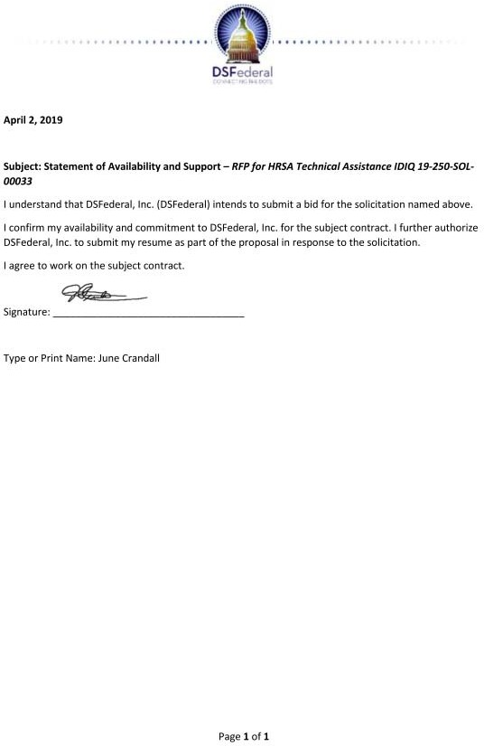

|  |
| --- |
| Qualifications and Experience  Senior Study Director with more than 35 years of experience in the management and delivery of behavioral health services  Ed.D. from the University of Cincinnati  Barton Distinguished Fellow Award, College for Behavioral Health Leadership |

1. **Allen S. Daniels, Ed.D. - Behavioral Health Expert Summary**

Dr. Allen Daniels is a Westat Senior Study

Director with more than 35 years of experience in the management and delivery of behavioral health services. At Westat, he is contributing health policy expertise for the examination of behavioral health programs and initiatives. He has participated in projects related to health reform and evidence-based care, primary and behavioral health integration, and specific

population and treatment standards studies. Dr. Daniels previously held an appointment as Professor of Clinical Psychiatry and Public Health Sciences at the University of Cincinnati. In his faculty role, he was director of a multidisciplinary behavioral group practice affiliated with the university’s Department of Psychiatry, as well as CEO of a fully capitated managed behavioral health care organization. He has also served as Executive Vice President and Director of Scientific Affairs for the Depression and Bipolar Support Alliance. Among other professional activities, Dr. Daniels has participated in three IOM panels and two National Quality Forum studies. He has twice chaired the board of the American Managed Behavioral Healthcare Association. Dr. Daniels has served on the National Advisory Committee of CMHS and SAMHSA. He has a published and presented widely on the quality improvement and transformation of the U.S. mental health system, as well as the role of consumer delivered services.

# Education

Ed.D., Education, University of Cincinnati, 1990 M.A., Social Work, University of Chicago, 1977

B.A., Communication and Social Process, Albion College, 1975

# Relevant Project Experience

*Westat (2011 to Present)*

# Assessment of Innovative Models of Peer Support Services in Behavioral Health to Reduce Preventable Acute Hospitalization and Readmissions

**Client:** Office of the Assistant Secretary for Planning and Evaluation, U.S. Department of Health and Human Services (HHS)

Westat conducted a study to examine how innovative peer support service programs affect the avoidable or unnecessary utilization of hospital and emergency department utilization, focusing on peer support services organizations and their role in behavioral health care delivery systems. Dr. Daniels served as the project director and coauthored the environmental scan and final report. He also led case study site reviews.

**Technical Support to the Office of the Director, Center for Mental Health Services Client:** Center for Mental Health Services (CMHS), Substance Abuse and Mental Health Services Administration (SAMHSA)

Westat provided consultation in the areas of program development, execution of program requirements, support strategies, document development, writing, and editing. The Westat

team included a roster of 40 nationally recognized expert consultants in a wide range of behavioral health issues who agreed to be available to assist the Office of the Director as needed. Dr. Daniels is the project lead on a number of these studies, including evaluating the applicability of the Screening, Brief Intervention, and Referral to Treatment (SBIRT) in Behavioral Health; Patient Activation in Behavioral Health; and Peer Support and Self-Care Advocacy; Health Literacy for Behavioral Health Care. In these roles, he developed and oversaw comprehensive literature reviews, environmental scans, and program reviews and was responsible for the development of high-level briefings and reporting.

Dr. Daniels was also co-leader for Assessing the Evidence Base, which included a review of 25 current behavioral health services not traditionally covered in health benefits and block grants to evaluate their efficacy. He engaged national experts in the review. Dr. Daniels provided systematic literature reviews and analysis for the final report and briefings to SAMHSA senior leadership, resulting in the publication of 14 evidence-based reviews in the *Psychiatric Services Journal*.

# Innovative Medicaid Managed Care Coordination Programs for Comorbid Behavioral Health and Chronic Physical Health Conditions

**Client:** Office of the Assistant Secretary for Planning and Evaluation (ASPE), U.S. Department of Health and Human Services (HHS)

Westat conducted a study to identify innovative approaches for plan-level chronic disease care coordination for people with both physical and behavioral health disorders. The focus was on Medicaid managed care plans, including managed behavioral health organizations, in the context of Affordable Care Act implementation and Medicaid expansion. Dr. Daniels is project director. He is coauthor of a white paper on the role of behavioral health paraprofessionals, including peer support specialists and community health workers, in integrated systems of care; this work has included a literature review, environmental scan, and roundtable session with key leaders.

# Confidentiality and Privacy Issues Related to Psychological Testing Data

**Client:** Center for Substance Abuse Treatment (CSAT), Substance Abuse and Mental Health Services Administration (SAMHSA)

Westat conducted research to help the clients identify issues and stakeholder concerns about strategies for protecting the privacy of psychological test data. HIPAA accords psychotherapy notes a higher level of privacy protection than other forms of personal health information. Dr. Daniels facilitated a national expert panel focus group on key issues germane to psychological test data and HIPAA privacy requirements. He also facilitated and led group sessions for three regional meetings.

# Other Professional Experience

Depression and Bipolar Support Alliance, Chicago, IL, executive vice president and director of scientific affairs (2008- 2010)

University Managed Care, CEO, (1990- 2009)

University of Cincinnati, University Psychiatric Services, executive director and chairman of the board (1983-2006)

# Allen S. Daniels - Statement of Availability

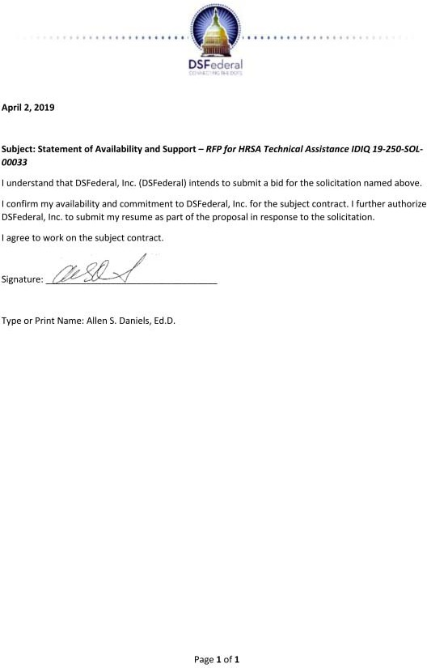

|  |
| --- |
| Qualifications and Experience  Consultant with 30 years of administrative experience delivering behavioral health services  Ph.D. from the University of Wisconsin  Board of Directors, National Association of State Mental Health Program Directors Research Institute, 2007 to 2011 |

1. **John Easterday, PhD - Behavioral Health Expert Summary**

Dr. John Easterday is a consultant with more than 30 years of administrative experience in delivering behavioral health services, as well as approximately 15 years of high-level state policy and budget experience. Between 2011 and 2014, he managed technical assistance and knowledge transfer for the SAMHSA Center for Financing Reform and Innovations (CFRI). Previously, he directed the Office of Policy Initiatives and Budget

within the Wisconsin Department of Health Services and was administrator of its Division of Mental Health and Substance Abuse Services. Dr. Easterday has managed behavioral health inpatient and outpatient programs in hospitals and community-based settings.

# Education

Ph.D., Public Administration and Health Care Policy, University of Wisconsin–Madison, 1991 M.A., Political Science, University of Wisconsin–Madison, 1975

B.A., Political Science, Indiana University–Bloomington, 1974

# Relevant Project Experience

*Westat (2016 to Present)*

**Analysis of Mental Health/SUD Services for Parity Compliance and Network Adequacy Client:** New Hampshire Insurance Department

In partnership with Freedman Healthcare, Westat provided expert assistance on behavioral health treatment practices and assessment carrier compliance with behavioral health/substance use disorder network adequacy and benefit parity requirements in the Affordable Care Act and state laws. Dr. Easterday provided a model for comparing substance use services in New Hampshire with the American Society of Addiction Medicine continuum of services.

# ASAM Level 3 Residential Certification for the Virginia Addiction Recovery and Treatment Services Program (ARTS)

**Client:** State of Virginia Department of Medical Assistance Services

As Project Director, Dr. Easterday oversaw on-site surveys of ARTS provider applicants for Level 3 certification (transitional group homes, group homes, residential treatment centers, and residential, crisis, and inpatient detoxification). This program is part of Virginia’s 1115 Medicaid Demonstration involving the certification of addiction programs for ASAM Level 3 Residential provider status in regional managed care programs. After each on-site survey and review, Westat issues a notification report with one of three outcomes from full certification to denial.

# Clinical Treatment Options Expert Panels

**Client:** Substance Abuse and Mental Health Services Administration (SAMHSA) **Project Overview:** SAMHSA developed a series of 11 topic papers about treatment and support options for people with mental illnesses and their families. Project staff used a

structured, moderator-facilitated process to reach consensus among expert panelists on the content of each paper. The papers were disseminated via SAMHSA’s communication networks, including its website. Dr. Easterday wrote descriptive summaries of schizophrenia and sleep disorders and chaired technical expert panels on sleep and anxiety disorders.

# Other Professional Experience

**Truven Health Analytics**, Washington, DC (2011 to 2014), Senior Project Manager for SAMHSA’s Center for Financing Reform and Innovations

**Wisconsin Department of Health Services**, Madison, WI (2003 to 2011)

* Director of the Office of Policy Initiatives and Budget (2011)
* Administrator of the Division of Mental Health and Substance Abuse Services (2007- 2011). Developed the Wisconsin 1915i Medicaid Program, 1915 C Medicaid Waiver, and Medicaid Rehab Options for Wisconsin 1915 A, B, and C Medicaid waivers. Secured grants for program implementation, learning collaboratives and TA.
* Associate Administrator for Mental Health and Substance Abuse Services in the Division of Disability and Elder Services (2003 to 2007). Oversaw 4 state facilities.

**Washington County Mental Health Center**, West Bend, WI (1997 to 2003), Administrator **Meriter General Hospital**, Madison, WI (1988 to 1997), Director of Psychiatry Program **Milwaukee County Mental Health Complex**, Wauwatosa, WI (1982 to 1988), Assistant

Administrator and Director of Outpatient Programs (7 clinics including 2 FQHCs)

**Department of Health and Social Services**, Madison, WI (1978 to 1982)

**University of Wisconsin–Madison, WI,** School of Social Work, LaFollette Center for Policy and Administration (1981 to 2003), graduate course instructor

# Awards and Professional Achievements

SAMHSA Grant Reviewer, 2015-present

Board of Directors, National Association of State Mental Health Program Directors (NASMHPD) Research Institute, 2007-2011

Technical Advisory Group, State Mental Health Directors and CMS, 2007-2011 Professional Technical Advisory Group, Behavioral Health, Joint Commission, 2005-2011

Wisconsin Single State Authority for Addiction Services, National Association of State Alcohol and Drug Abuse Directors, 2003-2011

Wisconsin Commissioner for Mental Health, NASMHPD, 2003-2011

# Selected Publications

Easterday, J., et al. (2015). *Issue brief: Behavioral health care expenditures for children and adolescents* (HHS Publication No. (SMA)-15-4926). Rockville, MD: SAMHSA.

Seibert, J., Ehrlich, E., Easterday, J., et al. (2014). *Crisis services: Effectiveness, cost- effectiveness, and funding strategies* (HHS Publication No. (SMA)-14-4848). Rockville, MD: SAMHSA.

Mark, T., Wier, L., Hohlbauch, A., Easterday, J., et al. (2013). *Behavioral health treatment needs: Assessment toolkit for states* (HHS Publication No. (SMA)-13-4757). Rockville, MD: SAMHSA.

Brolin, M., Quinn, A., Sirkin, J.T., Horgan, C.M., Parks, J., Easterday, J., and Levit, K. (2012). *Financing of behavioral health services within Federally Qualified Health Centers*. Rockville, MD: SAMHSA.

# John Easterday, PhD - Statement of Availability

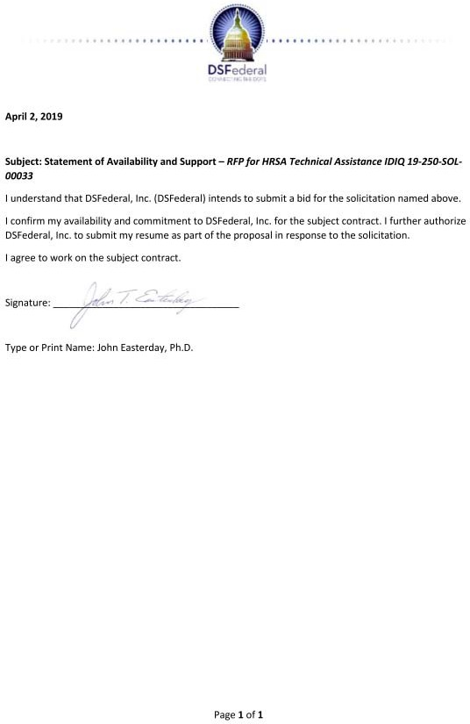

|  |
| --- |
| Qualifications and Experience  Research associate with 15 years of experience in child welfare research  B.S. from Georgetown University |

1. **Marneena L. Evans - Quality Program Specialist Summary**

Marneena Evans is a research associate with more than 15 years of experience in child welfare research and evaluation and qualitative development and dissemination. She conducts qualitative data collection and analysis for evaluations. As a continuous quality

improvement (CQI) and evaluation lead on tailored services projects, she supports tribal programs in building their capacity to collect, manage, analyze, and report data and to monitor and evaluate their programs. Ms. Evans previously conducted qualitative data collection and analysis and worked with county child welfare agencies.

# Education

B.S., Foreign Service, Georgetown University, 2000

# Relevant Project Experience

*Westat (2000 to Present)*

**Third-Party Evaluator for Performance-Based Child Welfare System (PBCWS) (1831) Client:** Michigan Department of Health and Human Services

Westat is leading a rigorous evaluation of a 5-year PBCWS project for the placement of children in out-of-home foster care in Michigan. The process evaluation design, for which Ms. Evans conducts qualitative data analysis, includes a participant satisfaction survey, review and analysis of administrative data from state and provider data systems, interviews and focus groups with key stakeholders and staff, and site visits.

# National Child Welfare Capacity Building Center for Tribes (CBCT) (1691)

**Client:** Administration for Children and Families, U.S. Department of Health and Human Services (HHS)

CBCT is the focal point for coordinated and culturally competent capacity building training and technical assistance to Title IV-B and IV-E programs in American Indian and Alaska Native Nations. Westat is responsible for developing universal products, webinars, and tools on data use for management, Continuous Quality Improvement, GIS and child welfare, and the use of technology for data reporting and management. Westat also works directly with tribal child welfare agencies on capacity building projects in these topical areas. As the continuous quality improvement (CQI)/evaluation lead on tailored services projects, Ms.

Evans supports tribal programs in building their capacity to collect, manage, analyze, and report data and to monitor and evaluate their programs. She also chairs the Tools for Growth data products workgroup, which develops data and CQI-related resources and tools for tribal child welfare programs.

**Michigan Title IV-E Waiver Demonstration Project Protect MiFamily (1489) Client:** Michigan Department of Human Services

Michigan’s Protect MiFamily Program provides an innovative array of prevention services to families with young children who are at high or intensive risk for maltreatment as determined

by child protective services. The demonstration is being implemented by private agencies in Kalamazoo, Macomb, and Muskegon Counties. Westat is conducting an independent evaluation of each waiver demonstration project. Westat’s activities involve evaluation plan and methodology development; implementation of process and outcome evaluations; primary and administrative data collection; outcome measurement and analysis; cost-benefit and cost- effectiveness analysis; and preparation of reports. Ms. Evans conducts qualitative analysis for the process evaluation and conducted site visits to child protective services and agency offices at demonstration sites.

# Evaluation of the Permanency Innovations Initiative (PII)

**Client:** Administration for Children and Families, U.S. Department of Health and Human Services (HHS)

Westat and its subcontractors are conducting cross-site and site-specific evaluations of the interventions in state or county child welfare systems intended to reduce long-term foster care and improve outcomes for children who experience serious barriers to permanency. Activities include completing the designs of rigorous site-level evaluations, implementing the evaluations, collecting and analyzing administrative data on distal outcomes, studying the implementation process, and conducting a cost study to assess the resource requirements of grantees’ interventions. Ms. Evans conducts qualitative analysis and reporting, manages dissemination approval and tracking between PII grantees and the client, and helped develop the dissemination plan. She also developed and administers the evaluation’s SharePoint site, which is used by Federal staff, grantees, and the training/technical assistance and evaluation teams.

**National Resource Center for Child Welfare Data and Technology (NRC-CWDT) (8754) Client:** Children’s Bureau, Administration for Children and Families, U.S. Department of Health and Human Services (HHS)

The goals of the NRC-CWDT were to assist state and tribal child welfare agencies in (1) developing and improving information management systems related to child welfare; (2) building capacity in using data from statewide child welfare information systems and other sources; (3) developing and improving use of new technologies; and (4) promoting and assisting in the exchange of data between child welfare agencies and the family and juvenile courts, to better integrate policy and practice and improve service delivery and outcomes for children and families. As a subcontractor, Westat provided technical assistance to states and tribes, developed and maintained the NRC-CWDT website, participated in the NRC-CWDT annual conference, and evaluated NRC-CWDT activities. Ms. Evans led communications planning for the NRCCWDT and regularly contributed to the development and writing of technical assistance documents, specializing in emerging technologies and social media. She oversaw the NRCCWDT website, contributed to website redesign, and served on the website content team.

# Publications

Lorthridge, J., Evans, M., Heaton, L., Stevens, A., and Phillips, L. (2018). Strengthening family connections and support for youth in foster care who identify as LGBTQ: Findings from the PII- RISE Evaluation. Child Welfare, 96(1), 53-78. Available at: https://search.proquest.com/docview/2056448552?accountid=28100.

# Marneena L. Evans - Statement of Availability

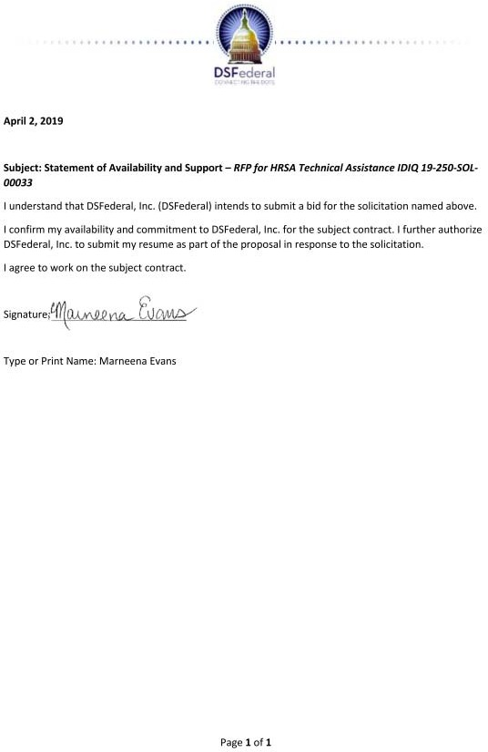

|  |
| --- |
| Qualifications and Experience  Senior research analyst with 5 years of experience providing research, technical assistance support, and policy analysis  M.P. Aff from the University of Texas  Teaching experience |

1. **Jocelyn C. (Kuhn) Franke - Senior Technical Personnel Summary**

Jocelyn Franke is a senior research analyst with 5 years of experience providing research, technical assistance (TA) support, and policy analysis for the 21st Century Community Learning Centers (21st CCLC) program. She provides support to more than 25 grantees across Texas and helps build the knowledge and capacity of organizations and staff and assists in

troubleshooting complex problems, proposing initiatives, and recommending or negotiating solutions. She synthesizes data and information to determine the effectiveness of education policies and TA policies.

# Education

M.P. Aff., Public Affairs, University of Texas at Austin, 2014 B.A., Secondary Education, University of Arizona, Tucson, 2008 B.A., Psychology, University of Arizona, Tucson, 2008

# Relevant Project Experience

*Westat/Edvance Research, Inc (2013 to Present), Rockville, MD (Edvance Research, Inc., was acquired by Westat in 2015)*

# Texas 21st Century Community Learning Centers (21st CCLC): Program Enhancement and Quality Assurance, Conferences and Meeting Coordination

**Client:** Texas Education Agency (TEA)

Westat provides program enhancement and quality assurance services and has served more than 150 fiscal agents, 1,000 campuses, and 145,000 students annually. Westat has provided three-tiered technical assistance to build grantee capacity to manage, continuously improve, and sustain their local programs. Other services have included extensive resources on research-based practices and national best practices; interactive in-person and virtual training and meetings tailored to grantee needs; annual grantee conference coordination, data analyses and grantee-level evaluation review; and national, state, and local policy analyses. Ms. Franke provides ongoing individual and statewide technical assistance and training to grantees.

**EDTASS: Teacher Incentive Fund (TIF) Technical Assistance Task Order Client:** U.S. Department of Education (ED)

Westat and its partners are providing in-depth technical assistance services to TIF grantees; supporting ED in monitoring their progress; and preparing tools and products for grantees and other stakeholders interested in implementing educator workforce reforms, including compensation reform. Ms. Franke ongoing individual technical assistance and training to a grantee.

# Promise Neighborhoods (PN) Program Technical Assistance for Grant-Related Activities and Performance Data Collection

**Client:** U.S. Department of Education (ED)

Westat provided training and technical assistance (TTA) to address grantees’ challenges in evaluating their programs and translating their findings into actionable recommendations.

Based on an assessment, the team delivered group-level TTA (guidance briefs, training sessions, webinars) and individual support (in-person or virtual meetings, an online forum, telephone and email contact). Other tasks included implementation of an annual project director’s meeting, maintenance and design of an online community of practice, updating of Annual Performance Report and ad hoc data collection instruments, and analysis and reporting of grantee data. Ms. Franke supports the technical assistance lead in providing ongoing training and support to a grantee.

**National Evaluation of AT&T Aspire Programs Client:** AT&T Foundation

Westat conducted an impact evaluation of Aspire grantees (2012 cycle, 48 grantees) and has continued to evaluate the 2014 and 2016 cycles (30 and 18 grantees, respectively). The evaluation uses de-identified student-level data acquired from more than 150 school districts across the nation. The project team annually estimates impacts on school attendance, GPA, and on-track-to-graduation status for each grantee. Westat also implemented a structured website to facilitate assurances about grantee program quality and capability to provide information, developed an online review process and scoring application, and provided other consultative services. Ms. Franke managed the website and worked closely with the client to revise content for the 2016 competition.

**Facilitation and Analysis Services to Inform Funding and Programming Client:** Rackspace Foundation (RSF)

Westat is responsible for developing school and provider logic models and recommending next steps based on program needs. Ms. Franke developed and administered needs-based training to grantees and provided formative feedback on their work products. She reviewed all grantee logic models and coauthored a summative report of findings.

*Office of the Student Ombuds, University of Texas, Austin, TX (2012 to 2014)*

Ms. Franke mediated university-related concerns in a confidential, informal, independent, and neutral environment. She clarified policy and helped students work through concerns by developing problem-solving skills.

*Lyndon B. Johnson School of Public Affairs, University of Texas, Austin, TX (2012 to 2014)*

Ms. Franke evaluated the quality and effectiveness of states K-16 dual and concurrent enrollment policies and collaborated on a policy brief for the Education Commission of the States to guide state best practices.

# Other Professional Experience

Ms. Franke was an eighth-grade social studies teacher at Sahuarita Middle School, Sahuarita, AZ from 2008 to 2012.

# Recent Technical Reports, and Presentations

Evans, A., Archuleta, B., Barrett, C., Bell, L., Berry, M.J., Dewald, A., Donovan, J., Fernandez, G., Hawley, K., Kuhn, J., et al. (2013). *Reclamation of the U.S. Congress* (Policy Report Project 176). Austin, TX: Lyndon B. Johnson School of Public Affairs, University of Texas.

Kuhn, J. (2015, October). *The impact of quality afterschool.* National Dropout Prevention Network Conference, San Antonio, TX.

# Jocelyn C. (Kuhn) Franke - Statement of Availability

|  |
| --- |
| Qualifications and Experience  Senior Study Director with 20 years of experience conducting research on substance use etiology, prevention, and treatment  Ph.D. from the University of California  Led treatment program certification reviews |

1. **Kevin C. Frissell, PhD - Behavioral Health Expert Summary**

Dr. Kevin Frissell is a Westat Senior Study Director with more than 20 years of experience conducting research on substance use etiology, prevention, and treatment. At Westat, his work involves study design, data analysis, program evaluation, and manuscript/report preparation across multiple Federal contracts and grants.

Dr. Frissell has considerable training and experience in research methodology, design, and statistical analyses. He has published research studies on various topics concerning

the etiology, treatment, and prevention of addictive behaviors among adults and adolescents, as well as several methodological studies investigating measurement validity and response bias. He is also a member of the editorial board for the peer-reviewed journal *Substance Abuse: Research and Treatment*, and he has been an ad hoc peer reviewer for numerous other peer-reviewed journals focused on addictions, mental health, and general health issues.

# Education

Ph.D., Joint Doctoral Program in Clinical Psychology (with a concentration in Experimental Psychopathology), University of California, San Diego/San Diego State University, 2007

Predoctoral Clinical Internship, Brown University School of Medicine, 2005-2006 M.S., Clinical Psychology, San Diego State University, 2003

B.A., Psychology, University of Maryland, 1996

# Relevant Project Experience

*Westat (1996 to Present)*

# ASAM Level 3 Residential Certification for the Virginia Addiction Recovery and Treatment Services Program (ARTS)

**Client:** State of Virginia Department of Medical Assistance Services

The VA DMAS has contracted Westat to conduct on-site surveys of ARTS applicants for Level 3 certification (transitional group homes, group homes, residential treatment centers, and residential, crisis, and inpatient detoxification). Virginia estimates 99 facilities will apply for certifications. Dr. Frissell led treatment program certification reviews for multiple programs throughout Virginia. He conducted document reviews and site visit interviews with program staff, drafted certification reports, and made recommendations for certification based on ASAM criteria.

**Population Assessment of Tobacco and Health Study (PATH 1.0 and 2.0) Client:** National Institute on Drug Abuse (NIDA)

The PATH 1.0 panel survey involved interviewing approximately 32,000 adults plus 14,000 youth (aged 12-17) annually. For PATH 2.0, Westat is interviewing already-participating adults and youth (approximately 28,000 and 12,000, respectively) on a semi-annual basis and refreshing the sample with approximately 6,000 adults and 3,000 youth. The current contract covers four follow-up data collection waves with the entire sample, plus semi-annual follow- up interviews with all youth; Westat has completed the first PATH 2.0 data collection wave

(Wave 4) and is conducting the first round of youth follow-up interviews. Biologic specimens are being collected from all adults (PATH 1.0) and from all adults and youth (PATH 2.0). Dr. Frissell works as a senior data analyst.

**CSAP Prevention Management Reporting and Training System (PMRTS) Client:** Substance Abuse and Mental Health Services Administration (SAMHSA)

Westat was responsible for reactivating and then continuing the operation of the PMRTS, a data collection and management system for CSAP grant programs. The system supported CSAP in demonstrating its accountability to Congress and those in the prevention field. The Westat team maintained the functioning of the PMRTS; collected, analyzed, and reported high-quality data; and produced performance measures and results reports, the HIV Report to Congress, and ad hoc reports. Dr. Frissell leads analytic and reporting tasks.

**CSAP Data Collection, Analyses, and Reporting (DCAR) Client:** Center for Substance Abuse Prevention (CSAP), SAMHSA

Westat supported CSAP in meeting its GPRA and National Outcome Measures reporting requirements. The team (1) developed a web-based system for collecting program performance and monitoring data from CSAP grantees and selected contractors, including user training and helpdesk support; (2) analyzed and reported performance data from grant programs and selected contracts to assess the extent to which CSAP was meeting its programmatic goals and objectives; and (3) completed the national cross-site evaluations of the Minority AIDS Initiative and the Strategic Prevention Framework State Incentive Grant (SPF SIG) program. Dr. Frissell led analyses and reporting for CSAP’s GPRA measures and DCAR’s HIV cross-site evaluation.

# CSAT Division of Services Improvement (DSI) Clinical Technical Assistance Bridge Contract

**Client:** Center for Substance Abuse Treatment (CSAT), SAMHSA

DSI awards grants to organizations that provide substance abuse treatment services to individuals and families, including grants focused on adolescents, American Indians and Alaska Natives, e-therapy alternatives, people with HIV, pregnant and postpartum women and their children, methamphetamine users, screening and brief intervention, referral to treatment, and treatment drug court and youth offender re-entry. Technical assistance providers delivered assistance in client location and retention; assisted grantees in developing outreach strategies, especially for clients with or at risk for HIV; provided input on effective treatment strategies for specific populations; provided technical assistance on staff development programs and evidence-based practices; and worked with grantees to maintain sustainability once the grant period of performance was over. Dr. Frissell provided program evaluation assistance to Adolescent Treatment grantees.

# Other Professional Experience

Dr. Frissell was an adjunct assistant professor at the Department of Clinical Research and Leadership, George Washington University School of Medicine and Health Sciences, from 2013 to 2015. He collaborated on research to assess pharmacotherapy for adolescent addictive behaviors at the Center for Alcohol and Addictions Studies, Brown University, from 2005 to 2006.

# Kevin C. Frissell, PhD - Statement of Availability

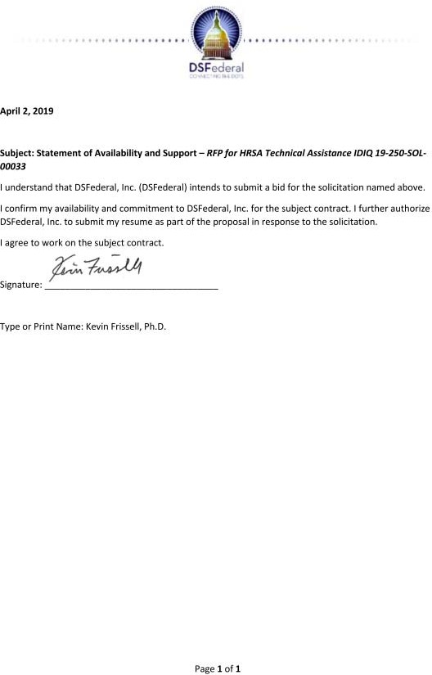

|  |
| --- |
| Qualifications and Experience  Senior Study Director with 20 years of experience developing and implementing public health projects and programs |

1. **Belinda Gaston - TA Specialist / Research Analyst Summary**

Belinda Gaston is a Westat Senior Study Director with 20 years of experience developing and implementing public health projects and programs. She has been the project director for a number of initiatives for CDC’s Division of HIV/AIDS Prevention and the National Center for Birth Defects and

Developmental Disabilities. Ms. Gaston offers expertise in strategic planning, management of large projects and project teams, partnership development, community engagement, training and technical assistance, development of communication materials, and creation and operation of stakeholder and community advisory groups.

# Education

M.P.H., Epidemiology, University of Alabama at Birmingham School of Public Health, 1997 B.A., English, Emory University, 1995

Certificates in Health Communication Leadership, 2016; Faith-Based Health Care to Reduce Health Disparities, 2006; Public Health Leadership, 2000

# Relevant Project Experience

*Westat (2011 to Present)*

# Health Marketing Support Services

**Client:** Office of the Associate Director for Communication, CDC

Westat provides expertise and support for CDC health communication programs covering a broad range of health topics and targeting a variety of audiences. Ms. Gaston is participating in the research projects described below.

# Act Against AIDS (AAA): Health Communication and Marketing Support for Multisectoral Partnerships

Westat supports the National Partnerships Team (NPT) within the Division of HIV/AIDS Prevention (DHAP) in its ongoing efforts to engage external partners in the prevention of HIV/AIDS. Westat provides health marketing, communications, strategic planning, and technical assistance expertise to help DHAP identify, recruit, engage, coordinate, and mobilize partnerships. Ms. Gaston serves as project director.

**Business Responds to AIDS (BRTA): Engaging the Private Sector in HIV Prevention** BRTA is a CDC partnership initiative that supports businesses with tailored resources and tools for workplace programs that reduce stigma and prevent discrimination against employees living with HIV. Ms. Gaston provides strategic direction to the project director.

**Health Marketing, Communications, and TA Services for Multisectoral Partnerships** Westat supported the National Partnerships Team in the Division of HIV/AIDS Prevention, National Center for HIV/AIDS, Viral Hepatitis, STD, and TB Prevention, in identifying, recruiting, engaging, coordinating, and mobilizing multisectoral partnerships. Ms. Gaston served as project director.

# Creative Services to Promote Awareness and Prevention of Congenital Cytomegalovirus (CMV) Among Pregnant Women

Westat supported the National Center on Birth Defects and Developmental Disabilities in developing branded communication products to encourage risk reduction behavior among pregnant women and reduce congenital CMV infection. Ms. Gaston served as project director.

# Development and Dissemination of a General Awareness Social Marketing Campaign for the Act Against AIDS Campaign

Westat developed a national social marketing campaign for The National Center for HIV/AIDS, Viral Hepatitis, STD, and TB Prevention to raise awareness of the importance of and to encourage universal HIV testing. Ms. Gaston provided leadership and communication support for CDC’s AAA Leadership Initiative and was the African American campaign director for the HIV Testing Campaign.

# Engaging Partners and Leaders to Promote Influenza Vaccination Through a Communication and Social Marketing Campaign

The National Center for Immunization and Respiratory Diseases contracted with Westat to promote vaccination among the U.S. population and specific groups for which immunization is especially important. Westat developed an award-winning, multipronged marketing strategy with a strong digital focus to reach a national audience and key groups at higher risk for flu complications. Ms. Gaston recruited and engaged national partners for the campaign.

# Promoting Childhood Immunization to Parents and Health Care Professionals Using Communication and Social Marketing Strategies

Westat worked with CDC’s National Center for Immunization and Respiratory Diseases to create a social marketing campaign to promote childhood immunization to the parents of infants and young children and to child care and health care professionals. Ms. Gaston served as project director.

**Community Guide Communication Technical Assistance and Support Client:** Centers for Disease Control and Prevention (CDC)

Westat developed communication products to promote the *Community Guide* and a toolbox of resources to help decisionmakers select and implement its recommendations; developed and pilot tested a training course to support the development of evidence-based guidelines; and conducted a range of evaluation activities to provide feedback on the products and strategies developed to support the *Community Guide*. Ms. Gaston helped develop a toolbox to assist public health professionals in implementing recommendations from the Community Guide.

# Other Professional Experience

Cicatelli Associates, Inc., Atlanta, GA (2011-2011)

Directed CDC’s Region IV Infertility Prevention Project, and deputy director for National Teen Pregnancy Prevention: Integrating Services, Programs, and Strategies Through Community-Wide Initiatives, Training, and Technical Assistance Center.

Danya International, Inc., Atlanta, GA, health communications manager and project director (2007 to 2011)

American Cancer Society, Atlanta, GA, manager of African American Initiatives for the South Atlantic Division (2003 to 2007)

# Belinda Gaston - Statement of Availability

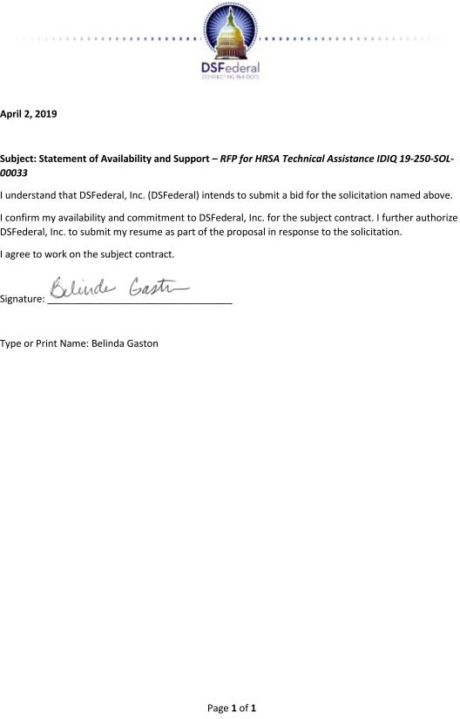

|  |
| --- |
| Qualifications and Experience  Research analyst with 5 years of experience in the fields of substance abuse prevention, tobacco, research methods and design, quantitative data analysis, and program evaluation  M.A. from Columbia University |

1. **Kristin Harkness - Data Administrator / Statistician Summary**

Kristin Harkness is a research analyst with 5 years of experience in the fields of substance abuse prevention, tobacco, research methods and design, quantitative data analysis, and program evaluation. In support of the Population Assessment of Tobacco and Health Study, she manages thousands of analytic variables across multiple waves of

data collection through their life cycles. Ms. Harkness also worked as an analyst on the Center for Substance Abuse Prevention’s Data Collection, Analysis, and Reporting (DCARS) and Prevention Management and Reporting System (PMRTS) contracts. She specializes in quantitative data analysis, derived variable creation, multivariate research methods, and report preparation.

# Education

M.A., Quantitative Methods in the Social Sciences, Columbia University, 2013 B.A., Sociology, Skidmore College, 2008

# Relevant Project Experience

*Westat (2013 to Present)*

**Population Assessment of Tobacco and Health Study (PATH 1.0 and 2.0) (1464) Client:** National Institute on Drug Abuse (NIDA)

Westat is conducting a large national longitudinal cohort study of U.S. tobacco users and nonusers (aged 12+). By measuring the behavioral and health effects associated with FSPTCA regulatory changes, this study will provide an empirical evidence base for developing, implementing, and evaluating tobacco regulations. For PATH 2.0, Westat is interviewing already-participating adults and youth on a semi-annual basis and refreshing the sample with approximately 6,000 adults and 3,000 youth. Biologic specimens are being collected from all adults (PATH 1.0) and from all adults and youth (PATH 2.0). Westat also conducts a wide variety of analytic tasks, including rapid-turnaround analyses and preparation of journal articles; to date, more than 60 articles have been published in juried journals. Ms.

Harkness is primarily responsible for derived variable creation.

# CSAP Data Collection, Analyses, and Reporting (DCAR)

**Client:** Center for Substance Abuse Prevention (CSAP), Substance Abuse and Mental Health Services Administration (SAMHSA)

Westat supported CSAP in meeting its GPRA and National Outcome Measures (NOMs) reporting requirements. The project team was responsible for (1) developing a web-based system for collecting program performance and monitoring data from CSAP grantees and selected contractors, including providing user training and helpdesk support; (2) analyzing and reporting performance data from grant programs and selected contracts, to assess the extent to which CSAP was meeting its programmatic goals and objectives; and (3) completing the national cross-site evaluations of the Minority AIDS Initiative and the Strategic

Prevention Framework State Incentive Grant (SPF SIG) program. Ms. Harkness worked as an analyst for the cross-site evaluation of the SPF SIG program and SAMHSA’s annual Accountability Report. She conducted analyses in SPSS, wrote analysis specifications for SAS programmers, resolved issues with SPSS syntax to replicate analyses, interpreted results, and wrote and edited annual reports.

**CSAP Prevention Management Reporting and Training System (PMRTS) Client:** Substance Abuse and Mental Health Services Administration (SAMHSA)

Westat is responsible for reactivating and continuing the operation of the PMRTS, a data collection and management system for CSAP grant programs. The system supports CSAP in demonstrating its accountability to Congress and those in the prevention field. The Westat team is maintaining the functioning of the PMRTS; collecting, analyzing, and reporting high- quality data; and producing performance measures and results reports, the HIV Report to Congress, and ad hoc reports. Ms. Harkness worked as a research analyst on this project.

# Multi-jurisdiction Research on Kiosk Supervision

**Client:** National Institute of Justice, U.S. Department of Justice (DOJ)

This study was designed to expand and strengthen the evidence base on kiosk reporting for supervising probationers and parolees. The study collected and analyzed information on the prevalence of kiosk reporting, implementation experiences of adopters, and associated outcomes and costs. In addition to enhancing the evidence base, the findings informed development of a practical guidebook that will help community supervision agencies make knowledgeable decisions. This mixed-method study involved (1) a brief telephone screener and in-depth telephone interviews, (2) an implementation and cost study, and (3) an outcome study. Ms. Harkness developed analytic files for use by senior researchers.

# Other Professional Experience

*Columbia University, New York, NY (2012 to 2013)*

Ms. Harkness worked with public health faculty to design and implement a longitudinal analysis of neighborhood access to health services in New York City. She conducted literature reviews, synthesized information for journal articles, developed data definitions, and created data requests.

**ForceChange (2012 to Present) –** As an editor, Ms. Harkness reviews and publishes petitions. Originally a top writer in the program, she researched and drafted several online petitions on important social issues.

# Publications, Technical Reports, and Presentations

Karp, D.R., and Harkness, K.L. (2008). Research update: Recent research on the impact of neighborhoods on offender recidivism. *Perspectives*, 32(3), 15-16.

Curry, S.T., and Harkness, K. (2017, August). *Unsafe driving behaviors after using marijuana and other substances among high school seniors: Monitoring the Future, 2011-2015* (invited poster). National Cannabis Summit, Denver, CO.

# Kristin Harkness - Statement of Availability

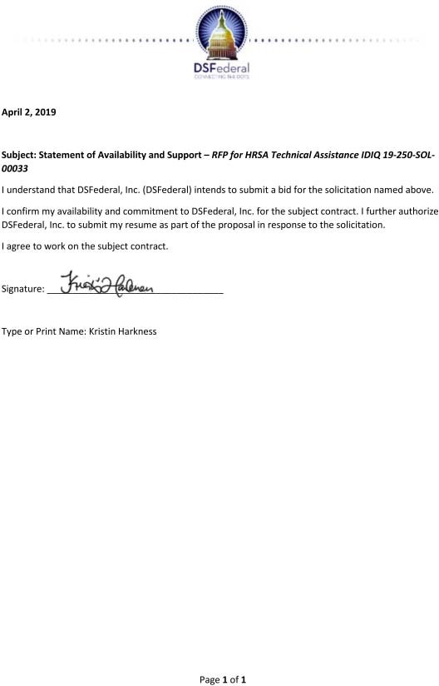

|  |
| --- |
| Qualifications and Experience  Health communications specialist with 15 years of experience in research-driven strategic communication, marketing, and promotion  B.A. from St. Mary’s College  Skilled in branding, messaging, and translation of complex information into plain language |

1. **Erin Loomis - Health Communications Specialist Summary**

Erin Loomis is a health communications

specialist with 15 years of experience in research-driven strategic communication, marketing, and promotion for public health clients. She has the broad expertise to lead projects from planning and formative research, through implementation and evaluation. Skilled in branding, messaging, and translation of complex information into

plain language, Ms. Loomis creates compelling messages and multimedia products that can reach a wide range of audiences across multiple communication channels. She has collaborated closely with partners from Federal agencies, state and local health departments, professional organizations, community-based organizations, and advocacy groups to develop resources and strategies.

# Education

B.A. (summa cum laude), English, St. Mary’s College of Maryland, 1995

B.A. (summa cum laude), Psychology, St. Mary’s College of Maryland, 1995

# Relevant Project Experience

*Westat (2008 to Present)*

**Community Guide Communication Technical Assistance and Support Client:** Centers for Disease Control and Prevention (CDC)

Westat developed additional communication products to promote the *Community Guide*, as well as a toolbox of resources to help decisionmakers select and implement its recommendations; developed and pilot tested a training course to support the development of evidence-based guidelines; and conducted a range of evaluation activities to provide feedback on the products and strategies developed to support the *Community Guide*. Ms. Loomis planned and developed technical assistance tools to support state and local health departments in selecting and implementing community-based public health interventions. She led a team of writers, editors, graphic designers, and Section 508 compliance specialists in developing a suite of print and electronic resources—including factsheets and “success stories”—that synthesized complex *Community Guide* findings and recommendations into actionable information for policymakers, decisionmakers, program planners, and community advocates.

# Health Marketing Support Services

**Client:** Office of the Associate Director for Communication, Centers for Disease Control and Prevention (CDC)

Westat provides expertise and support for CDC health communication programs covering a broad range of health topics and targeting a variety of audiences.

Ms. Loomis is the strategic communications and materials development lead for CDC’s Division of Adolescent and School Health (DASH), which focuses on reducing adolescent sexual risk behaviors, HIV/AIDS and STDs, and teen pregnancy. She coordinates

communication planning and the development and production of print, electronic, and digital materials and resources to support DASH outreach. She oversees the Division’s branding and messaging, ensuring that they are consistent across channels.

Ms. Loomis is the creative director for the Communication Research to Understand Women’s Awareness and Knowledge About Cytomegalovirus (CMV) Infection and Prevention project. Ms. Loomis oversaw all product development, providing creative, technical, and administrative direction to graphic, digital, and video production staff. She compiled all final products into a creative toolkit that included technical and dissemination guidance for partners.

Ms. Loomis was the content development manager for CDC’s National Center for Injury Prevention and Control’s state profiles that described the burden of motor vehicle crash injuries and deaths as it relates to restraint use and alcohol-impaired driving. She led the development of two sets of profiles on two high-priority injury prevention topics: drunk driving and seatbelt use. Ms. Loomis developed a creative brief for the materials and oversaw the design of creative concepts and prototypes for audience testing. She worked with NPIC to integrate feedback from subject matter experts and prepare materials for various levels of clearance. Ms. Loomis oversaw final development of the suite of 102 profiles, which included graphic design work, editing and proofreading, and Section 508 compliance.

**Increasing Provider Referrals to State Arthritis Programs Client:** Directors of Health Promotion and Education

Westat conducted a comprehensive literature review to examine factors that influence healthcare provider referrals to programs funded by CDC. Literature review findings— combined with data from in-depth interviews and an online survey of provider audiences— guided development of electronic and print materials and appropriate distribution channels. Ms. Loomis worked with DHPE and CDC to develop a toolkit as the centerpiece of a social marketing strategy aimed at increasing patient participation in community-based chronic disease self-management programs. Ms. Loomis used the formative research findings to guide toolkit development.

# Health Care Innovations Exchange

**Client:** Agency for Healthcare Research and Quality (AHRQ)

Westat operated and maintained this multipronged program, which promoted the adoption, implementation, and dissemination of novel care delivery methods. The Innovations Exchange featured a web-based, national information hub focused on innovative healthcare delivery practices and policies summarized in structured innovation profiles. Ms. Loomis helped refresh editorial criteria for Innovations Exchange entries, identified and researched innovation examples to profile, reviewed and edited content and coordinated graphics.

# Other Professional Experience

Ms. Loomis previously worked for Aspen Systems Corporation/Lockheed Martin, Rockville, MD (2003 to 2008); Department of Obstetrics/Gynecology and Reproductive Sciences, University of California, San Francisco, CA (1999 to 2002); Department of Obstetrics/Gynecology, Johns Hopkins Bayview Medical Center, Baltimore, MD (1997 to 1998); and Planned Parenthood of Maryland (1995 to 1997).

# Erin Loomis - Statement of Availability

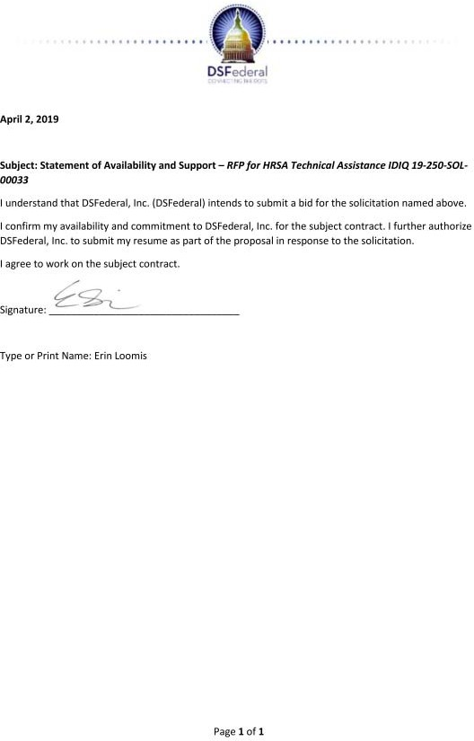

|  |
| --- |
| Qualifications and Experience  Senior Study Director with 15 years of experience in the evaluation of community-based programs aimed at improving outcomes for families, youth, and children  Ph.D. from the University of California  Reviewer for the Children and Youth Services Review |

1. **Jaymie Lorthridge, PhD - Project Director/Contract Manager Summary**

Dr. Jaymie Lorthridge is a Westat Senior

Study Director with 15 years of experience in the evaluation of community-based programs aimed at improving outcomes for families, youth, and children. In collaboration with multidisciplinary teams, she has designed and implemented process and outcome

studies that informed program implementation and jurisdictional policies. She designs data collection tools, including surveys, interview and focus group protocols, and data extraction protocols, and uses quantitative and qualitative methods to assess achievement of project objectives. She currently serves as a reviewer for the Children and Youth Services Review.

# Education

Ph.D., University of Southern California School of Social Work, 2014

M.S.W., Community Organization, Planning, and Administration, University of Southern California School of Social Work, 2006

B.A., Psychology, Spelman College, 1998

# Relevant Project Experience

*Westat (2012 to Present)*

**Social Services Reform and Child Welfare Reform Plans Client:** North Carolina Office of State Budget and Management

In response to 2017 legislation, the Office of State Budget and Management must develop recommendations for reforming the social services system and prepare a detailed plan to reform the child welfare system. Partnering with the Center for the Support of Families, Westat is responsible for collecting and examining administrative data from social service agencies to assess current practice, efficiency, and effectiveness and is responsible for examining staffing data to support development of recommendations for collecting and using administrative data for continuous quality improvement. Additionally, Westat is developing a dashboard to provide up-to-date state and county data on agencies’ performance and management activities. Dr. Lorthridge directs and coordinates Westat analysts and dashboard staff. She reviews administrative data, ensuring that it meets project needs; is co-developing the dashboard; and communicates with the client to ensure fulfillment of project expectations.

**California Title IV-E Waiver Demonstration Evaluation Client:** California Department of Social Services

Westat is part of a team conducting an independent third-party evaluation of this waiver demonstration, which allows greater flexibility in the use of funding to reimburse out-of-home foster care and adoption services for eligible children and youth under the supervision of child welfare and probation agencies. The evaluation includes (1) a process evaluation to describe how the demonstration was implemented and identify how services differ from those available before implementation; (2) an outcome evaluation to analyze changes in specified outcomes, and outcome sub-studies to analyze changes in specific counties; (3) a study of the cost of key elements of services and a comparison with costs of services available before the

demonstration or received by children, youth, and families not designated to receive demonstration services; and (4) a cost sub-study of key elements of service implemented in a selected waiver county. Westat is leading the outcome sub-studies, cost study, and cost sub- study. Dr. Lorthridge directs the Westat methodologists, analysts, and data collectors working on the outcome, process, and cost studies. She contributed to the development and refinement of research questions, the identification of outcome indicators, and the creation of data collection tools and analytic plans. She created initial logic models and managed the testing of parent engagement measures, leading to measurement finalization, and collected data during site visits. She updates and monitors Westat’s budget and staffing hours and contributes to reports.

**Evaluation of the Permanency Innovations Initiative (PII) Client:** Administration for Children and Families, HHS

The Children’s Bureau funded six grantees to develop and implement innovative interventions to reduce long-term foster care and improve outcomes for children who experience serious barriers to permanency. Westat and its subcontractors are conducting cross-site and site- specific evaluations of the interventions. Activities include completing the designs of rigorous site-level evaluations (using randomized control groups wherever feasible), implementing the evaluations (monitoring the fidelity of the interventions and collecting primary data on proximal outcomes from treatment and comparison cases), collecting and analyzing administrative data on distal outcomes (children’s exit from foster care and permanent placement), studying the implementation process, and conducting a cost study to assess the resource requirements of grantees’ interventions. Dr. Lorthridge worked with RISE leaders at the Los Angeles Gay and Lesbian Center and with project managers, the client, and the training and technical assistance partner to develop an evaluation plan for interventions targeting multiple levels (child, family, organization) and aimed at reducing foster care placement and length of placement for gay, lesbian, bisexual, transgender, and gender- nonconforming children and youth. She created and refined the qualitative protocol to be used with minor participants; created and updated supporting materials such as a logic model and IRB applications, juvenile court petitions, and research requests; and participated in data collector hiring and materials development. Dr. Lorthridge collaborated with local site partners and child welfare departments to develop administrative data exchange procedures, coordinated forums to facilitate project collaboration, and developed strategies for achieving evaluation buy-in by child welfare departments. Dr. Lorthridge managed data collection, ensuring that the site adhered to pre-established quality standards, and conducted a site-level case study to document implementation context.

# Other Professional Experience

Ms. Lorthridge worked for Los Angeles Department of Children and Family Services (DCFS) and First 5 LA, Los Angeles, CA (2005 to 2012); University of Southern California School of Social Work, Los Angeles, CA (2006, 2010); as a Contract Researcher, Los Angeles/Pasadena, CA (2005 to 2007, 2008 to 2009); the City of Los Angeles Workforce Investment Board, Los Angeles, CA (2003 to 2004); and the Atlanta Police Department, Atlanta, GA (1998 to 2002)

# Publications, Technical Reports, and Presentations

Lorthridge, J., Evans, M., Heaton, L., Stevens, A., and Phillips, L. (2018). Strengthening family connections and support for youth in foster care who identify as LGBTQ: Findings from the PII-RISE Evaluation. *Child Welfare*, 96(1), 53-78.

# Jaymie Lorthridge, PhD - Statement of Availability

|  |
| --- |
| Qualifications and Experience  Research analyst with more than 12 years of experience in education research and policy studies  M.A. from the University of Wyoming  Manages large-scale data collection reviews |

1. **Carrie A. Murthy - Population Health Advisor Summary**

Carrie Murthy is a research analyst with more than 12 years of experience in education research and policy studies. At Westat, she manages a large-scale data collection; creates and disseminates technical assistance outreach and communication to grantees and states; conducts site visits and monitoring reviews of state and grantee progress toward project goals and sustainability; conducts data analysis; and

provides logistical support for site visits, workshops, and conferences.

# Education

M.A., Political Science, University of Wyoming, 2010

B.A. (summa cum laude), Sociology (with a concentration in Criminology), Winthrop University, 2006

Certifications and Licensures: Certified CLASS K-3 Observer, Teachstone, 2013-2014

# Relevant Project Experience

*Westat (2006 to Present)*

# HEA Title II—The Secretary’s Report on Teacher Preparation and State Initial Certification and Licensure

**Client:** Office of Postsecondary Education, U.S. Department of Education (ED)

Westat supports reporting specified in Title II of the Higher Education Act (HEA) by collecting the required data, developing and maintaining an electronic reporting system, hosting the Title II website, and preparing the Secretary’s annual report to Congress. Ms. Murthy leads the Title II data collection, managing a team that provides outreach and technical assistance to 59 states and more than 1,200 institutions of higher education. Ms. Murthy conducts training webinars, creates and disseminates training materials and manuals, and provides outreach and support to assist states and higher education institutions in fulfilling Title II reporting requirements. She leads planning activities, data analysis, and writing efforts for the annual Secretary’s Report on Teacher Quality.

**Technical Assistance (TA) to Investing in Innovation (i3) Program Client:** U.S. Department of Education (ED)

The Westat team provided TA to all i3 grantees and the program for 5 years in order to increase the likelihood of grantee success in carrying out their projects and to generate lessons for the broader education field and increase stakeholders’ ability to perform the type of evidence-based work envisioned by i3. Ms. Murthy was the lead technical assistance liaison for seven i3 grantees.

**Teacher Quality Evaluation, Needs Assessment, Data Collection, and Analytic Support Client:** Office of Elementary and Secondary Education, U.S. Department of Education (ED) Westat continues to collect and analyze data on teacher quality, research promising practices, and convene annual workshops for Title II, Part A coordinators. Westat convened a peer review on State Equity Plans and reviewed plans to ensure that they met the requirements of

the review and ESEA. The team provided policy and logistical support to ED’s Teacher-to- Teacher Initiative (T2T); organized regional workshops; and organized, coordinated, and participated in Teacher Assistance Corps visits to all states. Ms. Murthy assists with data collection and has researched and compiled state-specific data packets to supplement site visits. She conducts monitoring visits and writes reports documenting and analyzing findings and current practices. Ms. Murthy has assisted with a district-level survey on the use of funds under Title II, Part A, of NCLB. She also maintained a monitoring matrix comparing and analyzing findings across states.

# Technical Assistance for Teacher Incentive Fund (TIF) Grants Funded Under the American Recovery and Reinvestment Act (ARRA)

**Client:** U.S. Department of Education (ED)

Westat led a team of organizations to support the third and fourth cohorts of TIF grantees. The team monitored the progress of TIF grants and provided TA in areas such as data quality, stakeholder engagement, program evaluation, and sustainability. The Westat team also provided logistical support for annual grantee meetings and analyzed and reported project information required to meet GPRA requirements. Ms. Murthy directed monitoring activities and directly monitored seven TIF grants. She conducted site visits and monitoring reviews and wrote monitoring reports summarizing grantee progress toward project goals and sustainability.

**21st Century Community Learning Centers (21st CCLC) Grant Monitoring Client:** U.S. Department of Education (ED)

Westat led monitoring for the 21st CCLC program. Westat drafted a monitoring guide, developed and delivered yearly training for ED and contractor program monitors, helped facilitate logistics across three contractor organizations and ED, and built an online system to manage travel and itineraries. Westat program monitors conducted 18 to 20 visits per year.

Murthy conducted monitoring reviews and wrote detailed monitoring reports and state profiles documenting findings and current practices.

**Center for Educator Compensation Reform (CECR) Client:** U.S. Department of Education (ED)

Westat supported ED in establishing the center, monitored and provided technical assistance, convened annual symposia on compensation reform, developed policy and content briefs, and created and maintained a national clearinghouse. Ms. Murthy monitored three grantees, conducted on-site monitoring reviews, and wrote monitoring reports.

# Publications, Technical Reports, and Presentations

Murthy, C., and Pietryka, D. (2018, April). *Supporting a diverse teaching force through alternative teacher preparation* (workshop presenter). National Association of Alternative Certification Annual Conference, Las Vegas, NV.

# Carrie A. Murthy - Statement of Availability

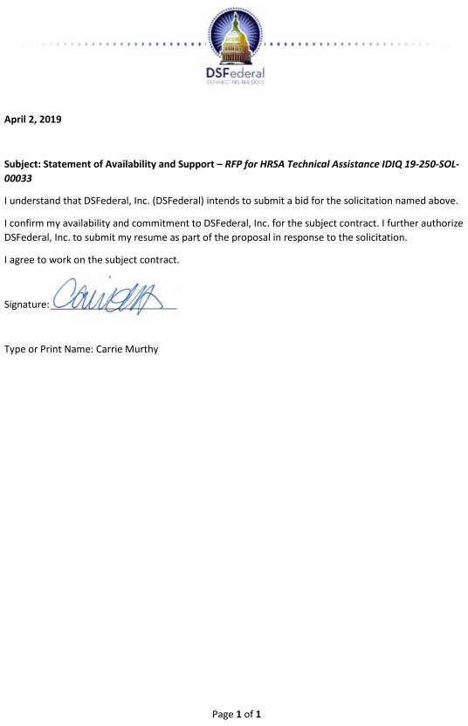

|  |
| --- |
| Qualifications and Experience  Senior Study Director with 17 years of experience in public health research  Ph.D. from the University of Geneva, Switzerland  Designs and develops project implementation plans |

1. **Saloni Sapru, Ph.D. - Rural TA Specialist/Research Analyst Summary**

Dr. Saloni Sapru is a Westat Senior Study Director with more than 17 years of experience conducting a wide range of public health research and evaluation studies. At Westat, she has directed several projects and is taking part in the design and implementation of public health education research and evaluation projects in areas such as smoking cessation, fetal alcohol spectrum disorders, alcohol screening and brief intervention, perinatal

quality collaboratives, eye care, vaccine reporting, biomonitoring, ovarian and endometrial cancers, and health protection. Dr. Sapru has developed research designs and protocols for in- depth interviews, focus groups, and surveys for a number of audiences, including health care providers, health department officials, advocacy groups, mothers of young children, at-risk women, and representatives of community organizations. She has experience conducting interviews and site visits as well as developing case studies to evaluate programs. Using mixed- method (quantitative and qualitative) designs, Dr. Sapru has conducted research nationally and internationally and has published in peer-reviewed journals

# Education

Ph.D., Educational Sciences, University of Geneva, Switzerland, 1999 M.Phil., Applied Social Psychology, University of Delhi, India, 1994 M.A., Clinical Psychology, University of Delhi, India, 1991

B.A. (Hons.), Psychology, Lady Shri Ram College, University of Delhi, India, 1989 Additional Training: Focus Group Moderation, RIVA Training Institute, 2012

# Relevant Project Experience

*Westat (2009 to Present)*

# Health Marketing Support Services

**Client:** Office of the Associate Director for Communication, Centers for Disease Control and Prevention (CDC)

Westat provides expertise and support for CDC health communication programs covering a broad range of health topics and targeting a variety of audiences. Dr. Sapru has participated in formative research, development of process and outcome measures, and manuscript preparation for the projects below.

# CDC Emergency Risk Communication Outcomes Measures Development and Assessment

Westat is developing, operationalizing, and evaluating an evidence-informed set of measures to assess the quality, effectiveness, and impact of emergency risk communication messages. Activities include research to inform outcome measures and metrics, and recommendations for future research to assess the impact of CDC emergency risk communication.

# Vaccine Adverse Event Reporting System

Westat assessed clinicians’ decision-making processes and their knowledge, beliefs, and practices regarding vaccine adverse event reporting. Key tasks included conducting formative research with clinicians, developing a quantitative survey to be fielded with clinicians nationally, analyzing data, and preparing a manuscript on survey findings.

# Health Protection Communication and Marketing Variables

The purpose of this project was to develop and test communication and marketing variables that could be used to track trends and compare outcomes over time and across interventions. Project activities included cognitive testing, pilot testing, and a large, nationally representative, multimode field study.

# Evaluating Systems-Level Practice Change for Fetal Alcohol Spectrum Disorders (FASDs): A Cross-Site Evaluation of the Contributions of FASD Practice Implementation Centers and Professional/Partner Organizations

**Client:** Centers for Disease Control and Prevention (CDC)

Westat is designing and implementing a cross-site evaluation across several CDC grantees, to assess practice changes related to the prevention, identification, and treatment of FASDs by trained health care providers. Dr. Sapru participates in the design and development of the evaluation plan, instruments, and reports which focus on best practices in collaboration, training and practice implementation, consistent and science-based messaging, and practice change, particularly from a system change perspective.

**Community Guide Communication Technical Assistance and Support Client:** Centers for Disease Control and Prevention (CDC)

Westat assisted CDC in increasing awareness and access to its *Guide to Community Preventive Services*, which summarizes the state of knowledge about effective and efficient disease prevention and health promotion interventions. Westat developed, disseminated, and evaluated messages, materials, and strategic communications to promote *The Community Guide*. Dr. Sapru led tasks which included formative evaluative research to assess the needs of target audiences, recommend new formats, develop display materials for conferences and other venues, and work with CDC to gather and prepare success stories through print and web vehicles. The project also included development of marketing strategies for the entire *Community Guide* and for targeted recommendations. Formative, process, and summative evaluations were conducted to support product development, dissemination, and assessment.

# Selected Publications and Presentations

Sapru, S., Berktold, J., Crews, J.E., Katz, L.J., Hark, L., Girkin, C.A., Owsley, C., Francis, B., and Saaddine, J.B. (2017). Applying RE-AIM to evaluate two community-based programs designed to improve access to eye care for those at high risk for glaucoma. *Evaluation and Program Planning*, 65, 40-46. doi: 10.1016/j.evalprogplan.2017.0 PMID: 28689028

Sapru, S., Chansky, M., Green, P., and Butler, M.O. (2017, November). *Evaluating interprofessional collaborations for the prevention of fetal alcohol spectrum disorders* (paper presenter). 31st Annual American Evaluation Association, Washington, DC.

# Saloni Sapru, Ph.D. - Statement of Availability

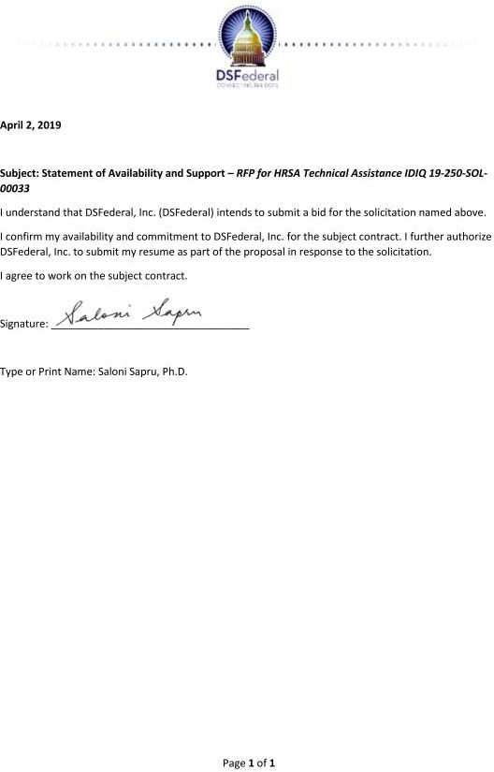

|  |
| --- |
| Qualifications and Experience  Over 10 years of technical assistance for HRSA HAB programs  Master of Public Policy from Harvard University |

1. **Elizabeth Coombs – Senior Technical Personnel**

## Career Summary

Ms. Coombs is an Associate at Mission Analytics where she directs projects and conducts quantitative and qualitative research, training and technical assistance (TA), and communication activities. She has been the project director for numerous complex projects within the Department of Health and Human Services,

including the Health Resources and Services Administration HIV/AIDS Bureau (HRSA HAB), the Centers for Medicare and Medicaid Services (CMS), the Assistant Secretary for Planning and Evaluation (ASPE), the Office on Women’s Health (OWH), and the Office of HIV/AIDS and Infectious Disease Policy (OHAIDP). Her areas of expertise include HIV care delivery, hepatitis C treatment access and policy, data management and reporting, paid family leave policy, and Medicaid-funded home and community-based services (HCBS).

## Education, Training, and Certifications

* Harvard University, Kennedy School of Government, Master of Public Policy, Cambridge, Massachusetts, 2004
* University of California, Los Angeles, Bachelor of Arts, Anthropology, Los Angeles, California, 1998

## Work Experience

Project Director 2008 – Present

Mission Analytics Group, Inc., San Francisco, CA

*Electronic Data Collection, Storage and Retrieval: National Training and Technical Assistance Cooperative Agreement*: HRSA HAB

Subcontractor to CAI Global

Mission Analytics provides TA to Ryan White HIV/AIDS Program (RWHAP) recipients and providers to support and improve the collection, storage, and retrieval of client-level data for program reporting, evaluation, and quality improvement purposes. Ms. Coombs:

* Analyzes data to identify data quality issues.
* Works directly with providers to improve their data collection, extraction, and submission processes.
* Works with Electronic Health Record (EHR) and other data management systems to develop tools to support RWHAP data management and reporting.
* Develops webcasts and other technical assistance resources.

Project Director 2017 – Present

Mission Analytics Group, Inc., San Francisco, CA

*Integration of Oral Health and Primary Care Evaluation/Technical Assistance to Ryan White HIV/AIDS Program (RWHAP) Recipients*: HRSA HAB

To promote access to oral health care for people living with HIV (PLWH), Mission Analytics is identifying and disseminating information on oral health and primary care integration strategies. Ms. Coombs:

* Conducted an environmental scan of primary care and oral health integration, describing best practices and challenges identified in the literature within and outside of RWHAP settings.
* Conducted site visits with three of nine sampled providers that have demonstrated successful models of care.
* Develops webinars and a Toolkit on integration strategies to disseminate findings.
* Will conduct site visits to support RWHAP providers in implementing integrations strategies.

Project Director 2015 – 2018

Mission Analytics Group, Inc., San Francisco, CA

*Building Futures: Supporting Youth Living with HIV*: HRSA HAB Subcontractor to DSFederal

Mission Analytics helped assess the current state of youth living with HIV aged 13-24 receiving RWHAP-funded care, their unique barriers to care, and RWHAP providers' capacity to engage and retain them in care with optimal health outcomes. The project resulted in a TA Toolkit and webinars for providers to adopt strategies to more effectively treat youth. Ms. Coombs:

* Designed the approach to select the sample of providers and developed the Paperwork Reduction Act package for Office of Management and Budget (OMB) approval.
* Conducted site visits with six RWHAP providers to identify strategies to effectively serve youth living with HIV.
* Synthesized information and contributed to final reports and TA products.

Facilitator 2015 – 2018

Mission Analytics Group, Inc., San Francisco, CA

*Learning Collaborative – Strengthening the Part A Care Continuum:* HRSA HAB Subgrantee to Abt Associates

Mission Analytics supported the development of the CCLC and led two domains: data integration and using data to improve outcomes. Ms. Coombs leads the data integration domain, facilitating monthly discussions and provided technical assistance, conducting literature reviews or coordinating with experts to participate in calls.

Project Director 2018 - Present

Mission Analytics Group, Inc., San Francisco, CA

*State-Level Paid Family Leave Project:* Office on Women’s Health (OWH)

OWH contracted with Mission Analytics to inform the national conversation around state-level Paid Family Leave programs by analyzing the relationship between these programs and women’s physical and mental health. The project team will analyze national survey data and conduct 16 focus groups with new mothers in the four states with operating programs – California, New Jersey, Rhode Island, and New York. Ms. Coombs:

* Developed and tested the focus group protocol.
* Will conduct half of the focus groups, design the data coding and analysis process, and lead report writing.

## Publications and Awards

Ms. Coombs has contributed to many reports, presentations and trainings. A list of presentations will be furnished on request.

# Elizabeth Coombs - Statement of Availability

|  |
| --- |
| Qualifications and Experience  Experience in program planning, evaluation, and data analysis  Over three years of experience providing technical assistance for Department of Health and Human Services (HHS) program grantees  Master of Public Health from University of California, Berkeley |

1. **Elizabeth Crane – Research Analyst/Advisor**

## Career Summary

Ms. Crane is a Senior Analyst. She contributes to quantitative research, technical assistance, qualitative research, and project coordination for projects related to health and developmental disabilities services.

## Education, Training, and Certifications

* University of California, Berkeley, Master of Public Health, Berkeley, California, 2018
* Brandeis University, Bachelor of Arts, Politics & International and Global Studies, Waltham, Massachusetts, 2011

## Work Experience

Senior Analyst 2018 – Present

Mission Analytics Group, Inc., San Francisco, CA

*Electronic Data Collection, Storage and Retrieval: National Training and Technical Assistance Cooperative Agreement*: HIV/AIDS Bureau, Health Resources and Services Administration (HRSA HAB)

Subcontractor to CAI Global

Mission Analytics provides technical assistance to Ryan White HIV/AIDS Program (RWHAP) recipients and providers to support and improve the collection, storage, and retrieval of client- level data for program reporting, evaluation, and quality improvement purposes. Ms. Crane:

* Analyzes submitted data and prepares reports and presentations to highlight data quality issues and trends among RWHAP recipients and providers.
* Provides help desk support for technical assistance requests from recipients and providers on data management and reporting issues.

Senior Analyst 2018 – Present

Mission Analytics Group, Inc., San Francisco, CA

*Hepatitis C Medicaid Affinity Group:* Office of HIV/AIDS and Infectious Disease Policy (OHAIDP)

Mission Analytics was contracted by OHAIDP to facilitate the Hepatitis C Medicaid Affinity Group, a collaboration of state Medicaid programs and federal partners. The group aims to explore and implement innovative strategies to improve treatment and cure for people with hepatitis C virus (HCV). The group consists of monthly webinars, in-person convenings, and regular technical assistance. Ms. Crane:

* Develops content and identifies speakers for monthly webinars and in-person convening sessions.
* Provides direct technical assistance to support the implementation of state action plans and develops technical assistance resources for distribution.

Program Manager, Program Associate 2014 – 2016

Mathematica Policy Research, Inc. (MPR), Cambridge, MA

*WISEWOMAN Program Evaluation, Technical Assistance, and Data Management*: Centers for Disease Control and Prevention (CDC)

MPR supported SRA International with technical assistance and evaluation for a CDC program offering low-income, uninsured women cardiovascular screening, referrals, and lifestyle programs. Ms. Crane:

* + Provided ongoing technical assistance to 21 states and tribal entities to support quarterly data reporting requirements.
  + Conducted one-on-one site visits and qualitative analysis of site visit data and coauthored national evaluation reports.
  + Managed $400,000 annual budget and operations.

Program Associate 2014 – 2016

Mathematica Policy Research, Inc., Cambridge, MA

*Technical Assistance and Analytic Support, Center for Medicaid and CHIP Services (CMCS) Core Set Measures*: Centers for Medicare & Medicaid Services (CMS)

MPR supported state Medicaid and Children’s Health Insurance Program (CHIP) agencies in collecting and reporting three CMCS Core Measure Sets: Child, Adult, and Health Homes. Ms. Crane:

* + Engaged in technical assistance, data collection, and quality assurance to assist 50 states in reporting Medicaid and CHIP clinical quality measures.
  + Developed specifications for a new online database to track and manage technical assistance requests.
  + Co-authored publications measuring state progress on data reporting and quality, including reports, briefs, and fact sheets.

## Publications and Awards

* + Van der Walt L, Crane E, Watterson J, van Dijke I. Strategies Used by Local Hotlines to Increase Women's Access to Safe Abortion. (Under revision; PLOS ONE).
  + Bixby Center for Population, Health & Sustainability. “Maternal Mortality in Uganda: Report.” Report to the Constitutional Court of Uganda. Berkeley, CA: 2018.
  + Centers for Medicare & Medicaid Services. “The State of Children’s Health Care Quality in Medicaid & CHIP: State Strategies to Promote Reporting and Performance.” Analytic Brief. Washington, DC: Centers for Medicare & Medicaid Services, March 2016.
  + Crane, Liz, Michaela Vine, and So O’Neil. “WISEWOMAN Program Technical Assistance Summary: March 1, 2015 to May 31, 2015.” Report submitted to the Centers for Disease Control and Prevention. Cambridge, MA: Mathematica Policy Research, June 2015.
  + Centers for Medicare & Medicaid Services. “The State of Children’s Health Care Quality in Medicaid and CHIP: Who Are the Higher-Performing States?” Technical Assistance Brief. Washington, DC: Centers for Medicare & Medicaid Services, May 2015.

# Elizabeth Crane - Statement of Availability

|  |
| --- |
| Qualifications and Experience  Over 13 years of experience serving Federal government clients including DoD, FDA, NIH, FAA, EPA; the Departments of Commerce, Homeland Security, Energy, Agriculture, and Interior; the National Science Foundation, and the Office of Personnel Management.  Ph.D., Clinical Psychology, University of Texas, Austin  20+ years of clinical practice experience as a licensed psychologist  Certifications in coaching, leadership training, and nonprofit management |

1. **Ann Deaton, Ph.D. – Consultant/Executive Coach**

## Career Summary

Ann Deaton is a seasoned consultant and coach with over 13 years of Federal government experience and extensive experience in the private sector. A trained psychologist and published author, Dr. Deaton has over 20 years of clinical practice experience and has served as a faculty member for several universities. As Executive Coach and Trainer with the Federal Executive Institute, she conducted group and individual sessions, providing focused and specialized leadership training to military and civilian Federal government executives. She now provides training and coaching for the CIA University Program on Creative Leadership; and serves as managing partner of The Bounce Collective, a leadership training company serving government, non-profits, academia, and private industry.

## Education, Training, and Certifications

* Ph.D., Clinical Psychology, The University of Texas at Austin, 1983
* M.A., Clinical Psychology, The University of Texas at Austin, 1981
* BS, Psychology, University of Dayton, 1978
* Licensed Clinical Psychologist, Virginia, 1985-2013
* Certified Mentor Coach, International Coach Federation, January 2019
* Team Diagnostic Suite and Team Coaching Certification, 2019
* Master, Polarity Thinking and Mapping, 2015-2017
* Additional certifications prior to 2015 available upon request

## Professional Experience:

**Managing Partner 2009 - present**

**The Bounce Collective, Richmond, Virginia** (2009 – Present)

* + Co-founder and managing partner of a leadership and relationship development company with client base spanning government, non-profit, corporate, and education.
  + Design and delivery of leadership and team development programs in government, corporate and non-profit organizations, including leadership and team coaching.
  + Intensive leadership development for education, community, and business leaders with a focus on servant leadership and business-community partnerships.
  + Workshops in emotional intelligence, coaching for managers, trust, positivity, polarities management, culture change, communication, diversity, and conflict resolution.

# President

**DaVinci Resources, Glen Allen, Virginia 2003 - present**

* + Founder and President of a leadership development company with clients including government, non-profit, corporate, healthcare, and education entities.
  + Design and delivery of leadership development programs for executives, business owners, and emerging leaders from a variety of organizations.
  + Special expertise in adult leadership, appreciative inquiry, servant leadership, strengths- based leadership, conflict resolution, emotional intelligence, and team development.

# Team Facilitator and Executive Coach 2015 - 2018

**Federal Executive Institute**

* + Team development and facilitation, executive coaching, 360 debriefs.

## Selected Clients:

* **CIA University Program on Creative Leadership.** Leadership coaching and debrief of Benchmarks and Leadership Circle 360sand other assessments. 2006 - present.
* **US EPA.** Leadership coaching, 2018-2019.
* **Federal Executive Institute. E**xecutive coaching for agencies including DoD, HHS, (FDA, NIH), DOT (FAA), EPA, DHS, USDA, Veterans Affairs, OPM, Department of the Interior, and more. 2015-2018.
* **US Patent and Trademark Office.** Leadership Circle 360 workshops. 2011.
* **Federal Reserve Bank of Richmond.** 2009-2014.

## Clinical Experience:

* + **Clinical Psychologist** (Part-time private practice), 1985 – 2006. Clinical assessment; individual, couples, group and family psychotherapy; neuropsychological evaluation.
  + **Clinical Psychologist,** Children’s Hospital, Richmond, VA, 2004 -2006
  + **Clinical Psychologist,** Westhampton Family Psychologists, Richmond, VA, 2004 – 2005
  + **Director of Psychology and Neuropsychology Services**, Children’s Hospital, Richmond, VA, 9/1992 – 12/2001
  + **Director, Psychological and Brain Injury Services**, Sheltering Arms Day Rehabilitation Center, Richmond, VA, 1/1989 – 9/1992
  + **Staff Psychologist**, Cumberland Hospital, New Kent, VA, 9/l984 – 12/198

## Publications:

* + *VUCA Tools for a VUCA World: Developing Leaders and Teams for Sustainable Results*

(2018)

* + *Being Coached: Group and Team Coaching from the Inside* (2014, with Holly Williams)
  + Numerous articles, book chapters, and white papers (titles upon request)

# Ann Deaton, Ph.D. - Statement of Availability

|  |
| --- |
| Qualifications and Experience  Over 20 years of program development, management, and implementation  Doctor of Education, Grand Canyon University, Phoenix, Arizona, Organizational Leadership  National Quality Center Fellowship Program- Certificate |

1. **M. Elizabeth (Betty) Cabrera, EdD - Quality Program Specialist**

## Career Summary

Project manager and educator- with over 20 years of senior level experience in healthcare with an emphasis on program development, management and implementation. An experienced grant writer and grant reviewer. A specialist in providing direction to and monitoring operations of HIV/AIDS related programs and services. Well versed in the design and implementation of programs for women, infants, children, youth and families. Quality management

instructor.HR management support for large department at UT Southwestern department. Trainer, facilitator, program and grant reviewer and writer. An organizational effectiveness consultant, master facilitator, educator specializing in strategic and action planning, effective communication, the design and delivery of productive meetings and quality improvement trainer of trainers.

## Education, Training, and Certifications

* Doctor of Education, Grand Canyon University, Phoenix, Arizona, Organizational Leadership, 2019
* Master of Education, City College of New York City, New York, New York, Science Education, 1989
* Bachelor of Science, Brooklyn College, New York, Health Science, 1979
* National Quality Center-Training-of-Trainers and Training Quality Leaders Program, Training for Coaches New York, New York (2009-2011)
* National Quality Center Fellowship Program- Certificate (2010)
* UCLA Anderson School of Management, Los Angeles, California, Certificate (2007)
* Health Care Management UCLA/Johnson & Johnson- Health Care Executive

## Work Experience

**Cabrera Consultants May 2009- Present**

* Administrative Management, and Coaching
* Grant Writer
* Federal Grant Review
* Federal Program Auditor
* Strategic Planning, Group Facilitation
* Quality Improvement Coaching

# National Quality Center New York, New York: 2009-2011 Trainer

Training Topics:

* Developing Quality Improvement processes in medical and support service programs
* Building Quality Improvement Teams
* Developing Quality Management Assessment Processes

**University of Texas Southwestern Medical Center (UTSW), Dallas, Texas 1998-July 2013. Director:** Over 15 years of experience senior level management. Principle grant writer for all Federal and State grants awarded to the program. Recruitment and hiring university program staff as well as provided leadership to a multidisciplinary 10 plus network of sub-contracting providers

consisting of healthcare professionals and community-based organizations. Included in this

responsibility is the whole spectrum of readiness requirements including alignment, communications, training, coaching and development of infrastructure to ensure sustainability of the changes across the network.

Design systems and processes which enhance efficiency and effectiveness of internal controls and ensure the integrity of the department (quality control). Assures effective internal controls are developed and maintained, ensures integrity of the programs within the department and divisions. Lead for the project Employee Engagement Initiative.

Manage the daily operations of Dallas FAN and Youth Angle network of medical and support services, the network includes services offered through UTSW and community-based subcontractor agencies. Provide oversight and management of multiple- programs, policies and special initiatives, events including symposiums, and national conferences.

# Parkland Health and Hospital System Dallas, Texas Program Coordinator - LifeSpan 1996 – 1998

* Responsible for the recruitment, hiring and supervision of the program’s health education staff.
* Recruited and lead program orientation for volunteer staff. Redesigned curriculum for program.
* Representative for program within the community. Established the LifeSpan program as a training site for University of North Texas Social Work department.
* Advocated for change in hospital protocol for teen mothers to receive nursing home visits… granted 1998. Prepared program reports.

## Publications and Awards

* Greenidge-Cabrera ME, (2019) Assessing the Differences in the Motivation of Millennial Managers and Non-managers in Private Healthcare Organizations: A Causal-Comparative Study, Doctoral Thesis: Grand Canyon University, Phoenix, Arizona.
* Cabrera E, “Improve your Serve” UT Southwestern Health Science Center in San Antonio, Texas (May 2013).
* Cabrera E, “Using Photo Novellas’’ as a Means to Engage HIV positive Youth. National Quality Center Part D Conference, Washington D.C. (August 2011).
* Cabrera E., Turnbull I, Taylor D., Beatty A. Beating the Odds: The Road to Success One Move at a Time. All Titles Grantee Meeting, Washington D.C. (August 2010).
* Cabrera, E, Increasing Access to Care through Collaboration: One Stop Shop approach to healthcare for HIV-infected women and their exposed infants, Workshop presenter, HIV Women’s International Conference (January 2010)
* Cabrera, E, Turnbull I, Taylor D., Beatty A., Beating the Odds from Chaos to Care. All Titles Grantee Meeting, Washington D.C. (August 2008).
* Cabrera E. Community Health Improvement Project; Johnson & Johnson Executive Health Care Management Program, Los Angeles, CA. (July 2007).

# M. Elizabeth (Betty) Cabrera, EdD - Statement of Availability

|  |
| --- |
| Qualifications and Experience  Over 30 years of research and teaching experience with extensive publication and presentation record  Ph.D., Social Work  Notable research experience as P.I or Co-P.I.  20+ years HRSA/Ryan White grant review experience |

1. **Ana Garcia, Ph.D. – Consultant**

## Career Summary

Ana Garcia is a teacher, author, and consultant with over 30 years of research and academic experience focused on HIV/AIDS. A published author with an extensive bibliography, she has also served as an invited speaker and presenter, with well over 50 appearances dating back to the mid-1990s. Dr. Garcia also holds clinical social work certifications and has worked professionally as a social worker and counselor.

## Education, Training, and Certifications

* + Barry University, Ph.D., Social Work, 2010; MSW, 1981
  + Florida International University, B.A., Social Work, 1977
  + Trauma-Informed Human Trafficking Certificate May 2018
  + Certified Social Work Supervisor, Florida, January 2000
  + Certified HIV Counselor, State of Florida, 1991
  + Licensed Clinical Social Worker; Florida, 1981; # SW964

## Work Experience

University of Miami 6/2011 – present

Assistant Professor of Clinical Pediatrics

* + Courses covering pediatric HIV/AIDS, adolescent HIV/AIDS, and impact of HIV/AIDS on families.
  + Member: Medical Education Committee, Florida Bio-Ethics Network, Pediatric Palliative Care Committee
  + Thesis and dissertation advisor.

Barry University School of Social Work 5/2013 - present Adjunct Professor

* + Courses and lectures covering pediatric HIV/AIDS, adolescent HIV/AIDS, and impact of HIV/AIDS on families.

Clinical Social Worker/Counselor

* + Jackson Memorial Hospital, 2/1983 – 7/1986
  + Douglas Gardens Community Mental Health Center, 3/1981 – 2/1983
  + Dade County Department of Human Resources New Careers Program, 7/1977 –5/1980

## Publications and Presentations

* + Five books/monographs and 10 refereed or peer-reviewed journal articles as primary or co- author. 25 additional works, publications, and abstracts. Titles upon request.
  + Over 50 invited presentations (English and Spanish). Details upon request.

## Grant Review

* + Center for AIDS Research: University of Miami; grant reviewer 2012, 2016, 2017, 2018
  + New Jersey Department of Health: Ryan White Part B; grant reviewer 2012
  + HRSA: Office of Minority Health, Minority HIV; grant reviewer; 1991-1995
  + HHS: SAMHSA, Center for Mental Health Services; grant reviewer; 1994

## Research Projects and Grants

* + Pediatric AIDS Foundation Emergency Assistance (Ana Garcia, LCSW P.I.)
  + Children Affected by AIDS Foundation Grant (Ana Garcia, LCSW P.I.)
  + HRSA 5H12HA00028-17 (Gwendolyn Scott, MD P.I.)
  + Ryan White HIV/AIDS Program Part D Grants for Coordinated HIV Services and Access to Research for Women, Infants, Children, and Youth
  + NINR R01 NR012711-01 (Maureen Lyon, Ph.D. P.I.)
  + Longitudinal Pediatric Palliative Care: Quality of Life and Spiritual Struggle
  + University of Miami Miller School of Medicine Developmental Center for AIDS Research (DCFAR) Ana Garcia, Ph.D. P.I., Seth Schwartz, PhD Co-P.I.
  + Toward a Strength-Based Understanding of Perinatally HIV-Infected Adolescents
  + Exploring Sexual and Reproductive Health Beliefs and Behaviors in HIV Positive Youth (Ana Garcia, P.I.) May 2015
  + Transitioning HIV-Infected Young Adults to Adult Clinical Care (Ana Garcia, P.I.) April 2013-2014
  + Maternal-Fetal Attachment and Health Behaviors among Women with HIV (Ana Garcia, P.I.) April 2012
  + Personal Resilience: The Impact on Health Outcomes of Adolescents with Perinatally- Acquired HIV/AIDS, Doctoral Dissertation, (Ana Garcia, P.I.) March 2010

## Professional and Honorary Organizations:

* + National Association of Social Workers. 2018 - present
  + Care Resources, Member, Board of Directors, 2007 - present
  + National Catholic AIDS Network, Member, Board of Directors, 1991-1994
  + Education Leadership Council, National Hispanic Education and Communications Projects; Steering Committee, member; 1990 - 1995
  + Health Crisis Network, Founding Member, Board of Directors, 1982 - 1994

## Honors and Awards:

* + Lumina Award: National Catholic AIDS Network, 1997
  + Mothers Voices Advocacy Award; March 1996

## Selected Committees

* + AIDS Alliance VOICES National Planning Committee, Member, 2004 – 2006
  + National HIV/AIDS Update Conference; Planning Committee: Co-Chair of Care and Services Track, 1993 – 2005
  + Ryan White C.A.R.E. Act Title I: HIV Health Services Planning Council, Member, 1997
  + Ryan White C.A.R.E. Act Title II: South Florida AIDS Consortia, Member, 1993-1996

# Ana Garcia, Ph.D. - Statement of Availability

|  |
| --- |
| Qualifications and Experience  Over 30 years of consulting and hands-on program management experience, focused on early childhood programs  Peace Corps veteran  Received international award for use of ESRI web-based data mapping platform to drive public policy |

1. **Daniel Marc Haggard - Policy Analyst**

## Career Summary

Daniel Marc Haggard is an experienced program manager and consultant with extensive experience

leading and supporting early childhood and family

programs, including HRSA-funded state programs. Mr. Haggard established and led a team to expand use of Title V MCH data to include education and social services data. This data was used for multiple public policy purposes, such as Needs Assessment for the Home Visiting Program and establishment of Early Childhood Investment Zones, used by the Department

of Health, Children Youth and Families Department, and Public Education Department to target universal Home Visiting, NM PreK, and other funding to communities.

## Education, Training, and Certifications

* + Doctoral Studies, Educational Administration, University of New Mexico
  + Master of Science in Education, New York, NY, Bank Street College

## Work Experience

Current: Consultant, DSFederal, Inc.

* + Conduct compliance reviews of HRSA-funded state Maternal Infant Early Childhood Home Visiting (MIECHV) Programs in New Mexico.

Founder and Principal Consultant 1985 – present Southwest Education Resources, Los Lunas NM

* + Consultant/trainer focused on integration of comprehensive early childhood systems.
  + Sample consultancy work: Mongolia Ministry of Education, State of Illinois, State of Iowa, State of Missouri, Palm Beach County FL and Puerto Rico.
  + Led initial design phase for comprehensive EC Professional Development Systems, focused on home visiting and early intervention for infants, toddlers, and families.

Deputy Division Director for Program 1994–2016

NM Children Youth & Families Department/Early Childhood Services Division, Santa Fe NM

* + Primary author of successful applications for federal MIECHV funding.
  + Directed MIECHV-funded universal NM Home Visiting Program.
  + Primary author of successful Race to the Top grant for early childhood systems.
  + Co-founder of Community Data Collaborative, using ESRI ArcGIS to map service needs.
  + Established partnership between Health and Children Youth and Families Departments to fund comprehensive Indicator-Based Information System (NM-IBIS).
  + Served on MCHB Early Childhood Comprehensive Systems (ECCS) teams.
  + Provided ongoing consultation to Minnesota home visiting program leaders.

Director, Office of Child Development

* + Directed first state-funded comprehensive early childhood program.
  + Directed Early Childhood Professional Development Initiative.
  + Developed Infant/Toddler Growth and Development Benchmarks.
  + Established competencies with multiple levels of fully-articulated licensure/certification.
  + Managed Kellogg Foundation Grant to establish statewide staff recruitment system. University of New Mexico and New Mexico State University 1987-1994

Consultant and Adjunct Faculty

* + Taught early childhood special education courses for Developmental Specialists. Christian Children’s Fund, Richmond VA 1988–1990

U.S. National Director

* + Directed five U.S. Regional Offices funding early childhood/family programs.

Alta Mira Specialized Family Services, Albuquerque NM 1985–1988

Director of Early Intervention Programs

* + Developed and directed national model of comprehensive home-based support programs. Pine Hill School/Ramah Navajo School Board, Inc., Pine Hill NM 1980–1985

Principal/Director of Early Childhood Programs

* + Directed BIA-funded model home visiting program for Ramah Navajo families.

U.S. Peace Corps, Kingston, Jamaica 1977–1980

* + Child Development Specialist, University of the West Indies/University Hospital.

## Awards

* + ESRI - Received international award for use of data mapping to drive public policy.

## Successful Funding Applications

* + - *Race to the Top/Early Learning Challenge*
    - *MIECHV initial and subsequent (formula and competitive)*
    - *Early Learning Advisory Council Strategic Plan*

## Selected Products Developed

* + - *New Mexico’s Early Learning Guidelines: Birth through Kindergarten*
    - *FOCUS (on young children’s learning)*
    - *Common Core Content for the Early Childhood Educator*
    - *NM Universal Catalogue of Courses for Early Care, Education. and Family Support*

# Daniel Marc Haggard - Statement of Availability

|  |
| --- |
| Qualifications and Experience  Over 25 years of public health experience, including government service at the state and federal levels (HRSA)  MPH, Emory University  Exceptional Performance Rating, HRSA, 2010, 2011, 2012  Expert SPSS/SAS user |

1. **Deborah Isenberg, MPH – Health Informatics Analyst**

## Career Summary

Deborah Isenberg has over 25 years of public health experience. She has extensive background in HIV/AIDS, evaluation, research, data management and systems development, program planning, performance management, needs assessment and health information technology. A published author and sought-after speaker and presenter, Ms. Isenberg has worked in county, state and federal government as well as academia, supporting grantees, providers, planning bodies and consumers.

## Education, Training, and Certifications

* + MPH, The Rollins School of Public Health of Emory University, Atlanta, GA. May 1996
  + Bachelor of Arts, Psychology, University of Michigan, Ann Arbor, MI, May 1987
  + Certified Health Education Specialist, #5046, National Commission for Health Education Credentialing, Inc.

## Selected Work Experience

Director 10/2013 -Current

Deborah J Isenberg Consulting Service, Belmont, MA

* + Needs assessment, program evaluation, data management, data systems development, program planning, performance measurement, quality improvement.

HIV/AIDS Bureau, HRSA, Rockville, MD 2010 -2012

Various positions, including Senior Data Health Scientist; Chief, Epidemiology and Data/Data Management Branch; and Acting Chief, Program Analysis and TA Branch

* + Acted as technical lead for HAB data reporting web systems, reviewing and approving technical system requirements to align with Bureau reporting needs.
  + Responsible for Ryan White Program analysis, response to Congressional requests, and evaluation of progress toward National HIV/AIDS Strategy goals.
  + Provided expertise in implementation of HHS initiative to implement common indicators, streamline data collection, and reduce reporting burden.
  + Coordinated data management for Ryan White Services Report client-level data.
  + Worked with CDC and other federal partners to implement National HIV/AIDS Strategy.
  + Represented the HIV/AIDS Bureau at National meetings.
  + Oversaw coordination of TA activities across HAB.
  + Implemented HAB evaluation strategy; used datasets to address programmatic questions.
  + Conducted analysis and developed reports using Ryan White HIV/AIDS Program data. Director, Research and Evaluation Unit 1/2007 – 9/2010

Office of HIV/AIDS Massachusetts Department of Public Health, Boston, MA

* + Developed and implemented plan to measure effectiveness of funded activities.
  + Acted as principal investigator for CDC-funded national HIV/AIDS study.
  + Collaborated with HIV/AIDS Surveillance Program on epidemiological research.
  + Represented the Office of HIV/AIDS at local, regional and national meetings. Emory University, Atlanta, GA 1994 – 2007 (intermittent)

Various positions, including Associate Director, Southeast AIDS Training and Education Center (SATEC); Research Project Manager, SATEC; Senior Program Associate, SATEC; and Assistant Training Coordinator

* + Designed, implemented and managed evaluation and research program activities.
  + Directed data/evaluation activities for federally funded six-state AETC region.
  + Developed and secured funding for Center for Applied Research and Evaluation Studies.
  + Research program activities including study conceptualization, quantitative and qualitative method development and implementation, data analysis plans and technical writing.
  + Developed training and training materials for substance abuse and mental health providers.

## Awards and Honors

* + HRSA Outstanding Group Award, 2012
  + HRSA Exceptional Performance Rating, 2010, 2011, 2012
  + Outstanding Poster, American Evaluation Association, 2003

## Publications/Presentations

* + Many peer-reviewed publications in respected journals, including *AIDS and Behavior* and

*AIDS Patient Care and STDS*.

* + County, state, and federal government reports, including reports to HRSA, NIH, and CDC.
  + Poster/presentation sessions at dozens of national HIV/AIDS conferences.

## Selected Appointments/Committee Memberships

* + Member, AIDS Education and Training Center National Evaluation Center Advisory Committee, 2014-2016, 2005-2007
  + Member, National Quality Center Evaluation Task Force, 2014
  + Chair, HIV/AIDS Bureau Data Utilization Workgroup for Project Officer Training, 2012

– 2013

* + Member, HIV/AIDS Bureau Communication Workgroup, Communities of Practice and Learning, 2012 – 2013
  + Member, HIV/AIDS Bureau Data Quality Workgroup, 2012 – 2013
  + Co-Chair, HIV/AIDS Bureau Triage Workgroup, 2011- 2013
  + Coordinator, HIV/AIDS Ryan White Part A and B Formula Workgroup, 2011-2013
  + Advertising Chair, HIV/AIDS Bureau World AIDS Day Committee, 2011
  + HAB National Meeting Representative, CDC/HRSA Prevention with Positives Linkages and Retention Workgroup Member, 2011 - 2013
  + National Quality Improvement/Management Technical Assistance Center Steering/Advisory Committee Member, 2004 – 2010
  + Member, Emory University President’s Commission on the Status of Lesbian, Gay, Bisexual and Transgender Concerns, 2001 - 2007

# Deborah Isenberg, MPH - Statement of Availability

|  |
| --- |
| Qualifications and Experience  Over 25 years of grant-writing and program development experience  Master’s in Non-Profit Leadership, and specialized experience with Ryan White programs and Section 330 compliance  Successful, proven grant writer awarded millions of dollars in grant funding |

1. **Rebecca McDonald Johnson – Senior Technical Personnel**

## Career Summary

Rebecca Johnson is a results-oriented leader with strong grant writing and program development experience, and hands-on experience with HRSA site visit preparation. With over 25 years of experience providing leadership and strategic program development in community health center and public health environments, she has proven highly successful in implementing process improvements and governance strategies to support compliance with federal regulations. With an extensive network and proven ability to connect organizations with resources, she uses keen analytical skills, unique insight, and a team approach to develop relationships and drive organizational improvements.

## Education, Training, and Certifications

* + Masters Non-Profit Leadership, Seattle University, Seattle, WA
  + Graduate Certificate, Public Health, University of Washington, Seattle, WA
  + Bachelor of Arts, Humanities, Washington State University, Pullman, WA

## Work Experience

President 11/2013 – present

Health Center Solutions, Inc.

Independent health center management consultant and grant writer, specializing in all aspects of program development and successful grant writing for health center programs.

* + - FQHC/FQHC Look-alike planning, development, application, and award management.
    - Grant writing - Section 330, Look-alikes, and Ryan White Grants -- New Access Points, Service Area Competitions, Service Expansion, Capital grants, and Ryan White A, C & D.
    - Grant prospecting – research, fund development planning.
    - Section 330 compliance – demonstrate compliance with all program requirements.
    - Board development/strategic planning, with focus on meaningful and engaged governance
    - HRSA operational site visit preparation.

Consultant 10/2009 – 11/2013

Community Link Consulting, Inc.

* + - Operational assessment and pre-site visit assessments.
    - Program planning and grant writing to support 330, Look-alike and Ryan White program development, and ongoing management support.
    - Strategic planning and board training.

Interfaith Community Health Center 2002 – 2010

Various Positions (including Interim CEO, Director of Planning and Development, Operations Director, and Ryan White HIV/AIDS Program Coordinator)

* + - Development and grants management: developed and wrote proposals, managed grant programs, responsible for contract development and oversight, grant/program budget

development, monitoring, and reporting.

* + - Obtained two new state grants in 2008 ($600,000 total); 330, Ryan White, City of Bellingham, United Way, Health Care Authority.
    - Community relations and resource development on multiple initiatives including opening NAP site and managing conditions of award on federal grants; property negotiations.

HIV Prevention Outreach Coordinator 1995 - 2002

Whatcom County Health Department:

* + - Contributed to planning, program development, implementation and evaluation of County HIV Prevention Outreach Program.
    - Within an extremely conservative county, proposed, implemented and managed first needle exchange program with local public health and criminal justice support.

## Successful Grant Awards

* + - New Access Points FY2008, FY2011, FY2013, FY2015
    - HIIP FY2016 – Three $1 million awards
    - Substance Abuse Expansion FY2016 – two $325,000 awards
    - Oral Health Expansion FY2016 – four $350,000 awards
    - J. Hartford Social Innovations Award, 2013, $320,000/2 years
    - School-Based Health Center Capital - $500,000
    - Facility Improvement Program – FIP FY2010 $1.06M
    - New Ryan White Part C Ambulatory Care, FY2012 $350,000/year
    - 2013 Skagit County Drug Court award $450,000/year

## Northwest Regional Primary Care Association (NWRPCA) Conferences

* + - Fall 2017, Governance Series, and Site Visit Prep
    - Spring 2015, Service Area Competition: A §330 Compliance Check
    - Spring 2016, 19 §330 Program Requirements Primer & Review
    - Fall 2014, 19 §330 Program Requirements Primer & Review
    - Spring 2014, Ins & Outs of 330 Grant Writing
    - Spring 2014 Preparing for a HRSA Operational Site Visit
    - Fall 2013, Write a Successful 330 Grant
    - Winter 2015, six-part series §330 19 Program Requirements (webinar)
    - November 2014, two-part series Prepare for SAC or NAP Grants (webinar)

## Board Positions/Community Service

* + - Whatcom Community College Board of Trustees, 2017- present
    - League of Women Voters, 2011 – present (Co-President 2016/17; 17/18; 18/19)
    - Whatcom Alliance for Healthcare Access Board of Directors, 2006 – 2010
    - Pipeline Safety Trust Board of Directors, 2005 – 2013
    - Bellingham/Whatcom Co. Commission Against Domestic Violence, 2002 – 2012, Chair
    - Region 3 HIV/AIDS Planning Council – 2008 – 2010, Care Committee Chair

# Rebecca McDonald Johnson - Statement of Availability

|  |
| --- |
| Qualifications and Experience  Over 6 years of technical assistance including 6 years for HRSA HAB Programs  Master of Public Health from University of Maryland |

1. **Andrew (AJ) Jones – TA Specialist/Research Analyst**

## Career Summary

Mr. Jones is a Senior Analyst. He contributes primarily to projects related to HIV/AIDS including training and technical assistance, project coordination, and quantitative and qualitative research.

## Education, Training, and Certifications

* University of Maryland, Master of Public Health, College Park, Maryland, 2018
* George Mason University, Master of Arts, Interdisciplinary Studies, Fairfax, Virginia, 2016
* James Madison University, Bachelor of Arts, Psychology, Harrisonburg, Virginia, 2012

## Work Experience

Technical Assistance Specialist 2017 – Present

Mission Analytics Group, Inc., San Francisco, CA

*Electronic Data Collection, Storage and Retrieval: National Training and Technical Assistance Cooperative Agreement*: HIV/AIDS Bureau, Health Resources and Services Administration (HRSA HAB)

Subgrantee to CAI

Mission Analytics provides technical assistance (TA) to Ryan White HIV/AIDS Program recipients and providers to support and improve the collection, storage, and retrieval of client- level data for program reporting, evaluation, and quality improvement purposes. Mr. Jones:

* Delivers comprehensive and nuanced technical assistance to program recipients and service providers.
* Develops and delivers Web-based training sessions.
* Provides support to data evaluation and outreach efforts.

Project Manager, Researcher 2017 – Present

Mission Analytics Group, Inc., San Francisco, CA

*Integration of Oral Health and Primary Care Evaluation/Technical Assistance to Ryan White HIV/AIDS Program (RWHAP) Recipients*: HRSA HAB

Mission Analytics supports HRSA HAB by identifying best practices and providing technical assistance to RWHAP providers on the integration of oral health and primary care. The project team conducted an environmental scan and site visits to nine providers that have demonstrated successful models of care. Mission Analytics will conduct nine additional TA site visits for providers who want to better integrate oral health and primary care. Mr. Jones:

* Assisted in the completion of the environmental scan and study design.
* Led four site visits.
* Contributed to reports and a Toolkit on project findings.
* Will present best practices in a series of training webinars about the project and will lead several TA site visits.

Part C Task Lead 2017 – Present

Mission Analytics Group, Inc., San Francisco, CA

*Alternative Resource Allocation Methodologies for Ryan White HIV/AIDS Programs Part A & Part C – Phase II:* HRSA HAB

Subcontractor to WRMA, Inc.

Mission Analytics developed for HRSA HAB two Excel-based tools that allocate RWHAP Part A and Part C funding based on program data and publicly available data. The project team also conducts analyses using the tools, assess the impact of the RWHAP on access to care (particularly in rural areas), and provides ongoing TA to HAB staff to use the tools to test alternate approaches to funding allocation. Mr. Jones:

* Leads activities related to the Part C funding allocation tool, such as data updates, analyses of results, reports and presentations.
* Responds to HRSA HAB TA requests.

Researcher 2018 - Present

Mission Analytics Group, Inc., San Francisco, CA

*HRSA HAB Recipient Compilation of Best Practices and Interventions,* HRSA HAB Subcontract to John Snow International (JSI)

Mission Analytics, under subcontract to JSI, is developing a methodology to systematically document and make publicly available best practices in HIV care for RWHAP recipients and providers. This compilation will highlight a wide range of best practices in moving clients along the HIV care continuum, including contextual information such as provider size and location to help recipient and providers select appropriate strategies to implement. Mr. Jones:

* Supports the development of the scoring criteria and the Paperwork Reduction Act (PRA) package.
* Will conduct site visits to test the scoring criteria?

Researcher 2017 – 2018

Mission Analytics Group, Inc., San Francisco, CA

*Building Futures: Supporting Youth Living with HIV:* HRSA HAB Subcontractor to DSFederal

Mission Analytics helped assess the current state of HIV infected youth aged 13-24 receiving

RWHAP funded care and treatment, their unique barriers to care, and RWHAP providers' capacity to engage and retain them in care with optimal health outcomes. Mr. Jones:

* Conducted site visits with providers as a lead and youth consultant.
* Synthesized information and contributed to final reports.
* Developed TA products including a Toolkit and four training webinars.

## Publications and Awards

*Mr. Jones has contributed to many reports, presentations and trainings related to the RWHAP, many of which are available on TargetHIV. A list of presentations will be furnished on request.*

# Andrew (AJ) Jones - Statement of Availability

|  |
| --- |
| Qualifications and Experience  Over 15 years of experience overseeing and participating in research and evaluation projects, including serving as Project Director for HRSA’s Maternal and Child Health Workforce Development Technical Assistance contract  Doctor of Philosophy in Public Policy from George Washington University |

1. **Ami Lynch, PhD – Training Specialist**

## Career Summary

Ami Lynch, PhD, is Social Solutions’ Senior Vice President of Operations, has been involved in public health and social science research for over 15 years, overseeing and participating in research and evaluation projects for more than 20 federal agencies as well as for international agencies and non-governmental organizations. As Senior Vice President, Dr. Lynch oversees all contracts and programming and Social Solutions, as well as Human Resources operations, which involves protection of employees’ and consultants’ personally identifiable information. Dr.

Lynch is a skilled trainer and facilitator, having taught online courses and traditional courses to undergraduate and graduate students at George Washington University for a decade. Dr. Lynch served as Project Director on the Maternal and Child Health Workforce Development Technical Assistance contract. Dr. Lynch also served as facilitator and subject matter expert for a number of projects that assisted HRSA with the development, translation, adaptation, revision, and updating of the various domains in the Bright Futures for Women’s Health and Wellness educational materials. As part of these projects she facilitated meetings with various stakeholders to determine a definition of healthy relationships. Dr. Lynch served as Project Director for the NIH CSR Survey of Grant Applicants’ Application and Submission Experiences and CSR Peer Review Evaluation Study, where she led the designs of the studies, provided technical expertise on the development of the measures, facilitated focus groups with grant application and peer review stakeholders, oversaw data analysis and reporting of key findings, and served as a primary point of contact to the CSR Contracting Officer and Contracting Officer’s Representative. Dr. Lynch holds a doctorate in Public Policy, with specialization in gender and social policy, from The George Washington University.

## Education, Training, and Certifications

* George Washington University, Doctor of Philosophy, Public Policy, Washington, DC, 2006
* George Washington University, Master of Philosophy, Public Policy, Washington, DC, 2003
* University of Connecticut, Bachelor of Arts, English, Storrs, CT, 1997

## Work Experience

Senior Vice President of Operations 2013 – Present

Vice President, Gender and Special Populations 2010 – 2013

Director, Gender and Special Populations 2008 – 2010

Senior Research Associate 2007 – 2008

Social Solutions International, Rockville, MD Select Projects:

Bright Futures Emotional Wellness Tools: HRSA, Office of Women’s Health

Maternal and Child Health Workforce Development Technical Assistance: HRSA

State and Community Resource Development to Prevent, Assess, and Provide Interventions Addressing Intimate Partner Violence and Perinatal Depression: HRSA MCHB

State and Community Resource Development to Prevent, Assess, and Provide Interventions Addressing Intimate Partner Violence and Perinatal Depression: HRSA, MCHB

* Directs all projects and tasks related to contracts and programming
* Monitors project budgets and organizational growth; staff coverage
* Supervises, manages, and mentors doctoral, master’s, and bachelor’s level staff
* Responsible for the day-to-day management of project and organizational operations
* Primary foci: Women’s Health, Violence Against Women, Research Process, Special Populations
* Provides support and guidance to health research design, implementation, evaluation and management
* Serve as Project Director/Investigator on government and private grants, contracts, and research
* Develops, implements, and evaluates health and gender specific curriculum, training, and other educational materials
* Facilitates focus groups, trainings, research design meetings, and expert panel meetings

Consultant 2019 – Present

Office of Victims of Crime, Training and Technical Assistance Center, Fairfax, VA

* Provide training and technical assistance to Department of Justice, Office of Victims of Crime clients.

Assistant Professor (Contract), Women’s Studies 2007 – 2011

Lecturer, Women’s Studies and Sociology 2001 – 2007

* Taught graduate and undergraduate courses on gender, history, sociology and behavioral research.

Academic Advisor, Honors Program 2001– 2003

* Provided students will curriculum options and prepared schedules to ensure successful graduation.
* Provided major, minor, and graduate school consultations.
* Ensured students-maintained honors program grade and class requirements

Deputy Director / Case Worker, Agency Liaison Office 1999 – 2001

* Responded to correspondence on behalf of White House
* Referred correspondence to federal agencies for appropriate response
* Provided President with monthly reports of successes
* Supervised staff, interns, and volunteers

# Ami Lynch, PhD - Statement of Availability

|  |
| --- |
| Qualifications and Experience  Over 25 years of training, coaching, and consulting experience at all levels of industry and government  MBA, International Management, Specialization in International Development  Fluent French, conversational Spanish |

1. **Jeanne Oliver, MBA, CPC – Executive Coach**

## Career Summary

Jeanne Oliver is a certified leadership and performance consultant with notable expertise designing and executing programs for improved leadership and team performance. With over 25 years of experience in leadership and management roles and extensive federal consulting experience (including consulting work for HHS, USAID, Department of State, and many others) she offers comprehensive understanding of how to build and lead high-performing teams. Ms. Oliver works with federal government and corporate leaders at all levels (including SES and C-suite) to improve leadership skills

and boost performance. She facilitates workshops and conflict resolution sessions; and teaches leadership topics including communication skills, managing conflict, negotiating, leading change, emotional intelligence, resilience and stress management, trust and team building, and time management.

## Education, Training, and Certifications

* + MBA, International Management, Specialization in International Development Thunderbird School of Global Management, Glendale, AZ, 2003
  + BA, Radio, Television, and Film, Northern Kentucky University, 1990
  + Certified Professional Coach, Institute for Professional Excellence in Coaching (IPEC)
  + Professional Certified Coach – International Coach Federation (ICF)
  + Certified Practitioner, Myers-Briggs Type Indicator (MBTI), Leadership Battery, Leadership Profile 360, CCL Benchmark 360, and many more

## Work Experience

President, Certified Leadership Coach, and Performance Consultant

Leadership & Life Strategies, Inc., Reston, VA April 2011 – Present

*Small woman-owned business specializing in professional coaching, leadership development and training, and performance consulting for leaders, organizations and individuals*

* + Leadership expert, coach, trainer, and facilitator, improving leadership effectiveness and organizational results. Design and deliver leadership, team performance, and conflict management workshops. Conduct leadership and personality assessments. Analyze organizational and team effectiveness and design/deliver programs for enhanced success.
  + Delivered one-on-one leadership coaching to over 600 individual clients and training to over 4,000 participants (majority are public sector leaders).
  + Designed/implemented leadership assessment program for NIH leadership team.
  + Delivered one-on-one feedback and coaching sessions to C-level defense contractor executives using Leadership 360 and an extensive leadership assessment.
  + Designed and delivered 4-day, 3-day, and 2-day courses on Conflict Resolution Skills for federal leaders through OPM and directly to other federal agencies.
  + Provide behavioral assessment, facilitation, and coaching services as part of Executive Communication Skills training under contract with OPM’s Federal Executive Institute.

Vice President, Education and Performance Development

PAL-TECH, INC., Arlington, VA August 2005 – April 2011

* + Designed and led leadership development programs, serving as principal executive coach.
  + Served as SME and trainer in the development of the Mentor® Leadership Battery.
  + Identified, trained and developed new Mentor® feedback providers, ensuring consistently high-quality developmental guidance and leadership coaching.
  + Designed and delivered training on leadership effectiveness, assessment feedback and developmental advising, team communications, project and operations management.
  + Provided technical assistance for program leadership and strategic management.
  + Director of Operations: Led company operations and project performance. Defined and communicated business strategies and objectives across business units.

Operations Lead/Strategy and Change Consultant

IBM Business Consulting Services, Bethesda, MD April 2004 – July 2005

* + Managed operations of $25 million/year USAID-funded development projects.
  + Managed overall team performance, resources, profit and loss, and risk management.
  + Trained and mentored Project Managers to improve project performance.
  + Directed last year of $29 million USAID maternal/child health project (West Bank/Gaza). Independent Consultant, Worldwide September 2002 – April 2004
* PM/technical writer for government contractors specializing in international development. Associate Director, Quality Assurance Project

University Research Corp, LLC, Bethesda, MD October 2000 – August 2002

* Used TQM to manage a $41 million USAID contract to improve health care in 22 countries.
* Designed/delivered PM training and directed project HR and strategic workforce planning. Independent Consultant, Washington, DC April 1999 – September 2000
* PM/technical writer for government contractors specializing in international development. Program Officer

Family Health International, Arlington, VA March 1997 – April 1999

* Managed USAID-funded health and family planning projects in Africa and Latin America.
* Built capacity of local officials and NGOs through training and direct technical assistance. Program Officer, Muyinga, Burundi and Tabou, Côte d’Ivoire

United Nations High Commissioner for Refugees February 1992 – July 1996

* Managed $3 million annual program budget benefiting 130,000 Liberian refugees.
* Supervised offices and managed major emergency operations in Burundi and Côte d’Ivoire.

## Federal Consulting Experience (selected)

HHS, USAID, Department of State, EEOC, National Science Foundation, OMB, OPM, Department of Agriculture, Department of Commerce, DoD, Department of Education, DHS, DOJ, Department of Labor, DOT, Department of Veterans Affairs

# Jeanne Oliver - Statement of Availability

|  |
| --- |
| Qualifications and Experience  Over 16 years of technical assistance and consulting experience focused on HIV care and treatment  Medical License # BR 2393166  Doctor of Medicine, Wake Forest University  Over 20 years of service on various HIV expert boards and panels at state and Federal levels  Conversational French speaker |

1. **Polly Ross, MD – Clinical Consultant**

## Career Summary

Polly Ross is a passionate healthcare provider and advocate with federal and private non-profit leadership experience, including over five years as a GS-15 HRSA employee and 16 years of consulting experience, specializing in technical assistance for domestic and global HIV healthcare systems. She began her career as a family physician; and as founder and director of a clinic for underserved residents of western North Carolina, she spent over 15 years serving as healthcare champion for the indigent in Appalachia. Dr. Ross is well-respected in the HIV community; and in addition to her extensive clinical experience, she has contributed to the field of HIV care and treatment through teaching and research.

## Education, Training, and Selected Certifications

* + Mountain Area Health Education Center, Family Practice Residency Program. Affiliate of University of North Carolina, Chapel Hill, 1989 – 1982
  + M.D., Bowman Gray School of Medicine, Wake Forest University, 1989
  + A.B., Anthropology, Duke University, 1983 (*cum laude*)
  + Diplomate, National Board of Medical Examiners
  + HIV Specialist, American Academy of HIV Medicine, 2002. Renewed in 2009- 2013
  + International AIDS Society/ United States (IAS/USA), Core Faculty Member, 2008-2012.

## Work Experience

CEO, PR Health Consulting, Asheville, NC 2003 – present

* + Provide technical assistance and analysis of domestic and global HIV healthcare systems.
  + Develop and facilitate training and workshops for a wide range of audiences.

Clinical Advisor/ Medical Officer 7/2015 – 7/2017 Office of HIV/AIDS Training and Capacity Development, HIV/AIDS Bureau, HRSA (GS-15)

* + PEPFAR Agency POC in Zimbabwe, Cambodia, and Papua New Guinea.
  + Co-Lead, TDY to South Sudan, evaluating HRH capacity for Fragile States initiative.
  + Agency lead/HRSA Representative for PEPFAR Technical Working Group (TWG).
  + Member of Interagency TDY for HTS TWG to Botswana.
  + Assisted Ukraine with HIV testing strategies in COP 17.
  + Provided high-level analysis of medical research and policy development.
  + Served as office liaison for GAO inquiries.

Director 7/2013 – 7/

2015

Division of Community HIV/AIDS Programs, HRSA (GS-15)

* + Provided leadership and oversight for the largest grant-based HIV/AIDS Bureau program for the 2009 Ryan White Care and Treatment Modernization Act Parts C, D and F Dental.
  + Supervised eight senior professionals; indirectly supervised 35 additional staff members.
  + Responsible for budget oversight of $290 million dollars distributed to 593 grantees. Deputy Director

Division of Community HIV/AIDS Programs, HAB, HRSA (GS-15) 2/2012 – 7/2013

* + Provided leadership and oversight for the largest grant-based HIV/AIDS Bureau program for the 2009 Ryan White Care and Treatment Modernization Act Parts C, D and F Dental.

Medical Director, Co-Founder

Western North Carolina Community Health Services. Asheville, NC 1/1996 – 2/2012

* + Built comprehensive healthcare system for people with limited resources. Grew facility from one room with 20 HIV patients to encompass full medical care needs of over 14,000 poor and indigent patients in rural Appalachia.
  + Responsible for exponential growth, nurturing, and management of staff that grew from two part–time clinicians to over 120 dedicate clinical, administrative, and technical staff.
  + Responsible for clinical administrative supervision of federal grants, including oversight of the Ryan White Program Parts B, C & D, as well as oversight of the Bureau of Primary Health Care (BPHC) H80 330 program.
  + Developed and implemented program services including primary medical care of chronic illness, and HIV primary care.

Adjunct Instructor Department of Family Medicine, UNC School of Medicine 7/2000 –2/2012 Lead Rural Clinical Preceptor, SEATECH (Ryan White Part F Recipient) 6/2005 –2/2012 ***Selected Awards, Presentations, Grants, and Appointments***

* + HIV/AIDS Bureau Work Group Team Award for Site Visit Modernization, 2013
  + The William Bruce Award, 2006
  + NC HHS, Lifetime Appreciation Award for HIV Care, 1998
  + Select presentations: “Ryan White and the Affordable Care Act,” “Ryan White HIV Care Act: Domestic Lessons for a Global Approach,” “HIV 101," “HIV in Rural America,” “HIV Resistance - The Basics,” “HIV in Women,” “HIV in Pregnancy,” “Intersections of Mental Health Issues and HIV Care,” and “The United States’ Response to HIV”
  + Federal Representative, American Conference on the Treatment of HIV – 2014- 2017.

## Federal Appointments

HRSA/HAB Physician Representative for Medical Claims Review Panel (9/2015 – 7/2017)

HHS, Board of Corrections of Public Health Services Commissioned Corps (6/1/2015 – 7/1/2017)

HHS, Federal Panel Member US Perinatal Guidelines (6/1/2012- 7/1/17)

# Polly Ross, MD - Statement of Availability

|  |
| --- |
| Qualifications and Experience  Decades of wide-ranging clinical, policy, research, and teaching experience, with specialized expertise in HIV  Ph.D., University of Antwerp; dissertation on HIV/AIDS testing and counseling in Uganda  Dozens of publications and presentations, and specific experience with HRSA-funded research  Extensive service on boards and committees dedicated to HIV/AIDS research and treatment |

1. **Rhoda Wanyenze, Ph.D., MPH – TA Specialist**

## Career Summary

Dr. Rhoda Wanyenze holds a medical degree (MBChB from Makerere University) a Master’s in Public Health; and a Ph.D. from the University of Antwerp, Belgium. She has extensive training in HIV/AIDS program leadership and management, gender and health research and policy development, project planning and management, and clinical research design. A published author and recognized leader in HIV/AIDS research, Dr. Wanyenze has 25 years of healthcare and medical experience, including clinical experience, research, teaching, program management, and policy development.

## Education, Training, and Certifications

* + Ph.D., University of Antwerp, Belgium, July 2010. Thesis: *Provider-Initiated HIV Testing and Counseling in Uganda*: *Assessment of Feasibility, Approaches, and Outcomes of Implementation*
  + MPH, Makerere University School of Public Health, Kampala, Uganda, August 2002
  + MBChB (Medical Degree), Makerere University School of Medicine, July 1993
  + Finance for non-financial managers; ACLAIM Africa Limited, 2006
  + MakSPH-CDC HIV/AIDS Fellowship (Leadership and Management); Makerere University School of Public Health, 2002 – 2004

## Work Experience

Professor, Department of Disease Control and Environmental Health Makerere University School of Public Health (MakSPH)

10/2018 – present

Dean, Makerere University School of Public Health 10/2017 - present

Associate Professor, Disease Control and Environmental Health Makerere University School of Public Health (MakSPH)

|  |  |
| --- | --- |
| Program Director, MakSPH-CDC Fellowship Program  Lecturer, Disease Control and Environmental Health: MakSPH | 12/2010 – 6/2013 |
| Senior Manager Programs, MakSPH-CDC Fellowship Program | 12/2011 – 11/2012 |
| Program Manager, MakSPH-CDC Fellowship | 4/2008 – 11/2011 |
| Program Manager, Mulago-Mbarara Joint AIDS Program (MJAP) | 10/2004 – 3/2008 |
| MakSPH-CDC HIV/AIDS Fellow | 10/2002 – 9/2004 |
| MPH Officer – Rakai District Health Services | 10/2000 – 10/2002 |

10/2013 - present 12/2012 - present

## Committee/Board Positions

* + - 3/2018 - present: Board Member, Uganda AIDS Commission (UAC)
    - 2/2018 - present: Board Member, Makerere University Center for Health and Population Research
    - 2/2017 - present: Board Chairperson, AIDS Information Center (AIC)
    - 2/2015 - present: Board Member, AIDS Information Center (AIC)
    - 2/2013 to 9/2018: Board Member, Uganda Health Marketing Group (UHMG)
    - 9/2012 to 9/2015: Board Member, The AIDS Support Organization (TASO)
    - 5/2011 to 9/2017: Board Member, Development Initiatives International (DII)
    - 6/ 2004 - present: Ministry of Health (Uganda) HIV Counseling and Testing Committee

## National and International Policy and Guideline Development (Committee Service, selected)

* + - Participated in revision of the National HIV Counseling and Testing Policy (2015)
    - Reviewed the WHO-CDC guidelines on home-based HIV testing and counseling (2011)
    - Reviewed the WHO guidelines on disclosure of HIV status to children (2011)
    - Participated in revision of the National HIV Counseling and Testing Policy (2010)
    - Participated in review and pilot testing of WHO HIV testing, treatment and prevention, generic tools for operational research (2009)
    - Participated in a technical consultation meeting convened by WHO in Geneva (2007)

## Selected Evaluation of Projects and Grant Applications

* + - Ministry of Health/CCM–TB-HIV Application to the Global Fund (Team Leader). 2017
    - UNAIDS-Development of the Joint UN Program of Support on AIDS in Uganda (JUPSA) 2016- 2020 Strategy (Team Leader). 2015
    - Ministry of Health/UNICEF – Joint TB-HIV Application to the Global Fund (Team Leader). 2014
    - I-TECH/ HRSA – Team Lead/Administrative Reviewer for the HRSA-funded NEPI Ethiopia program implemented by Columbia University/ICAP Ethiopia. 2014
    - University of Washington, International Training and Education Center for Health (I- TECH)/ HRSA– Administrative Reviewer for HRSA-funded Nursing Education Partnership Initiative (NEPI) program implemented by Columbia University/ICAP Zambia and three Schools of Nursing in Zambia. 2012

## Publications

* + - Kiwanuka G, Kiwanuka N, […], Wanyenze RK. Retention of HIV infected pregnant and breastfeeding women on option B+ in Gomba District, Uganda: a retrospective cohort study. BMC Infect Dis. 2018 Oct 24;18(1):533. doi: 10.1186/s12879-018-3450-9.
    - Sileo KM, Kizito W, Wanyenze RK, et al. A qualitative study on alcohol consumption and HIV treatment adherence among men living with HIV in Ugandan fishing communities. AIDS Care. 2018 Sep 21:1-6. doi: 10.1080/09540121.2018.1524564.

## Conference Presentations

* + - Over a decade of presentation experience, at international conferences in Africa, Europe, and the United States. Titles and additional information available upon request.

# Rhoda Wanyenze, Ph.D., MPH - Statement of Availability

|  |
| --- |
| Qualifications and Experience  Over 20 years of technical assistance including 12 years for Oral Health Policy Liaison, New York State Department of Health, AIDS Institute  BA in Biology from Harvard, Doctor of Dental Surgery from New York University  Chair, Dental Standards and Policy Committee  New York State Department of Health, AIDS Institute |

1. **Stephen N. Abel - Dentist**

## Career Summary

A practicing dentist, professor, and consultant on dental care issues associated with HIV and AIDS. Dr. Abel is currently Associate Professor, Department of Periodontics and Endodontics and Associate Dean for Students, Community and Professional Initiatives at the School of Dental Medicine, University at Buffalo, NY.

## Education, Training, and Certifications

* Harvard University, Cambridge, MA

B.A. 1974 Biology (cum laude)

* New York University, New York, NY

D.D.S. 1978 Doctor of Dental Surgery

|  |  |  |
| --- | --- | --- |
| * Eastman Dental Center, Rochester, NY | Cert. 1979 | General Practice Residency |
| * University of Minnesota, Minneapolis, MN | Cert. 1982 | Periodontology |
| * University of Minnesota, Minneapolis, MN Dentistry | M.S.D. 1982 | Masters of Science in |

## Work Experience Academic Positions

2004-2005 Assistant Professor, Department of Oral Diagnostic Sciences,

Director of Extramural Programs, College of Dental Medicine Nova Southeastern University, Fort Lauderdale, FL

2005-2012 Associate Professor, Department of Oral Diagnostic Sciences, College of Dental Medicine, Associate Dean of Extramural Programs

Nova Southeastern University

2012-2013 Professor, Department of Oral Diagnostic Sciences,

Associate Dean of Extramural Programs, College of Dental Medicine Nova Southeastern University

2013-2014 Associate Professor, Department of Periodontics and Endodontics, School of Dental Medicine

Associate Dean for Community and Professional Initiatives, School of Dental Medicine, University at Buffalo, Buffalo, NY

2014-present Associate Professor, Department of Periodontics and Endodontics,

Associate Dean for Students, Community and Professional Initiatives, School of Dental Medicine, University at Buffalo

***Hospital Appointments***

1987-2004 Director of Periodontics, Department of Dental Medicine,

Christ Hospital, Jersey City, New Jersey

1987-2004 Director of Periodontics, Department of Dental Medicine,

St. Mary Hospital, Hoboken, New Jersey

1991-1998 Director of Dentistry, the Spellman Center for HIV-Related Disease, St. Clare’s Hospital and Health Center, New York, NY

1996-1998 Director of HIV Primary Care Services, the Spellman Center for HIV- Related Disease, St. Clare’s Hospital and Health Center, New York, NY

***Non-Academic Positions***

1998-2005 Oral Health Policy Liaison, New York State Department of Health, AIDS Institute, New York, NY

Responsible for quality improvement initiatives, development of oral health standards of care for all New York State Ryan White funded dental facilities.

**PRIVATE CLINICAL PRACTICE**

|  |  |
| --- | --- |
| 1983-2004 | Theodore Davis, DMD, Saltzberg, Wenger, PC  25 McWilliams Place, Jersey City, NJ |
| 1983-2005 | Stephen N. Abel, DDS, PC |
|  | 7 West 71st Street, New York, NY |
| 2005-2013 | Family Dental Associates |
|  | 6130 W. Atlantic Ave, Margate, FL |

## Publications and Awards

* + Kleinman DV, Abel SN, Mosca NG Help Wanted: Dental expertise to guide oral health integration into health care J Am Dental Association 2018 Jun, 149(6) 404-6
  + Parish, CL, Pereyra MR, Abel SN Intimate Partner Violence Screening in the Dental Setting: Results of a Nationally Representative Survey J Am Dent Assoc 2018; 149(2):112-121.
  + Parish, Siegel, Liguori, Abel, Pollack, Pereya and Metsch HIV testing in the dental setting: perspectives and practices of experienced dental professionals. AIDS Care. 2017 Aug 18:1-6.
  + Parish CL, Pereyra MR, Pollack HA, Cardenas G, Castellon PC, Abel SN, Singer R, Metsch LR. Screening for substance misuse in the dental care setting: findings from a nationally representative survey of dentists. Addiction 2015;110(9):1516-23.
  + Pollack HA, Pereyra M, Parish CL, Abel S, Messinger S, Singer R, Kunzel C, Greenberg B, Gerbert B, Glick M, Metsch LR. Dentists' willingness to provide expanded HIV screening in oral health care settings: results from a nationally representative survey. Am J Public Health 2014;104(5):872-80.
  + Parish CL, Singer R, Abel S, Metsch LR. Addressing the oral healthcare needs of special needs children: pediatric nurses' self-perceived effectiveness. Spec Care Dentist 2014;34(2):88-95.
  + Hamershock RA, Rajabiun S, Fox JE, Mofidi M, Abel SN, York JA, Kunzel C, Sanogo M, Mayfield TG. Dental students' HIV/AIDS-related knowledge, attitudes, and intentions: impact of the U.S. Health Resources and Services Administration's community-based dental partnership program. J Dent Educ 2014;78(8):1106-17.

# Stephen N. Abel - Statement of Availability

|  |
| --- |
| Qualifications and Experience  Over 15 years of relevant work experience including over 10 years teaching in public health and community medicine  PhD, University of Maryland in Maternal and Child Health/Public Health |

1. **Ndidi Amutah, PhD - Senior Technical Personnel**

## Career Summary

Passion for and commitment to HIV/AIDS steeped in 18 years of experience based in underserved communities. The field of HIV/AIDS continues to evolve as HIV progresses from an infectious disease to a chronic disease. Working on multiple research projects to stem the spread of the disease. The two research projects that I am currently working on are:

* Project Thanks (Turning HIV/AIDS into New

Knowledge for Sisters) The purpose of this study is to use a qualitative approach to understand health perceptions, and identify the personal, social, and environmental factors influencing the health seeking behaviors of ethnic minority HIV-positive women with substance abuse disorders.

* SHARE study (Stopping the Spread of HIV/AIDS through Relationship Engagement) HIV + mothers with adolescent daughters who self-identified as Black and live in the Greater Boston area are being recruited as dyads for the research study that focuses on PrEP, HIV/STI knowledge, and intergenerational trauma.

## Education, Training, and Certifications

* 2010-2012 Postdoctoral Fellow, Kellogg Community Health Scholars (Major: Public Health/ Health Disparities) Morgan State University, Baltimore, MD
* 2005-2010 PhD, University of Maryland College Park (Major: Maternal and Child Health/Public Health)
* 2003-2005 MPH, The George Washington University (Major: Maternal and Child Health/ Public Health)
* 1999- 2003 BS, Rutgers, the State University of NJ (Major: Public Health)
* 1999- 2003 BA, Rutgers, the State University of NJ (Major: Africana Studies)

## Work Experience

**2018- Present** Associate Professor, Department of Public Health and Community Medicine, Tufts University School of Medicine

**2018- Present** Secondary Faculty Appointment, Clinical and Translational Science Institute, Tufts University

**2017- 2018** Assistant Professor, Department of Public Health and Community Medicine, Tufts University School of Medicine, Boston, MA

**2012- 2017** Assistant Professor Department of Public Health, College of Education and Human Services, Montclair State University, Montclair, NJ

**2008- 2009** Teaching Assistant, University of Maryland College Park, College Park, MD **2008- 2011** Adjunct Professor, The George Washington University, Washington, DC **Client: Partnership for Maternal and Child Health of Northern NJ 2012-2013**

Tasks Accomplished: Conducted focus groups with pregnant and parenting women to discuss barriers to access health care in Northern NJ. Interviewed a total of 70 women across 8 counties in Northern NJ.

# Client: The State of New Jersey, Maternal and Child Health Programs 2014 - subcontract through Rutgers University

Tasks Accomplished: Created and administered a survey for community health workers across the State to examine competencies and learning objectives

# Client: March of Dimes, State of NJ 2014-2017

Tasks Accomplished: Evaluated the Centering Pregnancy program that was administered in Burlington County. Conducted focus groups with 40 pregnant women to determine the effectiveness of the curriculum on birth outcomes and maternal and child health outcomes. Examined data from the State of NJ Birth records to make comparisons with rates of preterm birth and low birth weight in Burlington County. Interviewed health care providers and provided recommendations regarding best practices for program delivery.

# Client: Build Health, DeBeaumont Foundation 2015-2017 Subcontract through Mendez and Associates

Tasks Accomplished: Developed and conducted case-study interviews with health department, nonprofit, and hospital partners. Developed and refined qualitative codebook for thematic coding and data analysis. Served as the qualitative lead for 4 of 10 case studies. Developed the evaluation metrics, survey instrument, and questions that were administered to gauge program effectiveness upon implementation.

# Client: American Public Health Association (APHA) 2017

Tasks Accomplished: Developed the evaluation plan for APHA’s continuing education (CE) program. Developed the suggested evaluation metrics, survey instrument, and questions that will be administered to gauge program effectiveness upon implementation.

Client: March of Dimes, National Headquarters 2017-2018

Tasks Accomplished: Developed and conducted interviews with national stakeholders in order to determine the impact of the Healthy Babies are Worth the Wait program at the local and national level health department, nonprofit, and hospital partners. Developed and refined qualitative codebook for thematic coding and data analysis. Served as the qualitative lead for 4 of 10 case studies. Developed the evaluation metrics, survey instrument, and questions that were administered to gauge program effectiveness upon implementation.

# Client: AIDS United Foundation 2018

Tasks Accomplished: Oversaw the development, design, and submission of a large federal grant on behalf of the organization.

## Publications and Awards

* Amutah-Onukagha N, Mahadevan M, Opara I, Rodriguez M, Trusdell M, and Kelly J. Project THANKS: Examining HIV/AIDS-Related Barriers and Facilitators to Care in African American Women: A Community Perspective. AIDS Patient Care and STDs, (2018); 32(4) 119-128.
* Amutah-Onukagha N, Opara I, Hammonds R, Guthrie B. Missed Opportunities for HIV Prevention: Results of a Qualitative Study on Mother-Daughter Communication. Journal of HIV/AIDS and Social Services, (2018); Advanced online publication, doi: 10.1080/15381501.2018.1502708.

# Ndidi Amutah - Statement of Availability

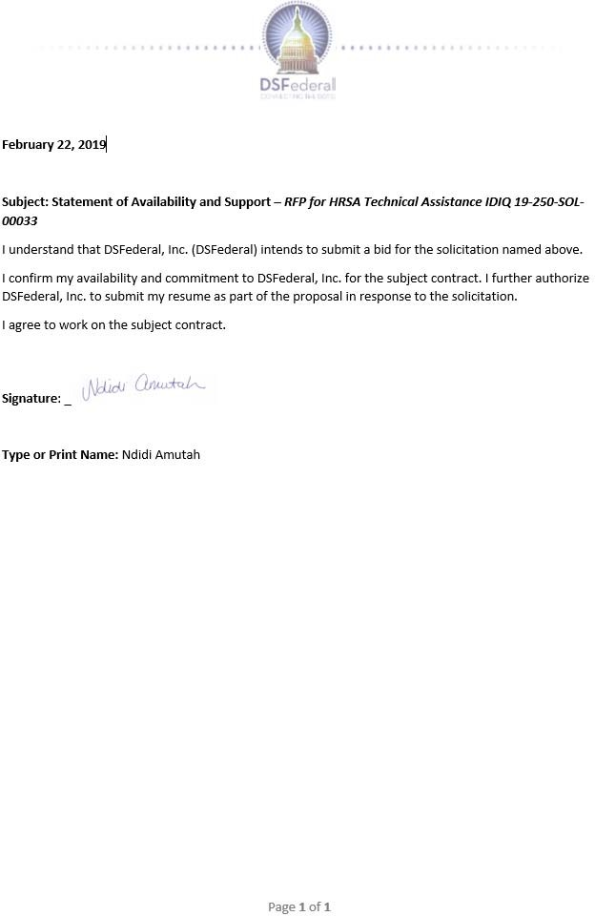

|  |
| --- |
| Qualifications and Experience  Over 12 years in HIV/AIDS care including HIV/AIDS clinical management, program monitoring and evaluation, training, health system strengthening and quality improvement  Doctor of Literature and Philosophy University of South Africa  CQI Fellowship with MakSPH-CDC HIV/AIDS |

1. **Ruth Atukunda, PhD – TA Specialist/Research Analyst**

## Career Summary

A public Health specialist with over 12 years’ experience in HIV/AIDS care including HIV/AIDS clinical management, program monitoring and evaluation, training, health system strengthening and quality improvement. Has built expertise in the analysis and use of health and program information for strategic planning and management. Led the assessment of AIDSRelief HIV/AIDS programs in Uganda through patient level outcomes and use of ‘Small tests of change” to improve quality of care. Has expertise in

developing country strategic health sector documents especially in HIV/AIDS and capacity building for health workers (Training, mentorship and support supervision). Conducted and participated in consultancies such as development of the Uganda Health Sector quality improvement frame work and strategic plan 2015/16 – 2019/20, development of the quality Improvement methods: A manual for health workers in Uganda; development and piloting of the Uganda Clinical and systems mentorship Framework. Has publications in the area of HIV/AIDS and conducted presentations in national and international conferences. Has experience working with people from different countries such as Kenya, Tanzania, Malawi, Rwanda, Nigeria, Swaziland and Australia.

## Education, Training, and Certifications

* 2014-2018 Doctor of Literature and Philosophy University of South Africa
* 2010-2011CQI Fellowship with MakSPH-CDC HIV/AIDS
* 2007-2008 Masters of International Public Health, Sydney University, Australia
* 2003 Registered with Uganda medical and Dental Council
* 1996-2002 Bachelor of Medicine and Surgery, Mbarara University
* 1994-1996 Uganda Advanced Certificate of Education (Advanced Level), Nabbingo
* 1990-1993 Uganda Certificate of Education, Nabbingo Trinity College

## Work Experience

**Oct 2018 – 10 Nov 2018**

**United Nations International Children's Emergency Fund (UNICEF) Swaziland** in collaboration with the World Health Organization and Ministry of Health Swaziland. Responsibilities: Pre-testing and adapting the global validation tools to Eswatini (Swaziland) context; Collecting and analyzing data in line with the global validation adapted tools and indicators; preparing a baseline report on the status of Eswatini against global benchmarks on the path to elimination; preparing recommendations and action plan to facilitate the country’s process towards achievement of elimination. Outcomes: Conducted an inception report presentation; conducted desk reviews on the Swaziland PMTCT program, developed data collection entry screens, adopted the WHO validation tools to the Swaziland context, trained data collectors, provided oversight on pre-testing tools and the data collection as well as data entry process. Generated report.

# Jan – June 2018

**United Nations International Children's Emergency Fund (UNICEF) and African Network for Care of Children Affected by HIV/AIDS (ANECCA)** in collaboration with the World Health Organization. Responsibilities: Conduct evaluation of the Uganda PMTCT/HIV/Syphilis program; Develop a protocol to assess the PMTCT/HIV/Syphilis program in Uganda, together with the MOH technical working team conduct take holder meetings, conduct survey, pre-testing and adopting data collection tools, oversee data collection and analysis process as well as compiling the evaluation report. Outcomes: Conducted presentation for stakeholders and developed protocol for PMTCT/HIV/Syphilis program evaluation.

# August 2017- Nov 2017

**African Network for Care of Children Affected by HIV/AIDS (ANECCA).** Responsibilities: Revising the Uganda National clinical systems mentorship and M&E framework, conducting workshops for various stakeholders (IPs, MOH technical teams and regional teams) and conducting trainings on the developed tools. Outcomes: Conducted workshop for stake, holders, have a revised CSM framework (incorporated new guidelines, differentiated service delivery models (DSDM) approaches and revised adolescent health approaches).

# January - March 2017

**African Network for Care of Children Affected by HIV/AIDS (ANECCA).** Responsibilities: Developing and adopting the National clinical systems mentorship and M&E framework for ANNECA supported countries’ Outcomes: Copy of the ANECCA CSM Framework.

# 20th -22nd July 2016

**Quality Assurance Department (QAD) Ministry of Health.** Responsibilities: Part of a team that reviewed abstracts for the National Quality Improvement (QI) Conference. Outcomes: Abstracts selected and presented in the National Quality Improvement (QI) Conference

# Nov 2015 – July 2016

**African Network for Care of Children Affected by HIV/AIDS (ANECCA).** Responsibilities: Part of a consultancy team in charge of developing the National clinical systems mentorship framework for health workers in Uganda, pre-testing the tools, engaging various stakeholders, conducting trainings on the developed tools. Outcomes: Participated in stakeholders’ meetings, pre-tested the tool in Health facilities in Uganda, developed CSM framework and conducted 1TOT for national trainers on the developed CSM framework as well as 3 TOTs for regional staff including about 90 health workers.

## Publications and Awards

* Atukunda, R, Memiah, P & Sibongile Shumba, C. 2013. Care for the caregiver: Stress relief and burnout among health workers in HIV care. Global Journal of Medicine and Public Health, 2 (2):1-7
* Shumba, SC, Atuhaire, L, Memiah, P, & Atukunda, R.2013. Assessment of Community Mobilization and Home-based HIV Counselling and Testing Offered by Health Facilities in Rural Uganda. Afr J Reprod Health (Special Edition); 17[4]: 171-176).
* Shumba, C, Memiah, P, Atukunda, R, Imakit, R, Mugadu, J & Stafford, K.2012. Continuous quality improvement in AIDS Relief supported HIV treatment clinics in Uganda: an evaluation of “See-Try-Observe- Continue” (STOC) model in patient care. International Journal of Medicine and Public Health, 2 (1):26-31

# Ruth Atukunda, PhD - Statement of Availability

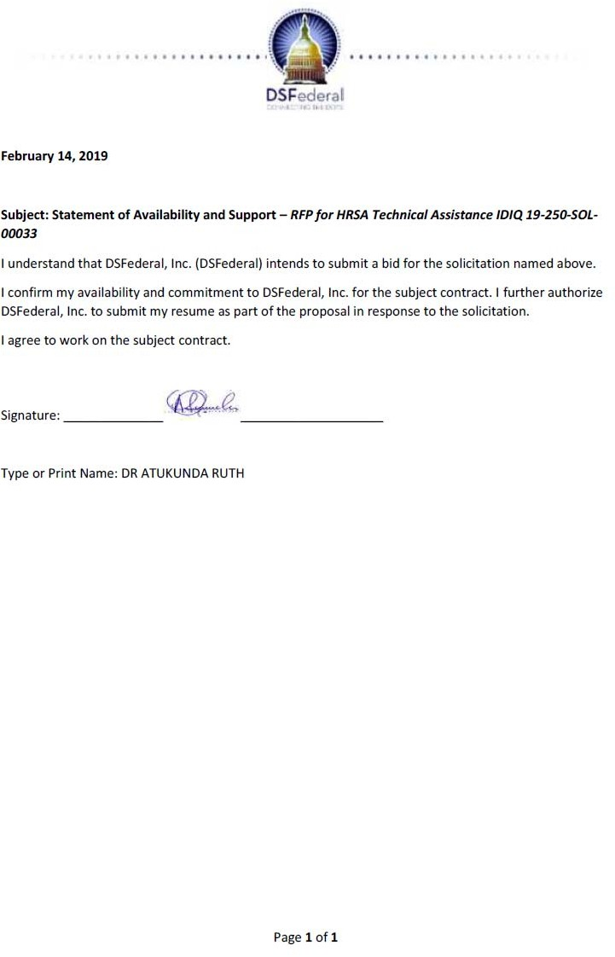

|  |
| --- |
| Qualifications and Experience  Over 15 years’ experience as a public sector organizational leader and 20 years of experience as a practicing organizational development professional  PhD Organizational Development and Transformation, International University of Professional Studies  Faculty in the Leadership and Organizational Development Graduate Program with the University of Texas |

1. **Jan Austin, PhD – Executive Coach**

## Career Summary

**Dr. Jan Austin** is an organizational development consultant, master certified coach, professional coaching instructor, leadership program facilitator, and author who brings more than fifteen years of experience as a public sector organizational leader and twenty years of experience as a practicing organizational development professional. Dr. Austin has worked extensively with mid-level and senior level leaders and their teams in Fortune 500 companies and Federal Government agencies, as well as professional coaches in training from the U.S. and abroad. Her work has

included both small scale projects as well as large, complex multi-level, multi-year initiatives. Her primary goal is to support her clients to leverage the values, skills, and behaviors that are integral to their success in their chosen roles. Clients value her astute observations, her questions that provoke deep reflection, and her unwavering optimism for their bigger aims and aspirations. They also value her support in developing compelling communications that connect, convince, and engage organizational stakeholders at all levels. In addition to her organizational development coaching and consulting, Dr. Austin is a faculty member in the Leadership and Organizational Development Graduate Program with the University of Texas at Dallas (UTD), a mentor coach to aspiring professional coaches, and a certification assessor with UTD, Coach University, and the International Coach Federation.

## Education, Training, and Certifications

* Ph.D. Organizational Development and Transformation, International University of Professional Studies
* Master’s Degree Public Administration (MPA), State University of New York
* Master’s Degree Clinical Psychology (MS), Augusta College/now Georgia Regents University
* Bachelor’s Degree Psychology (BA)/ minor in Sociology, Augusta College/now Georgia Regents University

## Work Experience

**OVERVIEW OF PROFESSIONAL COACHING EXPERIENCE**

**Potential at Work, Inc., 1999 to present:** Founder and president of an organizational development and coaching firm specializing in organizational leadership effectiveness, including individual and team coaching, strategic leadership consultation, and leadership program design and facilitation.

**University of Texas at Dallas Executive Coaching Training Program, 2010‒present:** Member of the coaching program faculty providing course design and instruction, individual and group mentor coaching, and certification assessments for students from the U.S. and abroad.

**University of Texas at Dallas Graduate Organizational Behavior and Coaching Program, 2016‒present:** Instructor for students completing their Capstone semester

**Federal Executive Institute, 2004 to present:** Member Executive Coaching Faculty providing coaching services to mid-tier and senior level U.S. government leaders participating in FEI’s leadership development programs.

**Coach Inc, 1998 to present:** Coaching Faculty Member providing course instruction, certification assessment, and mentor coaching for an international student body of professional coaches and organizational leaders.

**PRIVATE AND PUBLIC SECTOR ORGANIZATIONAL DEVELOPMENT AND COACHING EXPERIENCE**

**Knightsbridge Consulting, 2015:** group and individual mentor coaching and supervision for 27 internal and external coaches in a Canadian consulting firm in preparation for ICF coaching certification.

**Pacific Northwest University of Health Sciences, 2015:** design and facilitation of programs on inter-professional health coaching to the medical student body and to medical school faculty members.

**Blue Cross/Blue Shield of North Carolina, 2014:** instructional design and delivery of a professional coaching skills program for internal coaches within the HR and organizational development functions.

**CI Technologies, November 2010–2016:** organizational development consultation, strategic planning support, off-site instructional delivery and process facilitation, and executive coaching for the company’s president and operations executive.

**U.S. GOVERNMENT COACHING AND ORGANIZATIONAL DEVELOPMENT EXPERIENCE**

**U.S. Department of State Office of Inspector General, 2018:** facilitation of micro- communications programs for over 400 employees and managers in the U.S. and three international locations to support an inclusive workplace that respects and engages all organizational members.

**Federal Aviation Administration Flight Standards, 2016-present:** executive coaching for a senior executive to support effective leadership during an organization-wide reorganization.

**NASA, 2016:** executive coaching for mid-level leaders completing a candidate development program in preparation for assuming senior executive roles in the organization.

**Commodities Futures Trading Commission, 2015-present:** executive coaching for mid-level and senior level leaders, including political appointees, to enhance their leadership effectiveness in a complex organizational environment

## Publications and Awards

* HRSA Director’s Award for Technical Assistance. November 2017.
* “Review of Alternative Payment Report,” Report to HRSA, January 2010.

# Jan Austin, PhD - Statement of Availability

|  |
| --- |
| Qualifications and Experience  Over 30 years of teaching in medical institutions, clinical practice, and leadership experience in health sector first in Burundi and thereafter in Rwanda’s with 10 years in HIV programming  Doctorate in Medicine, University François Rabelais, Tours, France  Played strategic role rolling out HIV services in Rwanda since 2007 |

1. **Cyprien Baribwira, MD - Clinical Consultant**

## Career Summary

Over three decades of teaching in medical institutions, clinical practice, and leadership experience in health sector first in Burundi and thereafter in Rwanda’s with 10 years in HIV programming, serving first as country medical director for AIDs Relief and since 2011 as Country Director of Maryland Global health Initiative Corporation , an affiliate in Rwanda of the University of Maryland Baltimore, Dr. Baribwira has devoted his career to advancing the health in Burundi first and then health of Rwandan people. Upholding a mandate to improve health and wellness universally, Dr. Baribwira

has placed a special focus on children, women, and those most vulnerable in society including people living with HIV. He has extensive experience leading and managing organizations with international stakeholders and has a proven record in health systems strengthening to develop equitable, inclusive national health strategies and policies. Dr Baribwira is familiar with different working environments including teaching settings ,clinical leadership, clinical mentoring

/management at referral hospitals and district level, HIV program oversights and operational research .Using his clinical and leadership expertise, he has strategically influenced policy development, national strategy and programs design, advised senior government officials in Burundi and now in Rwanda and empowered the voice of local stakeholders to improve health for all..

## Education, Training, and Certifications

* 1996 - Maître de Conference Agrégé by CAMES – Conseil African Et Malgache Pour l’Enseignement Supérieur (African and Malagasy Council for High Education)
* 1985 - Master in pediatrics: University François Rabelais, Tours, France
* 1986 - Neonatology certificate: general hospital of Bourges (neonatology unity) France
* 1984 - Diploma in sports Medicine: University François Rabelais, Tours, France
* 1980 - Doctorate in Medicine, University François Rabelais, Tours, France
* 1976 - Pre-medicine Diplomas: University of Burundi, Bujumbura, Burundi

## Work Experience

**Country Director and Principal investigator April 2017– Present Maryland Global Initiative Corporation, Kigali, Rwanda**

Through IMAKAZA, CDC grant mandated to support Rwanda’s MOH in strengthening health systems for improved HIV service delivery; national laboratory capacity for increased testing and treatment efficiency; and information systems to better measure and monitor the clinical cascade with focus on quality services, programs own ship/internalization and sustainability.

* Advocacy for high skilled support and engagement of skilled consultant for LIS to Strengthen capacity and quality of Rwanda's laboratory network to support HIV diagnosis, prevention, care and treatment, disease monitoring and surveillance
* Provide technical assistance to RBC to strengthen affordable and sustainable quality HIV services through mentorship, policy, and capacity development by supporting developing and implementation of e learning platform for distance learning and mentoring
* In Process of development of national HIV QI framework
* Updating clinical and mentorship guideline Proven skills to support research for assessing ART resistance
* Proven Capacity to provide technical assistance to RBC to facilitate national policy and guideline development/revisions in alignment with PEPFAR-support HIV initiatives (including formalized index testing, recency testing, targeted self-testing, PrEP, TB preventive therapy)
* Skilled to support RBC to Implement and develop monitoring and reporting tools for PEPFAR HIV initiatives (continue M&E of DSDM, index, recency, PrEP and IPT)

# Country Director April 2012– March 2017 Maryland Global Initiative Corporation, Kigali, Rwanda

* Recognized for global leadership of a 5 years CDC funded project PACME ($ 10 million) dedicated to support Rwanda Ministry of health to oversight HIV and other infectious diseases after AIDS Relied and ICAP HIV programs transition to MOH to ensure quality of HIV services are maintained.
* Proven leadership in the design, implementation and evaluation of MGIC project by Contributing to the planning and development of strategic directions
* Skilled to lead technical assistance and leadership to MGI in country 5 seignior staff.
* Proven capacity of development and implementation new successful initiatives such as decentralized, district based clinical mentorship for the whole country where one MD and one nurse oversight all aspects of HIV in the district, this model is being replicated in different MOH programs including MCH, TB, and Malaria.

# Medical Director April 2009– September 2011 AIDSRelief Consortium

**Institute of Human Virology of the University of Maryland: Technical lead Kigali, Rwanda**

Provided technical leadership and vision on all aspects of the integrated HIV clinical Services of AIDSRelief, a PEPFAR-funded program supporting 20 health facilities in Rwanda to deliver high quality comprehensive HIV clinical services.

## Publications and Awards

* Recognized by Universities of Burundi and Rwanda for strong skills in teaching different medical students of different level and leading pediatric departments of teaching hospitals
* Played strategic role rolling out HIV services in Rwanda since 2007 focusing on PMTCT/pediatric services but also on adult HIV and strong support to HIV programs for evidence-based HIV guidelines every 2 years and tools development.
* Recognized by Rwanda Ministry of Health (MOH) and AIDS Relief Chief of Party for strong technical leadership as Medical Director

# Cyprien Baribwira, MD - Statement of Availability

|  |
| --- |
| Qualifications and Experience  Over 30 years of technical assistance including program assessment and evaluation.  PhD from Johns Hopkins University, School of Hygiene and Public Health, Behavioral Sciences and Health Education,  Written on cultural competency and HIV and oral health for the HRSA Care ACTION Newsletter |

1. **Deborah L. Brimlow, Ph.D. – Administrative / Governance Expert**

## Career Summary

An experienced administrative / governance expert with specialized experience in Health Center Program governance and administrative requirements. She performs the following:

* Conducts site evaluations to assess program outcomes for federally funded health care programs such as community and migrant health centers, public and private agencies or community-based organizations.
* Governance consultant for Bureau of Primary Health Care (BPHC) observational site visits.
* Federal Tort Claim Act (FTCA) site visit consultant.
* Evaluates adherence to federal regulations for Ryan White CARE Act Part C, Part D, Part F and AIDS Education and Training Centers.
* Provides on-site technical assistance related to administrative systems.
* Completes and submits written evaluations of the sites to the Health Resources and Services Administration.
* Conducts HIV-related chart reviews.

## Education, Training, and Certifications

* Lamar University, B.A., 1975, Sociology
* University of Houston, M.A., 1980, Sociology
* The Johns Hopkins University, School of Hygiene and Public Health, Behavioral Sciences and Health Education, Ph.D., 1986

## Work Experience

**The University of Texas School of Public Health** 1988-1996

**AIDS Education and Training Center for Texas and Oklahoma**

Assistant Professor

* Lectured and taught classes in HIV/AIDS and behavioral sciences.
* Advised students and served as a member of students’ graduate committees.
* Participated in university-wide committees (e.g. Infectious Diseases Committee).

Education Coordinator (AETC)

* Oversaw all education activities for the east Texas area of the AETC. Provided education and training to health care professionals throughout the Texas/Oklahoma region.
* Supervised and evaluated a staff of two employees.
* Developed and implemented over 300 training programs and presentations related to HIV/AIDS, substance use, infection control, women’s health, and burnout.
* Conducted training programs related to women's issues, OSHA standards, sexual history taking and other HIV-related topics.

Director, Dental Training Program

* Developed and implemented a clinical preceptorship program which provided didactic and “hands-on” clinical training for dentists, hygienists, and assistants.
* Developed and implemented over 100 clinical training programs related to HIV/AIDS for health care professionals.
* Developed, reviewed, and revised training curriculum materials.
* Produced a dental training videotape on HIV patient care.

## Publications and Awards

* Abel, S.N., Crosby-Kowal, H., Brimlow, D.L., Uchin, M. and Gerbert, B. A Collaboration to Enhance Oral Health Care for Survivors of Domestic Violence: Women’s Domestic Violence Shelters and Nova Southeastern University’s College of Dental Medicine. Journal of Dental Education 76(10): 1334-1341 October 2012.
* Brimlow, D.L., DeLorenzo, L., Menzer, J.A., and Thorner, S. Baltimore City Health Department Ryan White CARE Act, Title I Quality Improvement Program (QIP). Standards of Care Comparative Analysis: Dental Health Services. January 2004.
* Brimlow, D.L., Cook, J. S., and Seaton, R. (editors). Stigma and HIV/AIDS: A Review of the Literature. May 2003. Prepared for HRSA/HAB. Distributed at the HIV Stigma Community Consultation Meeting held at Georgetown University. [(http://hab.hrsa.gov/publications/stigm](http://hab.hrsa.gov/publications/stigma/front.htm))a[/front.htm)](http://hab.hrsa.gov/publications/stigma/front.htm))
* Brimlow, D. L., Ross, M. W. and Rankin, K. V. The Perception of Surrogate Teaching Patients with HIV Disease of Dentists’ Fear and Comfort. Journal of Dental Education. 64(8):597-602. August 2000.
* Brimlow, D.L. HIV/AIDS Dental Training through the AIDS Education and Training Center (AETC) Program. Dental Alliance for AIDS Care (DAAC) News Forum, Winter/Spring, 1996.
* Brimlow, D.L. Training to Prevent Burnout: HIV/AIDS Programs for Physicians and Dentists. In: Bennett, L., Miller, D., and Ross, M. W. (eds), Health Workers and AIDS: Research, Intervention and Current Issues in Burnout and Response. London: Harwood Academic Publishers, 1995.

# Deborah L. Brimlow, Ph.D. - Statement of Availability

|  |
| --- |
| Qualifications and Experience  Over 20 years of leading complex, clinical and public health programs focused on building evaluation and stakeholder capacity  PhD in Public Health, Community Health and Education  Public Health Program planning, implementation, and day-to-day operational direction. |

1. **Erika Copeland - Senior Technical Personnel**

## Career Summary

Dr. Copeland is currently the Principal Research Scientist for Karna, LLC, leading the Health Science, Research, and Evaluation Division. Dr. Copeland has over 20+ years of managerial experience specializing in complex, multi-site interdisciplinary clinical and public health research programs, working with CDC, NIH, FDA, and DoD. She has worked with national, state, and local professionals in public health, specifically in the areas of program planning, development, and management, research support, evaluation design and implementation for

evidence-based programs, measurement of stakeholder performance, and quality improvement to help impact policy and evidence-based decision making in health disparities, social determinants, and community health education and improvement.

## Education, Training, and Certifications

* Walden University, Doctor of Philosophy, Public Health, Minneapolis, MN, 2013
* Walden University, Master of Public Health, Minneapolis, MN, 2012
* University of Phoenix, Master of Business Administration, Atlanta, GA, 2008
* Georgia State University, Bachelor of Science, Biological Sciences; Chemistry, Atlanta, GA 2001

## Work Experience

Senior Program Manager/Principal Research Scientist Mar 2016 – Present Karna, LLC., Atlanta, GA

* Manage a portfolio of multi-functional Health Science, Research, and Evaluation program activities
* Define and oversee project scopes, schedule, tasks, deliverables, budgets, resource requirements, and quality
* Provide expertise and best practices in public health research support, monitoring and evaluation design and implementation, training/capacity building/technical assistance, and skills related to risk mitigation and problem-solving
* Manage oversight on the delivery of training and TA to state and local health departments funded for National DPP and DSMES diabetes prevention interventions, designed to enhance DDT-specific performance and evaluation activities amongst grantees
* Impart direction to a team of multi-disciplinary scientists, researchers, administrators, analysts, and communication specialists to conduct needs assessments, environmental scans, data analysis, health communications strategies and materials, and trainings
* Increase the capacity of healthcare providers/ professionals to deliver contraception options to their patients
* Provide design and planning for training to increase state-based users of the HAB reporting system’s capacity to identify and report HABs
* Translate technical scientific information into language appropriate for multiple audiences
* Develop National Outbreak Reporting System (NORS) training/guidance materials for quality improvement in reporting activities

Senior Global Manager March 2014 – March 2016 Q2 Solutions (Formerly Quintiles), Marietta, GA

* Managed, coached, and mentored day to day activities of international Project Management

teams on cross-functional pre- and post-launch activities ensuring programmatic, administrative, operational, and financial management of projects

* Coordinated client management across all projects
* Drove performance improvement and operational efficiencies

Project Manager, Women’s & Children’s Center Sept 2010 – Oct 2013

The National Children’s Study (NCS) - Funded by the National Institutes of Health (NIH) Rollins School of Public Health (RSPH), Emory University, Atlanta, GA

* Managed the multi-year, $28M contract of a team of 26 multi-disciplinary researchers charged

with developing and implementing strategies to segment, track, and evaluate the effects of environmental influences on the health and development of approximately 100,000 children across the United States

* Provided technical advice for RSPH’s Women’s and Children’s Center on performance measure, including program operations, participant recruitment and retention, outreach and engagement of local communities, and the collection and analysis of operational and visit assessment data for continuous quality improvement

# Erika Copeland - Statement of Availability

|  |
| --- |
| Qualifications and Experience  Over 30 years of technical assistance working with recipients of Federal Government Funds and Healthcare industry, specifically helping such entities to comply with Federal requirements  Universidad Sagrado Corazon, San Juan, PR bachelor’s in business administration - Cum Laude Accounting and Management (Double Major)  Certified Public Accountant  Bi-lingual in English and Spanish |

1. **Manuel Calas – Accountant / Financial Analyst**

## Career Summary

Mr. Calas brings more than 30 years of experience working with recipients of Federal Government Funds and Healthcare industry, specifically helping such entities to comply with Federal requirements and preparing federal proposals. He has a knowledge of 45CFR75 Uniform Administrative Requirements, Cost Principles, and Audit Requirements for Federal Awards - Management of audit/consulting engagements, including performing audit examinations for various types of enterprises such as: health care, governmental agencies (single audits) and non-for

profit enti ties; Forensic audit examination engagements. He is familiar with sub-recipient monitoring procedures and best practices - Frequently hired by the US Federal Government (J- IRSA) to perform monitoring and audit site visits to federal grant recipients, to ascertain compliance with grants and conditions. As well as to provide financial training and support

## Education, Training, and Certifications

* Certified Public Accountant License No.2719
* Universidad Interamericana De Puerto Rico, San Juan, PR MBA (Accounting Major- In Process)
* Universidad Sagrado Corazon, San Juan, PR bachelor’s in business administration - Cum Laude Accounting and Management (Double Major)

## Work Experience

**Manuel Calas & Assoc. CPA's and Consultants, Guaynabo, PR Audit Partner/Owner**

**2001 - Present**

* Management of audit/consulting engagements, including performing audit examinations for various types of enterprises such as: health care, governmental agencies (single audits) and non-for-profit entities, construction, distribution, advertising.
* Forensic audit examination engagements.
* Frequently hired by the US Federal Government (J-IRSA) to perform monitoring and audit site visits to federal grant recipients, to ascertain compliance with grants and conditions. As well as to provide financial training and support
* All types of tax work consulting (local and federal taxes).
* Have been in charge of major consulting projects, such as: preparation of various reports for health centers that receive federal funds, internal control reengineering, finance/accounting policies and procedures development, design and implementation, systems need evaluations, feasibility studies.
* Human resources policies and procedures development and implementation.

# VIRTUAL, INC. (EI Nuevo Dia – Internet Division), San Juan, PR Business Manager

**1999 - 2001**

Implementation and design of all operating systems for a start-up company. Full responsibility over all finance, administration and human resources matters, such as:

* Budget & Strategic Plan development
* Cash Management
* Risk Management
* Full Accounting Cycle
* Corporate and Payroll Taxes
* Handling of relationship with Banks, Insurance companies and external auditors
* Building maintenance and repairs
* Purchasing and contracting of services and/or products
* Recruiting
* Design and implementation of personnel policies and procedures
* Compensation Plan Administration

# Manuel Calas - Statement of Availability

|  |
| --- |
| Qualifications and Experience  Over 20 years of technical assistance including 10 years for HRSA HAB Programs  Bachelor of Science/Master of Public Administration in Health Administration, Long Island University  Johns Hopkins University, Health Science Informatics Intern Preceptor |

1. **Jeananne Cappetta - TA Specialist / Research Analyst**

## Career Summary

An experienced Technical Assistance specialist who currently serves as a consultant for HRSA/HAB site visits and provides technical assistance in the areas of administrative, data, program, and quality Management. Ms. Cappetta was formerly a Part A recipient and assisted in both Part B and Part D programs to ensure compliance with federal and programmatic requirements. She was originally recruited by HAB to work with a Part B/ADAP program focusing on conditions of awards, data, and program administration.

She has worked directly with recipient staff on conditions of awards and provided ongoing technical support.

## Education, Training, and Certifications

* Long Island University, C.W. Post Campus, Brookville, NY Accelerated Bachelor of Science/Master of Public Administration in Health Administration, May 1995
* Long Island University, C.W. Post Campus, Brookville, NY Certificate of Advanced Studies in Gerontology, May 1999
* University of Southern California, Los Angeles, CA Masters of Long-Term Care Administration, In progress

## Work Experience

**3/11-Present Health Care Consultant, Independent as requested**

Work independently for various HIV/AIDS health care organizations when requested who are seeking assistance with:

* Grant writing/submissions
* Data development/implementation
* Accountable for all data collection and reporting (includes the RSR report), recipient and provider trainings and submissions and conditions of awards on behalf of the program.
* Assisted grantees with Program related actions; & trained all staff responsible for utilizing the EHB system.
* Developed Standards of Care
* Developed Administrative Policies and Procedures for select service categories
* Data consultant providing technical support for local systems
* Administrative Consultant for Federal legislation, monitoring, and HAB Program requirements

# 8/09- 2/11 Collaborative Research, LLC Senior Manager, Ryan White Program

Managed data project for a Part A program which included analysis of data, providers, annual reporting & preparation conversion & implementation of CAREWare; assisting and conducting RSR trainings and day to day data and reporting tasks.

* Created policy and procedures regarding data security for a Part A TGA
* Conducted Needs Assessments such as Out of Care and New to Care for various TGAs and EMAs
* Assisted grantees with the preparation and submission of grant applications
* Served as interim Planning Council staff- Jan 2010-Nov 2010

# 3/08 –7/09 United Way of Long Island, Deer Park, N.Y.

**Ryan White Part A, Health Resources Services Administration, DHHS Sr. Contract Administrator/Data Manager/Quality Management Director**

* Oversight of funded Part A providers and contracts including service delivery
* Directly responsible for coordinating and organizing all conditions of awards and data reports related to HRSA mandates and requirements directed by the Notice of Grant award as well as any other ad hoc requests by HRSA or Planning Council.
* Liaison with NYSAIDS Institute & other regional recipients regarding fulfilling and analyzing
* data requests & reports
* Monitored provider requirements, goals, accomplishments and challenges
* Facilitated funding and priority setting process
* Supervised Quality Management consultants and deliverables in meeting regional goals
* Analyzed policy and legislation referring to Ryan White and HIV/AIDS
* Managed data systems and data compliance for region

# 4/08-6/08 United Way of Long Island, Deer Park, NY Interim Sr. Vice President, HIV/AIDS Grants Management

* Responsible for department staff and daily operations for Ryan White Parts A and B
* Liaison between Nassau County (Recipient) and Suffolk County Department of Health
* Facilitated Planning Council staff and functions, including resolving outstanding issues
* Mediator for regions’ provider concerns

# 2/01-3/08 United Way of Long Island, Deer Park, NY

**Ryan White CARE Act, Title I- Health Resources Services Administration, DHHS Contract Administrator, CARE Act Coordinator/Data Mgr., Planning and Grants Management**

* Acted as lead agency for awarded Recipient, Nassau County Department of Health
* Managed all aspects of 46 contracts at 19 funded agencies of the Nassau- Suffolk EMA
* Responsible for developing methods of collecting, monitoring, and analyzing demographic data and services for clients and agencies of Title I for Long Island.
* Directly responsible for reporting federal data reports to the Health Resources Service Administration (HRSA) division of the US Department of Health and Human Services

# Jeananne Cappetta - Statement of Availability

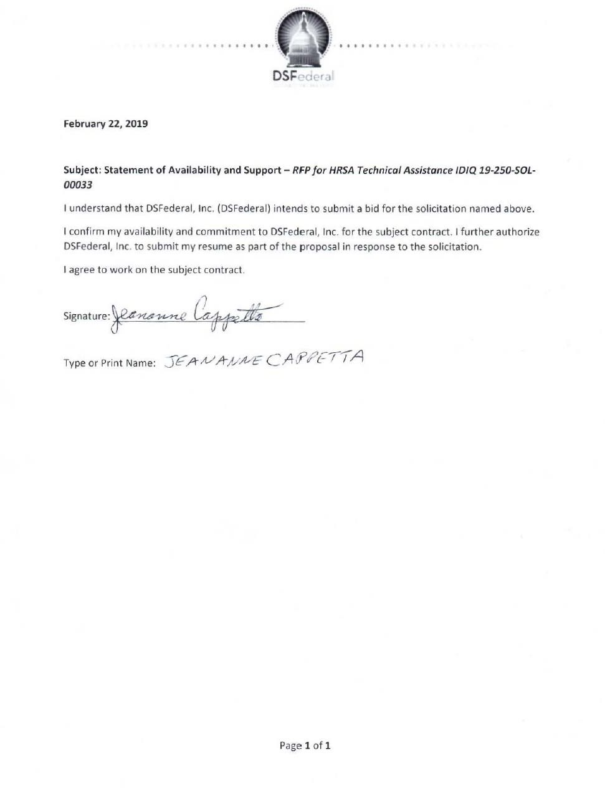

|  |
| --- |
| Qualifications and Experience  Over 10 years of as Executive Director of Affinity Health Center which grew from an HIV focused community-based organization to a Federally Qualified Health Center  Master of Social Work in 2001 from University of North Carolina at Chapel Hill  Instructor at Winthrop University in Rockhill, SC |

1. **Anita Case - TA Specialist/Research Analyst**

## Career Summary

Over 10 years of as Executive Director of Affinity Health Center which grew from an HIV focused community-based organization to a Federally Qualified Health Center.

## Education, Training, and Certifications

* Master of Social Work in 2001 from University of North Carolina at Chapel Hill

## Work Experience

**2005 – Present**

**Affinity Health Center, Rock Hill, SC Executive Director**

* Responsible for ensuring mission fulfillment by nurturing a culture focused on vision and aligned with organizational values
* Guide executive team to provide strategic leadership for a staff of 65
* Oversee $10 million-dollar budget and provide sound fiscal management
* Responsible for community relations and strategic partnership, leadership development, strategic thinking and planning, organizational oversight, performance management, policy development, medial relations, and public speaking.

# 2004 - 2005

**Hope Health Director**

* Program management and supervision of HIV prevention program

# 2001-2004

**Catawba Care, Rock Hill, SC**

**Social Work Case Management Supervisor**

* Provided program management for HIV case management and volunteer programs
* Facilitated Patient Support groups

# Anita Case - Statement of Availability

|  |
| --- |
| Qualifications and Experience  Over 15 years of technical assistance the administration of publicly funded programs including the Ryan White Care Act  MBA, Loyola University of Chicago, Chicago, Illinois  Fellow, Public Health Leadership Institute, University of Illinois School of Public Health |

1. **Dorothy Eileen Durkin - Billing Specialist**

## Career Summary

An experienced billing specialist with over 15 years’ experience. Expertise in healthcare delivery systems, State and Local government, Managed Care and Public Health. A deep knowledge of the administration of publicly funded programs including the Ryan White Care Act.

## Education, Training, and Certifications

* MBA, Loyola University of Chicago, Chicago, Illinois,
* BS, Medical Record Administration, University of Illinois, Chicago, Illinois
* BA, History, University of Charleston, Charleston, West Virginia,
* Fellow, Public Health Leadership Institute, University of Illinois School of Public Health
* Certificate, University of Delaware Leadership Institute on Developmental Disabilities

## Work Experience

**Independent Consultant, Chicago, Illinois July 2015 – present**

Current projects include coordination of county Mental Health Authorities in Illinois; Fiscal Consultant for Ryan White Parts A, C, D, F; Fiscal Consultant for Bureau of Primary Health Care 330 program.

# Community Counseling Centers of Chicago (C4) March 2012 – May 2015 President and Chief Executive Officer

Executive leadership of a comprehensive community behavioral health organization with 200 employees, four primary delivery sites, and an annual budget of $16m and serving 12,000 individuals yearly.

# Neumann Family Services Dec. 2000 – March 2012 President and Chief Executive Officer

Executive leadership of a human services agency with an annual budget of $15m. Provided wide array of services including housing and employment to 550 adults with developmental disabilities and mental illness.

# Howard Brown Health Center Oct. 1991 – Dec. 2000 Executive Director

Executive leadership of a community health center serving a low-income population, the majority of whom were diagnosed with HIV/AIDS.

# Independent Consultant Jan. 1996 – March 2012

Fiscal Consultant for Ryan White Parts C and D programs.

## Publications and Awards

* Outstanding Community Leader, Chicago Health Executive Forum, 2014
* Outstanding Leader, Women’s Health Executive Network, 2007
* Distinguished Citizen, Bank of America Community Leadership Award, 2000
* Distinguished Alumni Award, University of Illinois College of Applied Health Sciences, 1994
* Outstanding Member, Illinois Health Information Management Association, 1988
* Outstanding Member, Chicago Health Information Management Association, 1984

# Dorothy Eileen Durkin - Statement of Availability

|  |
| --- |
| Qualifications and Experience  Over 30 years of technical assistance experience designing, planning, and evaluating community health and community-organizing programs and campaigns  MPH, Health Education - University of California, Berkeley  Sierra Health Foundation – Health Leadership Program |

1. **Galen Ellis, MPH - Senior Technical Personnel**

## Career Summary

An experienced senior technical consultant with over 30 years’ experience designing, planning, and evaluating community health and community-organizing programs and campaigns. Demonstrated success developing curricula and designing capacity building and leadership development training programs.

## Education, Training, and Certifications

* MPH, Health Education - University of California, Berkeley, 1991
* B.A., Social Science - San Francisco State University, 1989

## Work Experience

**CONSULTING**

*Ellis Planning Associates currently provides consulting services in the areas of training and education, community organizing and community development, designing and planning programs, administration, and evaluation. A partial list of clients includes:*

* Alameda County-wide Homelessness Continuum of Care Council
* California Department of Health Services, STD Control Branch
* California Department of Social Services

# TECHNICAL ASSISTANCE, TRAINING, AND CURRICULUM DEVELOPMENT

*Developed training programs utilizing popular education methods, and developed technical assistance programs for local and statewide community-building initiatives:*

* Faculty and developer for the To the Point Facilitation’s Facilitator Certification Program, providing beginning to advanced meeting planning and facilitation skills training to individuals and organizations throughout California.
* Developed Bioterrorism Preparedness Training and Field Epidemiology Training-of-Trainers curricula for local health departments.

# COMMUNITY ORGANIZING AND LEADERSHIP DEVELOPMENT

*Twenty years of direct community organizing and leadership development experience, combined with management and administration of community building programs. Developed nationally recognized models that build on community strengths and assets, recognize and develop local leadership, and utilize participatory methods of training and education. Examples include:*

* Healthy Neighborhoods Project, a resident-lead neighborhood-organizing project in which 120 residents were trained as community organizers to improve the quality of life in their communities. Over 1000 residents participated in developing and implementing action plans in six low-income neighborhoods.

# PLANNING AND EVALUATION

*Facilitation and technical assistance in the areas of program planning, strategic planning, and evaluation:*

* Training and technical assistance to non-profits and public agencies on logic modeling and outcome-based prevention planning and evaluation.
* Developed participatory data analysis workshops for local community-based strategic planning processes.

# MEDIA ADVOCACY

*Utilized the media to advance public health and community development goals:*

* Developed media advocacy strategies to support local policy campaigns and to expose tobacco industry activities.
* Created on-going relationships with local media personnel to maximize coverage of health campaigns.
* Trained staff and local residents to develop media advocacy strategies and become spokespersons to the media.

## Publications and Awards

(1998-2005 listed under former name “El-Askari”)

* Ellis, G. and Walton, S. “Building Partnership between Local Health Departments and Communities: Case Studies in Capacity Building and Cultural Humility,” in Community Organizing & Community Building for Health and Welfare, 3rd Edition, Minkler, M. editor, Rutgers University Press, New Brunswick, NJ, 2012.
* El-Askari, G. A. et al, “The Healthy Neighborhoods Project: A Local Health Department’s Role in Catalyzing Community Development,” Health Education & Behavior, Vol. 25(2):146- 159 (April 1998).
* Ellis, G. A.; Reed, D. F.; and Scheider, H., "Mobilizing a Low Income African American Community Around Tobacco Control: A Force Field Analysis," Health Education Quarterly, Vol. 22(4): 443-457 (November 1995).
* Ellis, G. A.; Hobart, R. L.; and Reed, D. F., "Overcoming a Powerful Tobacco Lobby in Enacting Local Smoking Ordinances: The Contra Costa County Experience," Journal of Public Health Policy, Vol. 17(1): 28-46, 1996.

# Galen Ellis, MPH - Statement of Availability

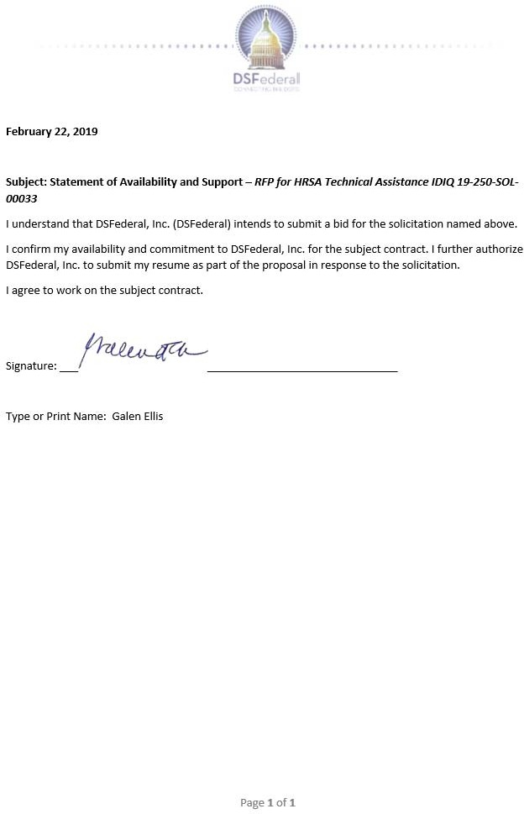

|  |
| --- |
| Qualifications and Experience  Over 20 years of consulting and dentistry including over 10 years of TA for HRSA  Howard University College of Dentistry, Washington, DC, DDS Degree  US-DHHS Secretary's Award for Distinguished Service, 2005  HRSA Administrator's Award, 1996  PHS Regional Health Administrator Award, 1989 |

1. **Cephas L. Goldman - Senior Technical Personnel**

## Career Summary

An experienced dentist and consultant with significant international experience including USAID Uganda PEPFAR OVC (Orphan and Vulnerable Children) Program Advisor. Dr. Goldman served in several management roles at HRSA including Director, Division of State and Community Assistance for the HRSA Bureau of Primary Health Care.

## Education, Training, and Certifications

* Virginia State University, Petersburg, Virginia, Biology B.S. 1971
* Howard University College of Dentistry, Washington, D.C., DDS Degree - 1975
* Loyola College, Sellinger School of Business and Management, Baltimore, Maryland, MBA- 2000
* University of Pretoria South Africa, MPHIL-Theology 2010

## Work Experience

**Consulting – 2012-2018**

USAID Uganda PEPFAR OVC (Orphan and Vulnerable Children) Program Advisor

Management Strategists Consulting Group-Community Health Center Program technical assistance and compliance/performance reviews for HRSA

USAID Missions- (South Africa, Malawi, Tanzania, Rwanda)

Provided broad range of technical assistance and consultation in areas of PEPFAR OVC program implementation that include:

**HIV/AIDS Orphan and Vulnerable Children (OVC) and Network Advisor**-IAP USAID South Africa- 4/2007-4/2012

Provided technical advice and consultation to the Health Team on the implementation of strategies to provide support to OVC.

**OVC Technical Advisor**-PACT South Africa 7/2007-3/2009 (Assigned to USAID South Africa to help and support for OVC program.)

**Consultant, the Foundation for Professional Development**, South Africa 2/2007-4/2007 Helped with the Foundation’s HIV/AIDs Services Mapping Project.

**Director, Division of State and Community Assistance**- 4/04-10/06-Bureau of Primary Health Care/Health Resources and Services Administration (HRSA)/HHS

**Principle Program Manager**, Division of State and Community Assistance-5/03-3/04

Exercised full authority as acting Division Director in directing the administration of technical assistance and training contracts, grants and cooperative agreements totaling over $140 million. Responsible for development and tracking of the division's strategic and operational plan.

Supervised 30 professional staff members.

**Deputy Director, Division of Community and Migrant Health**-2/98-4/03-Bureau of Primary Health Care/HRSA/DHHS

**Chief, Community Health Services Branch, Division of Community and Migrant Health**- 10/92-1/98 Led the administration of the grant program authorized by Section 330 of the Public Health Service Act, under which health centers in rural and urban areas receive Federal funds to provide primary health care to the underserved.

**Technical Assistance and Training Consultant**-8/85-9/92 -Provided assistance to health centers upon request. Conducted monitoring sites visits of grantees for the Bureau of Primary Health Care.

**Executive Director and Dental Director**-8/80-10/92-Central Virginia Community Health Center (CVCHC)-New Canton, Virginia

**Private Dental Practice**-6/75-7/80-Farmville, Virginia

## Publications and Awards

* HRSA Director’s Award for Technical Assistance. November 2017.
* “Review of Alternative Payment Report,” Report to HRSA, January 2010.

# Cephas L. Goldman - Statement of Availability

|  |
| --- |
| Qualifications and Experience  Over 30 years of clinical experience and various government staff positions at HRSA including MCHB and HAB  Master’s in Public Health, University of California at Los Angeles  Doctor of Medicine, Howard University College of Medicine, Washington, DC  HRSA Administrator’s Citation; Outstanding Team Performance |

1. **Thurma McCann Goldman, MD - Clinical Consultant**

## Career Summary

An experienced clinical consultant with over 30 years’ experience management positions in the US Public Health Service at HRSA and private clinical practice. Dr. Goldman’s time at HRSA included experience in HAB and MCHB.

## Education, Training, and Certifications

* Master’s in Public Health, University of California at Los Angeles
* Doctor of Medicine, Howard University College of Medicine, Washington, DC
* Bachelor of Science, Biology, Howard University, Washington, DC

## Work Experience

**Consultant, public health and community services – Sole proprietor of Health and Community Services Consulting, LLC**

1/2015-present

* Provided guidance and technical assistance through comprehensive site visits. Completed over

45 site visits reviewing Clinical and Administrative aspects of Ryan White HIV/AIDS Programs (RWHAP) including Part C and D.

* Conducted an international technical assistance visit to Botswana to improve client flow for HIV Testing and Counseling for International AIDS Education and Training Center’s PEPFAR HIV/AIDS program.
* Conducted an international technical assistance visit to The Philippines to improve uptake of prevention and outreach HIV services and for key populations. This visit was a contractual agreement with Save the Children USA and STC Philippines.

# Clinical practice in general Pediatrics and Adolescent Medicine

7/1989-7/2015

* Quality medical evaluation for newborn to adolescent and young adult populations
* Mental health screening, evaluation and treatment for children
* Senior Advisor, Pediatric HIV Center for Global Health, CDC
* As the Senior Administrator, provided guidance and technical assistance on Pediatric and Adolescent services to be conducted under PEPFAR in collaboration with country programs

# Country Director South Africa, Division of Global HIV/AIDS Programs, Center for Global Health, Centers for Disease Control and Prevention, Pretoria, South Africa (SA)

5/2009-5/2012

Supervision and management staff of professional and paraprofessionals in public health- included human resources, fiscal oversight, clinical policy and regulations. Ensured quality management of clinical services in the areas of HIV prevention and treatment.

Contributed in large part through painstaking commitment to the goals of the President’s Emergency Plan for AIDS Relief (PEPFAR) which resulted in SA becoming the most complex of

programs and the largest provider of ART in the world. Setting policy for ART treatment and HIV prevention services in urban and rural settings utilizing multiple federal cooperative agreements and complex contracts.

# Chief, Care and Treatment Branch, CDC South Africa, Division of Global AIDS Programs, NCCHHSTP, CDC, Pretoria, South Africa

Authority for management of 5 professional staff and 21 Federally funded cooperative agreements ranging from $1-15M, all relating to provision of care and treatment services for HIV/AIDS and TB. This included policy development and implementation of key activities for HIV counseling and testing and Prevention of Mother to Child Transmission and Pediatric ART.

# Director, Global Programs for HIV/AIDS, HIV/AIDS Bureau, Health Resources and Services Administration (HRSA), Rockville, MD

10/2002-4/2006

Provided oversight for HIV/AIDS Bureau’s technical assistance for HIV/AIDS in global communities utilizing best practice from primary care settings in the US. These activities were conducted through an interagency partnership involving USAID, HHS Office of International Health Affairs, Department of State Office of the Global AIDS Coordinator, Peace Corps, Department of Defense and multiple host countries.

# Director, Community Based Programs, HIV/AIDS Bureau, Health Resources and Services Administration, Rockville, MD

Management of over 50 professional staff, project officers and program planners for over 400 primary HIV care grantees in the US. Grant funding totaled over $260M.

# Director Division of Healthy Start, Maternal and Child Health Bureau, Health Resources and Services Administration, Rockville, MD

Supervised 20 health care and public health professionals in Maternal and Child Health (MCH) and $96M grant program to targeted communities in the US to reduce infant mortality

# Chief Medical Officer and acting Chief, Perinatal Branch, Special Populations Division and Division of National Health Service Corps (NHSC), Health Resources and Services Administration, Rockville, MD

As Branch Chief, supervised 3 technical and clinical staff to carry out the planning, oversight and coordination of all Branch projects related to perinatal systems in federally funded community health centers across the US.

## Publications and Awards

* 2007 Unit Commendation; Outstanding Unit Commendation
* 2006 Meritorious Service Medal; Crisis Response Service; 2 Outstanding Unit Commendation
* 1999 HRSA Administrator’s Citation; Outstanding Team Performance; Unit Commendation; DoD Certificate of Recognition-Service During the Cold War
* 1998 Surgeon General’s Bicentennial Award; Outstanding Unit Commendation; Certificate of Recognition and Appreciation AMSUS

# Thurma McCann Goldman, MD - Statement of Availability

|  |
| --- |
| Qualifications and Experience  Over 35 years of international public health experience including USAID building and leading large teams.  Master of Public Health, University of North Carolina (UNC)  HIV/AIDS Twinning Center (TC) Director, AIHA, 2013 - 2017 |

1. **Carl W. Henn, MPH - Senior Technical Personnel**

## Career Summary

Health systems leader, structuring efforts around the six WHO building blocks, 35 years of experience, including Africa, Middle East, Caribbean and Asia.

Broad vision and leadership. Extensive contacts within health field. Management experience with USAID and NGOs. Successful experience building and leading large, complex portfolios and teams. Adept at building and managing relationships, budgets, and portfolios.

Eager to build and guide an ambitious portfolio, contributing to business growth while innova ting solutions to health system needs.

## Education, Training, and Certifications

* MPH (Master of Public Health), University of North Carolina (UNC), 1989
* BA, Political Science/French, Indiana University (IU), 1981, Honors

## Work Experience

**Interim HIV/AIDS Team Leader, USAID Burundi, April 2018-Present, Bujumbura, Burundi**

Interim Team Lead in an insecure operating environment. French fluency. Leadership and technical direction for the USAID Burundi HIV-TB team in project implementation and in health system strengthening (HSS), health information systems (HMIS), and human resources for health (HRH) functions. Oversight of new partner start up, partner management, represent USAID in government discussions, work with partners to implement new and evolving PEPFAR strategies.

**Technical Director, American International Health Alliance (AIHA) July 2017-Present. Provide** technical expertise in HSS and Human Resources for Health (HRH) for the entire organization. Lead on HSS-HRH new business efforts for AIHA as a Prime or as a Sub. Develop strategies for HSS and HRH in line with state-of-the-art technical developments. Oversee technical quality of AIHA portfolio to ensure that AIHA remains on the cutting edge of HSS/HRH. Represent AIHA on the HRH2030 team and contribute to HRH2030 technical approaches based on Mission needs.

# HIV/AIDS Twinning Center (TC) Director, AIHA, October 2013-July 2017, Washington, DC.

Led successful re-bid for Twinning Center award from HRSA in 2013-14. Provided vision for PEPFAR “Next Generation” partnerships. Develop, expand, and oversee HIV/AIDS HSS/HRH strategies. Liaise with HRSA, CDC, USAID, other donors and host governments. Build rapport and ensure alignment of programs and priorities. Led AIHA TC unique partnerships, capacity building, HRH, and system strengthening efforts. Supervised 4 country directors and 5 HQ program staff.

# Director of Operations, Opportunity International, April-Oct. 2013, Wash., DC

Turn-around assignment. Course-corrected a jeopardized program. Provided interim strategic and program design and oversight. Ensured compliance and sound financial management. Enhanced

program quality, planning and implementation. Recruited competent, seasoned leadership. Set program on track to achieve objectives, reach targets, and produce results.

# Director, Save the Children US, HIV/AIDS Unit, 04-2012 to 03-2013, Wash., D.C.

Served on interim basis during the Save the Children International (SCI) transition. Led major new initiatives such as the “whole of government” Action Plan on Children in Adversity. Contributed strategically to two successive winning HIV bids after a lengthy winless streak.

# Deputy Director, RTI International, Malaria Control, 10-2010 to 2-2012, Nairobi

Deputy Director for $125 million RTI International regional malaria control award from PMI/ USAID, covering West, East, Central, and Southern Africa. Planned and ensured successful execution of large-scale annual spraying operations to knock down mosquito populations and break transmission of malaria. Managed a complex project close-out process for 12 countries.

# Director, Elizabeth Glaser Pediatric AIDS (EGPAF), 12-2009 to10-2010, Zambia,

Interim Country Director for EGPAF Zambia $30 million annual award from CDC for ART and PMTCT services. Launched transition of a large-scale ART/ PMTCT service delivery program from EGPAF to a local Zambian NGO (CIDRZ). Prepared partners for early hand-over of program.

**Senior HIV/AIDS and Nutrition Advisor, USAID, 08/2004-11/2009, Lusaka, Zambia** Managed multiple, large HIV/AIDS grant awards in Zambia (value $70 million), in care and support for Orphans and Vulnerable Children (OVC), HIV and Nutrition, and palliative care for adult and pediatric PLHIV, as well as supporting PMTCT, VCT, and ART patient adherence and

retention.

**Technical Specialist - HIV/AIDS PLAN International, Wash., DC, 02-2003 – 07/2004** Designed scale-up strategy for response to PEPFAR. Secured first PEPFAR award ($10m). **USAID Foreign Service Officer, HIV/AIDS, 2000 -2002, Harare, Zimbabwe**

Integrated HIV/AIDS services into existing family planning services in rural Zimbabwe.

## Conferences

* International Conference on AIDS and STIs in Africa (ICASA) 2015, Harare, Zimbabwe
* Multi-Country Knowledge Management Conference, AIHA, Cape Town, October 2013
* Launch of USG Action Plan on Children in Adversity, White House, December 2012
* International AIDS Conference (IAC), Washington DC, July 2012

# Carl W. Henn, MPH - Statement of Availability

|  |
| --- |
| Qualifications and Experience  Over 20 years of experience in Global Health, Program Assessments, Capacity Development, and Technical assistance  MPH. Emory University, Rollins School of Public Health, Atlanta, GA  Medical Ph.D. (Dr. Med. Sci.) Clinical Microbiology, Parasitology, and Tropical Diseases, Istanbul Faculty of Medicine, Istanbul, Turkey  Scientific and Medical Editor CACTUS International |

1. **Sureyya E. Hornston, Dr. Med. Sci, MPH - Senior Technical Personnel**

## Career Summary

An experienced consultant with over 20 years of experience in Global Health, Program Assessments, Capacity Development, and Technical assistance.

## Education, Training, and Certifications

* Master of Public Health (MPH) with emphasis on International Health and Behavioral Science/Health Communications. Emory University, Rollins School of Public Health, Atlanta, GA
* Medical Ph.D. (Dr. Med. Sci.) Clinical Microbiology, Parasitology, and Tropical Diseases, Istanbul Faculty of Medicine, Istanbul, Turkey
* Bachelor of Science (B.S.) Biology, Hacettepe University, Faculty of Science, Ankara, Turkey.

## Work Experience

**Scientific and Medical Editor March 2017–Present CACTUS International**

Have been editing scientific and medical journal articles for publication.

# U. S. Agency for International Development (USAID) August 2013–August 2015 Health, Nutrition and Population Office Ghana/West Africa

**U.S. President’s Malaria Initiative (PMI) Sr. Advisor/Country Program Manager**

Provided technical, programmatic, and strategic leadership and managed the U.S. President’s Malaria Initiative (PMI) in Ghana with $28 million annual budget. Recruited, selected, and supervised USAID technical and administrative staff effectively and efficiently.

# U.S. Centers for Disease Control and Prevention (CDC) January 2008 – July 2013 Division of Global HIV/AIDS Atlanta, GA

**Behavioral Scientist**

Worked on high visibility projects in another presidential initiative, U.S. President’s Emergency Plan for AIDS Relief (PEPFAR). Developed various guidance materials and training manuals and, together with colleagues, launched the Prevention with Positives (PwP) initiative in Africa. Built in-country capacity by training hundreds of health care professionals (doctors, nurses, clinical officers) in PEPFAR countries, such as Kenya, Namibia, Nigeria, Rwanda, Tanzania. Conducted program assessments in the field to observe gaps and assets, then provided recommendations for

improvements in health care delivery and health systems.

# U.S. Centers for Disease Control and Prevention (CDC) Oct. 1999 – January 2008 NCHHSTP/Division of STD Prevention Atlanta, GA

**Health Communications Specialist and Emergency Responder**

I have provided technical assistance to the U.S. Government’s global public health initiatives on HIV/AIDS, Sexually Transmitted Infections (STIs), avian and pandemic influenza. While providing technical assistance to the PEPFAR Team and the Guyana Ministry of Health (MoH) on their HIV/AIDS interventions in Guyana, I developed content for and supervised the design of the Guyana MoH’s HIV/AIDS website; developed marketing and management plans, reviewed MoH and CDC’s plans for programming and provided recommendations for next steps. The Guyana MoH’s HIV/AIDS web site earned the World Summit Award and was selected as the website with the best health content.

# U.S. Centers for Disease Control and Prevention (CDC) Aug. 1998 – Aug. 1999 NCCDPHP/Division of Nutrition and Physical Activity (DNPA) Atlanta, GA and Division of Adult and Community Health (DACH)

**Fellow, Association of Teachers of Preventive Medicine (ATPM)**

Developed a comprehensive Strategic National Communication Plan for Hemochromatosis. Advanced a CDC initiative aiming to increase knowledge and awareness on Hemochromatosis by successfully handling all written and oral communications with patients, advocacy groups, physicians, and the media.

## Publications and Awards

* Zegers de Beyl C, Monroe A, Hornston S, et al. Impact of a multi-channel continuous distribution program on ITN ownership and access in Ghana. Malaria Journal (2018); 17:124.
* Chesang K, Hornston S, Muhenje O, et al. Healthcare provider perspectives on managing sexually transmitted infections in HIV care settings in Kenya: A qualitative thematic analysis. PLoS Med. 2017 Dec 27;14(12): e1002480. doi: 10.1371/journal.pmed.1002480. ((May be accessed at: http://journals.plos.org/plosmedicine/article?id=10.1371/journal.pmed.1002480)

# Sureyya E. Hornston, Dr. Med. Sci, MPH - Statement of Availability

|  |
| --- |
| Qualifications and Experience  Over 15 years of medical experience including international experience in Uganda  Uganda Management Institute: Postgraduate Diploma in Project Planning & Management  Makerere University Kampala, Uganda, Master of Medicine in Pediatrics and Child Health  Consultant for HRSA Class Assessment for Systems Strengthening |

1. **Robert Iriso - Senior Technical Personnel**

## Career Summary

Dr. Robert Iriso is a goal-driven, dynamic medical professional with a strong understanding of program operations. He is poised to utilize skills in leadership, management, and clinical services to develop and set up systems, procedures, and monitoring of medical programs to contribute positively to organizational/program development. Dr. Iriso has established a strong track record of incorporating gender and youth considerations into health and research projects, such as when he oversaw the Saving Mothers Giving Life (Maternal Newborn and Child Health) project in Uganda, contributed to scale up the eMTCT, Paediatric and Adolescent HIV/AIDS Services

Program in Uganda and Nigeria, and established improved procedures for community care of HIV-afflicted children in Gulu with Health Alert Uganda. Over the last 14 years, working concurrently as Head of Pediatric Department (Lacor Hospital), Head of Department of Pediatrics (Gulu University) for five years, Director of Medical & Psychosocial Programs (Baylor Uganda) for seven years, and Programs Coordinator (ANECCA) for about three years, he has acquired clinical, leadership, management and research experience that has enabled him to successfully spearhead the implementation of comprehensive HIV/AIDS, MNCH, Malaria, and TB programs.

## Education, Training, and Certifications

* Uganda Management Institute: Postgraduate Diploma in Project Planning &
* Management
* Makerere University Kampala, Uganda, Master of Medicine in Pediatrics and Child Health
* Mbarara University of Science and Technology, Uganda. Bachelor’s degree in medicine and Surgery

## Work Experience

**Directorate Head of the Medical and Psychosocial Program. May 2008–November 2015 Baylor-Uganda, Kampala, Uganda**

Oversaw three, five-year national projects (funded by PEPFAR) in 30 districts in Uganda on: scaling up pediatric HIV/AIDS services in 148 public health facilities in Uganda; and Comprehensive HIV/AIDS program providing technical assistance on adult, pediatric and adolescent HIV/AIDS services in Ruwenzori region; comprehensive HIV/AIDS and TB care and treatment project in Eastern and West Nile Project; and Saving Mothers Giving Life (Maternal Newborn and Child Health) project in 3-districts in Ruwenzori region. During this time, also served as Director of the Baylor Uganda Laboratory at the Centre of Excellence (COE) - Pediatric Infectious Disease Clinic (with over 6,500 HIV Infected children).

# African Network for Care of Children and Adolescents (ANECCA), Kampala, Uganda. November 2015– To date

Initiate and develop Medical and Psychosocial Programs policies, strategies, guidelines, and SOPs for the programs department in line with ANECCA’s policies; proposal writing; participating in research; program planning, budgeting, and monitoring; periodic program reviews and report writing; establishing, strengthening, maintaining, and coordinating strategic technical partnerships; offering human resource technical support and supervision; and providing administrative leadership and guidance to the Medical and Psychosocial Programs.

Projects include: Catalyzing Access to Quality Services for Children and Adolescents Living with HIV, a project funded by Global Fund (implemented in Burundi, Ethiopia, Malawi, Nigeria, South Sudan, Tanzania, and Uganda), and Adolescent and Pediatric Components of the National HIV Response, funded by UNICEF (implemented in Uganda).

# Head of the Pediatrics Department. 2002–2008 St. Mary’s Hospital Lacor, Gulu, Uganda

Revamped and improved the systems, operations, and efficiency of the Pediatrics Department at St. Mary’s Hospital in Gulu, Uganda.

# Consultant for Class Assessment for Systems Strengthening (CIASS) 2011–2012 Health Resources Services Administration.

As Clinical Reviewer, participated in CIASS assessments of AIDS Relief Local Partner HIV/AIDS projects in Kenya, Tanzania, and Zambia

# Family Health International/Global HIV-AIDS Initiative Nigeria (GHAIN)

Provided consultancy services on the scaling up of the Pediatric HIV/AIDS Services Program, including technical assistance to state and facility health officers on implementation and roll-out of Pediatric HIV services in 5 states (Benin, Benue, Edo, Niger, and Taraba). This led to re- programming on Pediatric HIV services.

# Operations Specialist

**Health Alert Uganda, Gulu, Uganda**

Provided consultancy services to develop and establish community procedures and systems for follow-up and care of HIV-infected and -exposed children, and linkages/referrals from community to health facilities and vice versa.

## Publications and Awards

* Editorial and lead contributor team member (EDITORS: Rosemary Nasaba, Denis Tindyebwa, Victor Musiime, Robert Iriso, Resty Ingabire, Denis Nansera, Monica Etima-Kizito, Joseylee Kasule, Malia Duffy) on the writing of Handbook on Counselling and Psychosocial Care for Children and Adolescents living with and Affected by HIV in Africa by the African Network for the Care of Children Affected by HIV/AIDS – ANECCA September 2018
* Core team member (Nansera Denis, Atukunda Ruth, Denis Tindyebwa, Iriso Robert, Eleaneor Namusoke, Asire Barbara, Cordelia Katureebe, Joseylee S. Kasule, Rose Nasaba, Ivan Lukabwe) in developing / writing Clinical Systems Mentorship Framework for Comprehensive HIV and AIDS Prevention, Care, Treatment and Support Services - Uganda

# Robert Iriso - Statement of Availability

|  |
| --- |
| Qualifications and Experience  Over 16 years providing assurance and financial management consultancy services globally  2004: Association of Certified Chartered Accounts (ACCA)  2001: Bachelor of Commerce (Accounting major), Makerere University Kampala |

1. **Andrew Kigozi - Senior Technical Personnel**

## Career Summary

An experienced fiscal consultant with over 16 years’ experience in providing assurance and financial management consultancy services within the region and globally.

Andrew has experience in building the financial management capacity of civil society organizations to ensure quality financial systems and reporting leading to stronger organizations. He has supported organizations to optimize their cost recovery policies.

He has performed financial and compliance reviews, and has conducted training in donor compliance, financial management and finance for non-finance managers.

He has supported projects funded by USAID, HRSA, CDC, Sida, DANIDA, Gavi and the Global Fund.

## Education, Training, and Certifications

* 2004: Association of Certified Chartered Accounts (ACCA)
* 2001: Bachelor of Commerce (Accounting major), Makerere University Kampala

## Work Experience

**2007 – to date, Independent Financial Management Consultant**

Initiatives Inc. Advocacy for Better Health – performed simulated Non-US organizations Pre- Award Survey (NUPAS) for 6 grantees in Uganda who were supposed to be recommended for direct funding. Four of them have been recommended to USAID for direct funding.

JSI R&T. USAID DELIVER & SCMS projects in Zambia and Zimbabwe – Reviewed financial management practices and systems. Identified areas of risk and proposed additional safeguards to manage non-compliance and fraud; and performed a review and reorganization of finance department for efficiency and strong internal controls in Zambia office.

World Education Inc. (WEI) Tanzania & Zimbabwe – reviewed finance manuals of WEI Tanzania partners; and performed a simulated Non-US organizations Pre-Award Survey (NUPAS) for four WEI Zimbabwe partners to prepare them for direct funding from USAID. The four partners are currently direct recipients of USG funding.

John Snow Inc. TSHIP Nigeria – support to consortium partner, Management Strategies for Africa Nigeria through financial policies review, compliance review and financial records reconciliation. In addition, I supported the transition of the financial management systems.

John Snow Inc. New Partners Initiative for Technical Assistance – supported over 10 USAID funded partners across Africa and Europe through finance training, organizational capacity assessments, financial and compliance reviews, policies and procedures development, financial reporting, budget management, audit preparation exercises and subgrant management support.

# 2005 – 2007 Audit Senior, Ernst & Young Bermuda

Performed audits of financial statements of major investment funds and private equity funds

# 2001 – 2005 Senior Associate, PricewaterhouseCoopers Uganda

Led teams to perform audits of multinational and sometimes listed companies like British American Tobacco, Unilever, Multichoice, Shell and Tata

# Andrew Kigozi - Statement of Availability

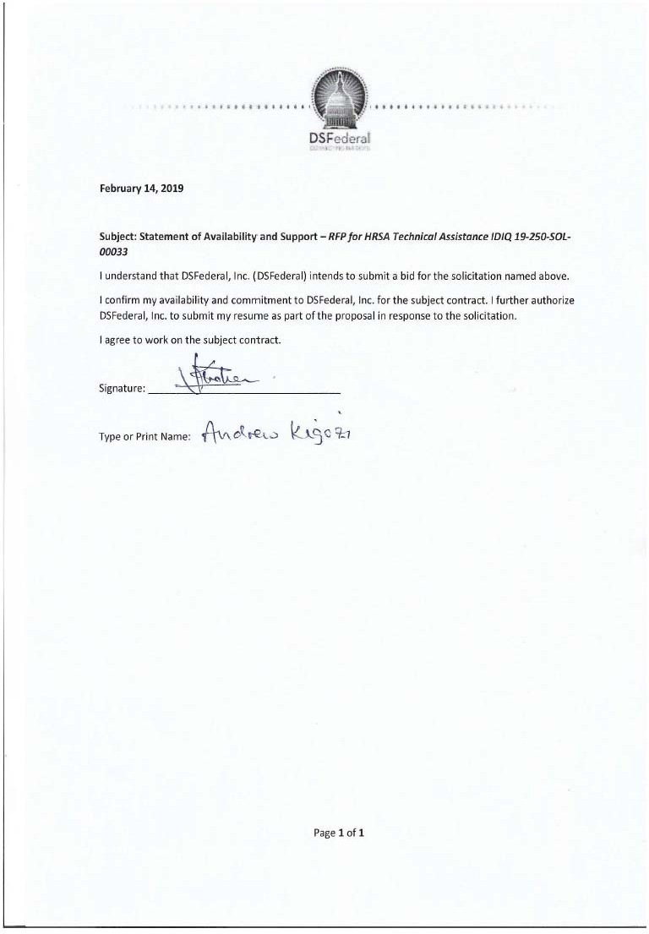

|  |
| --- |
| Qualifications and Experience  Over 10 years engaging interdisciplinary teams for health systems strengthening efforts. Work in Sub-Saharan Africa, Central/Southeast Asia, Latin America & Caribbean.  Johns Hopkins University, Master of Public Health  University of California, San Francisco, Master of Science in Nursing |

1. **Karen Carmen Kwok - Nurse**

## Career Summary

An experienced nurse with over 10 years engaging interdisciplinary teams for health systems strengthening efforts. Work in Sub-Saharan Africa, Central/Southeast Asia, Latin America & Caribbean. Expertise in oncology, immunizations, TB/HIV, & HMIS. UC San Francisco graduate & American Nurses Credentialing Center recognized as Family Nurse Practitioner Content Expert Panelist with 16 years in delivering patient care.

## Education, Training, and Certifications

* Johns Hopkins University, Baltimore, Master of

Public Health 2005 Specialty: Program Evaluation, Bill & Melinda Gates Reproductive Health Institute Awards: Alice & William Hinckley Fund, Association of Teachers of Preventive Medicine

* University of California, San Francisco, Master of Science in Nursing 2004, Specialty: Advanced Practice Nurse Practitioner in Family Medicine, Awards: School Traineeship, Asian Health Sciences Scholar, California League for Nursing

## Work Experience

**Nurse Practitioner, County Public Health Clinics, CA & Howard University, DC 2002 – 2016, 2018 - now**

Elected interdepartmental liaison with quality improvement for patient safety & efficient provider workflow

# Registered Nurse, San Francisco & Oakland, CA 2001 – 2005

**Kaiser Permanente, Mission Neighborhood, SF General Hospital, & Edgewood Children’s Center**

Designed multidisciplinary behavioral health care plan for Pediatric residents in Level 14 foster care home

# Guest Lecturer 2017 – now

**California Institute of Integral Studies, University of San Francisco, University of Maryland** Presented case studies in global maternal child health for graduate students in social work, humanitarian ethics, & medical anthropology to promote critical thinking in international diplomacy

# Workshop Trainer & Co-Facilitator 2009 - 2011, 2015 –2016

**Diversity Works & Soliya, San Francisco Bay Area, CA & online global forum**

Co-facilitated Diversity Works training on community volunteerism for after-school teachers, middle school students, & graduate business students from Japan to promote social entrepreneurism

Co-led Soliya virtual classroom discussions with students from US, Pakistan, Libya, & Italy on human rights, social services, & race relations topics to increase diversity awareness & inclusion

# Advisory Board: Strategic Planning Chair 2009 - 2012

**Young Nonprofit Professional Network, San Francisco Bay Area, CA & USA**

Led remote collaboration for San Francisco, Orlando, Chicago, & Boston chapters on lessons learned in strategic planning to promote knowledge sharing & nonprofit professionalism

# Project Management: Public Health Consultant 2018 J&M Global Solutions, Alexandria, VA

Devised team dashboard, process map, & logic model for project launch of $1 Million biodefense portfolio

# Clinical Practice Consultant 2006 - 2010

**Blueshift Global Partners, Panasonic Electronics, San Francisco & San Jose, CA**

Designed feasibility analyses, proposed user experience in key features, & drafted new business development in medical device innovation adapted for patients with low literacy & physical disabilities

# Public Health Technical Lead: Logistics Consultant 2011 – 2017 Project Hope & Mercy Corps: on-site in Latin America & Asia June 2011 – July 2011 Bayan Olgii & Khentii regions, Mongolia:

Trained 2 participants in facilitator role to assess social dynamics, youth development, & optimal child learning for nomadic families relocated to urban centers in the Social Safety Net Project

# Health Consultant 2007 - 2008, 2011 - 2012

**African Immigrant Refugee Resource Center & African Advocacy Network, San Francisco, CA**

Conducted focus groups on health, legal, & employment concerns of African refugees & immigrants based on needs assessment & utilization-focused evaluation plan to assist community integration

## Poster Presentations

* Effectiveness of Cascade Training & Supervision (CTS): Scaling Improved Maternal Health Outcomes, Zambia, AFREHealth Symposium Abstract 2017
* Community Health Workers: Addressing Childhood Micronutrient Deficiencies in Chittagong Hill Tracts, Bangladesh Development Initiative, Universities for Global Health 2015, 2016
* Bangladesh Health Systems Strengthening Initiative: Reevaluating Health Workforce Capacity, Bangladesh Development Initiative Conference 2015, 2016.

# Karen Carmen Kwok - Statement of Availability

|  |
| --- |
| Qualifications and Experience  Over 6 years of technical assistance including supporting HRSA MCHB  PhD, University of Missouri, Human Development and Family Studies, Emphasis in Children, Families, and Public Policy, Dissertation research conducted with Early Head Start home visitors  Masters University of Missouri, Early Childhood Special Education |

1. **Valeri J. Lane, Ph.D. - Social Science Analyst (Maternal and Child Health)**

## Career Summary

An experienced TA Specialist/Research Analyst with over 6 years’ experience including supporting HRSA MBHB.

## Education, Training, and Certifications

* PhD, University of Missouri, Human Development and Family Studies, Emphasis in Children, Families, and Public Policy, Dissertation research conducted with Early Head Start home visitors
* Masters University of Missouri, Early Childhood Special Education

## Work Experience

**DSFederal – Independent Consultant January 2019 To Present**

Serve as Programmatic Consultant for MIECHV triennial compliance site reviews.

Analyze awardee documents in preparation for site visit; Complete analysis during on-site compliance visit; In conjunction with fiscal consultant, write a report of findings.

# Zero to Three: NC ECDTL Washington, DC

**March 2016 to October 2018**

* Management and supervision of 12 Regional Field Specialists (RFSs) embedded in Office of Head Start Regional Offices for the National Center on Early Childhood Development, Teaching and Learning; supported RFS growth through reflective supervision and process consultation.
* Led and supported data collection for the team; created and submitted weekly and monthly reports based on data
* Supported RFS knowledge and capacity around implementation science in their work with federal staff
* Analyzed large data sets to support RFS interpretation and understanding of the status of grantees in their regions

# Zero to Three: MIECHV TACC Washington, DC

* February 2012 to March 2016
* Overall direction and management of the Maternal Infant and Early Childhood Home Visiting Technical Assistance Coordinating Center
* Oversight of technical assistance to HRSA-funded grantee states and territories
* Working with finance department, created and managed annual project budget of $2.8M
* Provided oversight of project deliverables, including work with MIECHV Model Developer

# Valeri J. Lane, Ph.D. - Statement of Availability

|  |
| --- |
| Qualifications and Experience  Over 10 years of data and grant-related technical assistance including HRSA HAB research assistant and administrator on various HIV and Hepatitis clinical and observational studies  Wesleyan University, Middletown CT, 1976 – 1978, Undergraduate Program, Psychology/Sociology |

1. **Philip Melemed - TA Specialist**

## Career Summary

Provided systems, data and grant-related technical assistance directly and as a subcontractor to the HRSA HAB. Including research assistant and administrator on various HIV and Hepatitis clinical and observational studies including proposal evaluation, budgeting, IRB approval, participant enrollment, data collection and monthly and annual data and budgetary reporting.

## Education, Training, and Certifications

* Wesleyan University, Middletown CT, 1976 – 1978, Undergraduate Program, Psychology/Sociology

## Work Experience

**11/2013 – 04/2014**

**People’s Community Health Centers. Assoc. Director, Ryan White Programs Baltimore, MD**

Coordination and management of Ryan White Parts A and B subcontracts and Part C grant; managed budget of $900k; directed staff of 4 Medical Case Managers and Outreach workers and matrix management of 5 other clinical staff at this FQHC; managed monthly and annual quality, program and financial data; wrote work- and staffing-plans for Part A and C non-competing continuations; designed and implemented a routine HIV and Hepatitis C testing program funded by Gilead. (GE Centricity)

# 07/2010 – 11/2013

**Total Health Care, Inc.**

**HIV Services MIS Coordinator Baltimore, MD**

At multi-site FQHC, provided Management Information Systems clinical data and technical support for an HIV Services Electronic Data Management System I designed including Visual Basic/SQL programs, Microsoft Access and Excel tools, CAREWare, GE Centricity and Allscripts EMR interfaces, SQL and HL7 data links and associated reports; trained technical, administrative and clinical staff, and supported CQI, PCMH, UDS and FQHC initiatives.

Coordinated HIV-related configuration for migration to Athena EMR. (Ryan White Parts A, B and C)

# 12/2010 - 11/2013

**Northern Virginia Regional Commission CAREWare IT Coordinator**

**Fairfax, VA**

Designed and implemented a networked installation of CAREWare for ten Ryan White Part A and B service providers and their fiscal intermediary. Customized CAREWare to reflect Virginia and District of Columbia reporting requirements. Migrated data from private CAREWare installations and other data management systems. Developed extensive suite of quality and grant-reports. Trained IT staff and non-technical users in installation, configuration and reporting. (This was a HIV/AIDS Bureau SPNS project for the Commonwealth of Virginia)

# 2000 – 2002 Outer Cape Health Services

**IT Manager Provincetown, MA**

Provided IT and Data management and hands-on support for 3 community health centers and 3 administrative/program offices, including hardware, software and network purchasing, installation and support, staff training and support, and development of IT policies and HIPAA implementation guidelines.

# 1994 – 1999 Microsoft Corporation

**Program Manager Redmond, WA**

Designed and managed implementation of the upgrade process for Microsoft Office 2000 application suite, improving migration of user settings from 20% to over 90%. Developed standards for implementing language-independent installation and configuration of Office applications. Specified configuration rules and software changes to support CITRIX / Terminal Services and roaming usage of Office applications. Reviewed 3rd Party software products for acquisition. Program and Operations Manager for Microsoft Access 97. Quality Assurance Lead for Microsoft Access 95.

# 1991 – 1994 Clinical Information Analysis, Inc.

**Operations Manager Waltham, MA**

Managed all software support functions, including on-site installation, training, documentation, quality assurance, release management and technical support for PC/Windows-based medical reporting system. Presented talks and training at parent company and medical conferences.

## Publications and Awards

* 2008 Ryan White All Grantees meeting: “Linking your Electronic Data Systems to CAREWare”
* 1999 Microsoft Developer Conference: “Upgrading in Place: Preserving User Preferences in Office 2000 upgrades”
* 1997 Microsoft Developer Conference: “Access Wizardry 101: Writing Your First Microsoft Access Wizard”

# Philip Melemed - Statement of Availability

|  |
| --- |
| Qualifications and Experience  Over 30 years of experience in the health and human service arena developing and delivering training  Graduate Studies, Counseling and Administration, University of the District of Columbia, 1982  Secondary Education Teaching Certification, Temple University, 1977  B.A., Biology, Temple University, 1976 |

1. **Cheryl D. Nesbitt - Training Specialist**

## Career Summary

Over 30 years of experience in the health and human service arena developing and delivering training, conducting needs assessments with organizations, conducting site visits to federally-funded programs. At least 20 years experience working with communities to develop and evaluate programs and services to better meet constituent needs including facilitating focus groups and meetings at the national, state, and local levels.

## Education, Training, and Certifications

* Graduate Studies, Counseling and Administration, University of the District of Columbia, 1982
* Secondary Education Teaching Certification, Temple University, 1977
* B.A., Biology, Temple University, 1976

## Work Experience

**Training Design, Development, and Delivery (1988 – present)**

Developed over 30 training curricula and content for programs funded by National Institute on Drug Abuse (NIDA), Health Resources and Services Administration (HRSA), Centers for Disease Control and Prevention (CDC) and Substance Abuse and Mental Health Services Administration (SAMHSA) and Department of Defense (DOD).

# Quality Management and Compliance Site Visits (1994-present)

Conduct diagnostic and compliance site visits for HRSA RWHAP Part A, C, D, and F programs as the Administrative Reviewer and Team Lead. Review areas include organization governance, organization structure and management; program management; subcontractor oversight and monitoring; organizational sustainability; human resource systems and policies and procedures; and organizational management information systems.

**Organization Assessments, Capacity Building and Technical Assistance (1988-present)** Conducted organizational operating systems assessment Open Door Health Center of Illinois and continue to provide technical assistance.

# Program Development/Management/Evaluation (1995-present)

Developed and delivered technical assistance to HBCUs on establishing and implementing Peer HIV Education Programs.

## Publications and Awards

* HRSA Director’s Award for Technical Assistance. November 2017.
* “Review of Alternative Payment Report,” Report to HRSA, January 2010.

# Cheryl D. Nesbitt - Statement of Availability

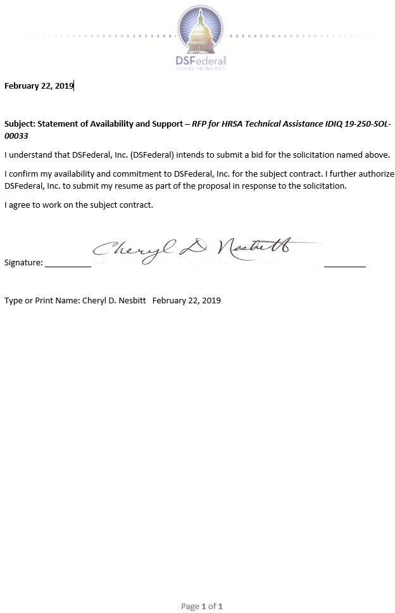

|  |
| --- |
| Qualifications and Experience  Over 8 years of experience in the health and human service arena developing and delivering training  Graduate Studies, Counseling and Administration, University of the District of Columbia, 1982  Secondary Education Teaching Certification, Temple University, 1977  B.A., Biology, Temple University, 1976 |

1. **Ekoto Zhang Ninon Elsie - Billing Specialist**

## Career Summary

Over 8 years of experience in non-profit accounting, expert familiarity with grants management, accounting principles, auditing, and program integrity.

## Education, Training, and Certifications

* Master’s Degree in Management, Finance and Accounting from the University of Yaoundé, Cameroun

## Work Experience

**Femmes-Santé-Development (FESADE) Non-profit organization funded by the Global Fund, PEPFAR**

**November 2018 – Present**

**Financial and Administrative Manager**

General Accounting

* Payroll
* Accounts Book handling
* Bank Reconciliation
* Account Analysis
* Quarterly and monthly Drafting of account statement
* Quarterly and monthly report to the donors
* Control and safeguard of supporting documentation Business and Analytical Accounting
* Analytical allocation
* Analytical Data Entry
* Drafting of Annual Work and Budget Plan, quarterly Cash flow
* Budget Control and budget monitoring and financial analysis
* Analytical Reconciliation

# Care and Health Program Nonprofit organization funded by the US department of state, the President Emergency Plan for AIDS Relief (PEPFAR) and the Global Fund

**November 2013 to October 2018**

**Head of the Accounting Department**

General Accounting

* Payroll
* Accounts Book handling
* Bank Reconciliation
* Account Analysis
* Monthly Drafting of account statement
* Monthly report to the Head quarter
* Control and safeguard of supporting documentation Business and Analytical Accounting
* Analytical allocation
* Analytical Data Entry;
* Drafting of Annual Work and Budget Plan
* Budget Control
* Analytical Reconciliation

# Ekoto Zhang Ninon Elsie - Statement of Availability

|  |
| --- |
| Qualifications and Experience  Health communications specialist with 13 years of experience in public health  M.P.P. from Georgia State University  Manages partnership efforts in major public health campaigns, such as HIV awareness and childhood immunization |

1. **Olubusola (Busola) Saka - Health Communications Specialist**

## Career Summary

Busola Saka is a health communications specialist with 13 years of experience in public health communications. For CDC’s Act Against AIDS Campaign: Business Responds to AIDS (BRTA), she has developed and implemented strategies to create and maintain business partnerships that promote HIV/AIDS awareness and education in the workplace. She has also supported CDC’s HIV/AIDS National

Partnership Team. In addition, she managed media relations and partnership engagement for CDC’s childhood immunization campaign and provided strategic support for materials development and digital media. As media relations manager for the American Cancer Society (ACS), Ms. Saka initiated and led ACS’s relationship with minority media, creating the organization’s first-ever partnership with the National Association of Black Journalists. She also managed media relations planning and activities for ACS’s global health initiatives, including media training for African journalists.

# Education

M.P.P., Public Policy, Georgia State University, 2011 B.A., Journalism, Georgia State University, 2005

# Relevant Project Experience

*Westat (2013 to Present), Rockville, MD*

# NHLBI Communications, Engagement, and Education Support Services BPA – Task Area 4: Health Education and Research Information Dissemination

**Client:** National Heart, Lung, and Blood Institute (NHLBI)

Westat provides health education, promotion, communications, and research support to NHLBI’s Office of Science Policy, Engagement, Education, and Communications. Project staff support strategic planning and targeted health education and communication initiatives aimed at targeted populations, health professionals, and community-based organizations using new, emerging, and evidence-based educational tactics and opportunities to reach these groups, in a cost-effective manner, with science-based health messaging linked to NHLBI’s research portfolio. Staff perform formative research; conduct strategic planning for health education programs and initiatives; and provide logistical and technical support for the planning, development, implementation, promotion, and evaluation for NHBLI health education programs. Ms. Saka provides partnership engagement support for NHLBI’s Move with Heart campaign. Her efforts led to a partnership with the National Recreation and Parks Association (NRPA). Activities from this partnership included a podcast interview, article placements in NRPA’s monthly magazine and weekly newsletter, and social media posts, with a total reach of over 40,000.

# Health Marketing Support Services

**Client:** Office of the Associate Director for Communication, CDC

Westat provides expertise and support for CDC health communication programs covering a broad range of health topics and targeting a variety of audiences. Project staff conduct research to inform program planning, including concept and message testing, literature reviews, environmental scans and situational analyses, and audience identification and segmentation. Westat develops strategic communication plans and plans, implements, and evaluates social marketing campaigns. Below are several examples of projects for which Ms. Saka has provided communications and partnership leadership and support:

**Business Responds to AIDS (BRTA): Engaging the Private Sector in HIV Prevention** BRTA is a CDC partnership initiative that supports small, medium, and large businesses with tailored resources and tools for workplace programs that reduce stigma and prevent discrimination against employees living with HIV. Westat is engaging businesses in HIV education by developing and disseminating tailored materials and by facilitating and/or supporting workplace HIV awareness events. This contract also includes business news monitoring, monitoring of program evaluation metrics, and support for the Cut for Life program to engage hairstylists and barbers in HIV education. As Project Director, Ms. Saka leads development and implementation of strategies to engage businesses in HIV/AIDS awareness, education, and prevention in the workplace.

# Health Marketing, Communications, and Technical Assistance Services for Multisectoral Partnerships

Westat supported the National Partnerships Team in the Division of HIV/AIDS Prevention, National Center for HIV/AIDS, Viral Hepatitis, STD, and TB Prevention, in identifying, recruiting, engaging, coordinating, and mobilizing multisectoral partnerships. Project staff provided training and technical assistance to improve partners’ capacity for HIV prevention work; created social media content and more than 150 individual communication products per year; and supported up to 15 events per year, including conferences, community engagement events, and on-site partner meetings. Ms. Saka managed partner engagement efforts for the National Partnerships Team. She provided partners with technical assistance, including communications materials, to enhance and promote their HIV/AIDS prevention efforts.

# Promoting Childhood Immunization to Parents and Health Care Professionals Using Communication and Social Marketing Strategies

Westat worked with CDC’s National Center for Immunization and Respiratory Diseases to develop and implement a social marketing campaign to promote childhood immunization to the parents of infants and young children and to child care and health care professionals.

Project staff conducted research to inform development of public health communication strategies about pertussis. Ms. Saka managed media relations and partner engagement efforts for CDC’s childhood immunization campaign. She provided strategic direction and support for materials development and other communications tasks.

# Relevant Project Experience

*American Cancer Society (ACS), Atlanta, GA (2005 to 2013)*

As media relations manager (2007 to 2013) and media relations specialist (2005 to 2007), Ms. Saka provided strategic media relations counsel to internal and external clients and to public relations agencies working on ACS campaigns. She led ACS’s outreach to and relationship with minority media and communicated the organization’s disparities goals, activities, and research. Ms. Saka arranged national network interviews with ACS experts.

# Olubusola (Busola) Saka - Statement of Availability

|  |
| --- |
| Qualifications and Experience  Senior digital media manager with 9 years of communications experience  B.A. (magna cum laude) from the University of Maryland  Develops social media and graphics for health research projects |

1. **Julie Yegen - Health Communications Specialist**

## Career Summary

Julie Yegen is a senior digital media manager

with more than 9 years of experience in communications. At Westat, she is responsible for integrating digital and social media campaigns within broader public health initiatives. Ms. Yegen is project director for Innovation Next, a program of Power to Decide. She also leads digital and social media strategy for CDC’s Act Against AIDS Doing It campaign, CDC’s Division of

Adolescent and School Health, and NHLBI. Her background includes experience in public relations, supporting nonprofit clients in their digital media, event planning, and partnership development efforts.

# Education

B.A. (magna cum laude), Communication (with a specialization in Public Relations), University of Maryland, College Park, 2009

# Relevant Project Experience

*Westat (2013 to Present)*

# Innovation Next – Stages 1 and 2

**Client:** Power to Decide (formerly National Campaign to Prevent Teen and Unplanned Pregnancy)

For Stage 1, Ms. Yegen planned the team’s vision and identified effective strategies. She guided the use of technology and digital media to support teen pregnancy prevention in a new and effective way. Stage-2 funds innovative technological solutions to teen pregnancy prevention. Westat teamed with SABEResPODER to design and pilot test Momentos, a program that provides Hispanic parents with mobile-based, culturally proficient tools and resources to help them communicate with their children about sexual health and pregnancy prevention. Project director. Ms. Yegen leads the team launching the text messaging service.

# NHLBI Communications, Engagement, and Education Support Services BPA – Task Area 4: Health Education and Research Information Dissemination

**Client:** National Heart, Lung, and Blood Institute (NHLBI)

Westat supports strategic planning and targeted health education and communication initiatives aimed at targeted populations, health professionals, and community-based organizations using new, emerging, and evidence-based educational tactics and opportunities to reach these groups, in a cost-effective manner, with science-based health messaging linked to NHLBI’s research portfolio. Ms. Yegen manages monthly social media content development, graphics development, and creative tactics for promotions for The Heart Truth campaign.

# Health Marketing Support Services

**Client:** Office of the Associate Director for Communication, CDC

Westat provides expertise and support for CDC health communication programs covering a broad range of health topics and targeting a variety of audiences.

Ms. Yegen is the social media strategist for CDC’s Division of Adolescent and School Health (DASH), which focuses on reducing adolescent sexual risk behaviors, HIV/AIDS and STDs, and teen pregnancy. She leads development of social media marketing strategies and manages social media activities to enhance DASH’s presence on Twitter. She also conducts Twitter content and audience analyses, using data to identify trends in top-performing content and apply findings to future social media strategies.

Ms. Yegen serves as the digital and social media lead for the Development and Dissemination of a General Awareness Social Marketing Campaign for the Act Against AIDS Campaign.

She plans, executes, and reports on digital and social media activations for the Doing It campaign. She manages monthly social media content, engages digital partners, supports digital media buying campaigns, and strategizes on creative ways to promote HIV testing online. She developed the incentive structure for the first paid influencer engagement campaign and is leading the pilot implementation of the new capability. She has implemented social platform “takeovers,” during which influencers take over CDC social media accounts for one day to expand the reach of CDC’s network.

Ms. Yegen led all digital activities, including digital media buy campaigns with Google, YouTube, Mbuy, and The Motherhood; publisher outreach; and digital PSA placements for CDC’s National Center for Immunization and Respiratory Diseases in order to develop and implement a social marketing campaign to promote childhood immunization to the parents of infants and young children and to child care and healthcare professionals.

Ms. Yegen provided expertise to CDC’s Division of Violence Prevention in developing a coordinated plan for conducting social media activities in support of its VetoViolence campaign and developing new materials to reach campaign target audiences. She prepared monthly reports on digital communications progress and identified lessons learned and recommendations for improving performance each month. She developed the campaign goals and rationale based on an evaluation of past performance and provided strategic guidance on materials development.

# Social Media for National Children’s Study (NCS) – Vanguard Study

**Client:** Eunice Kennedy Shriver National Institute of Child Health and Human Development **Project Overview:** Westat implemented an innovative social media approach for engaging and improving participant retention for NCS, which was a landmark prospective cohort study to follow approximately 100,000 U.S. children and their parents from before birth for up to 21 years. By creating a private online community for a representative group of NCS participants, Westat began building the evidence base and identifying best practices for the effective use of social media in study locations in the NCS West Regional Operations Center (West ROC).

**Responsibilities:** Ms. Yegen supported the development of the NCS social media plan.

# Other Professional Experience

*C. Fox Communications, Silver Spring, MD (2007 to 2013)*

Ms. Yegen developed social media strategies for numerous clients; presented public relations accomplishments to 150 child agency representatives at annual conferences; wrote and copyedited content; and managed vendor relationships.

# Julie Yegen - Statement of Availability

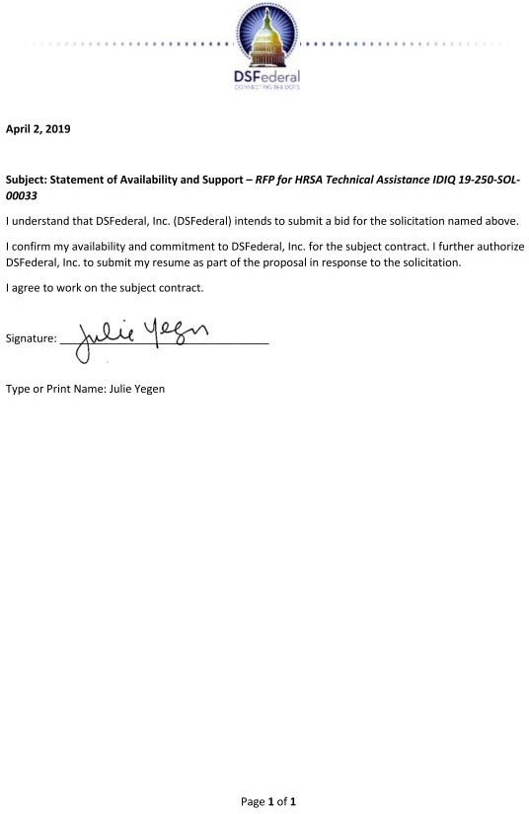

|  |
| --- |
| Qualifications and Experience  Over 20 years of experience directing quantitative and qualitative research for the Department of Health and Human Services  Over 10 years of technical assistance including for HRSA programs  Ph.D. in Economics from Stanford University |

1. **Margaret O’Brien-Strain – Project Director/Contract Manager**

## Career Summary

Dr. O'Brien-Strain is the President and Senior Associate at Mission Analytics Group, Inc. Her current work focuses on health care services delivery, child and family policy, and developmental disabilities. Across a wide range of projects, she provides expertise in statistical modeling, program evaluation and technical assistance, as well as writing for non-technical audiences.

## Education, Training, and Certifications

* Stanford University, Ph.D., Economics, Stanford, California, 1999
* Swarthmore College, Bachelor of Arts, Economics, Swarthmore, Pennsylvania, 1988

## Work Experience

Task Lead for Report Generation 2005 - Present

Mission Analytics Group, Inc., San Francisco, CA

*Risk Assessment and Mitigation*, California Department of Developmental Services (DDS)

As DDS’s risk management contractor, Mission Analytics works directly with DDS and the 21 regional centers, as well as indirectly through dissemination activities with consumers, families, and direct services providers. Dr. O’Brien-Strain leads a team to:

* Develop protocols for reporting alignment across the regional centers.
* Analyze data and provide training and technical assistance to regional center staff informed by data analyses, including the distribution of quarterly consumer incident reports.
* Manage the DDS Safety Net website for consumers.

Principal Investigator 2017 - Present

Mission Analytics Group, Inc., San Francisco, CA

*Alternative Resource Allocation Methodologies for Ryan White HIV/AIDS Programs Part A & Part C – Phase II,* Health Resources and Services Administration (HRSA HAB)

Subcontract to WRMA, Inc.

Continuing work previously completed under several contracts, this project supports HRSA HAB in using Excel tools previously developed by WRMA/Mission that calculate funding amounts for Ryan White HIV/AIDS Program (RWHAP) Part A supplemental grants and Part C grants. These calculation methods use publicly available data, RWHAP Services Report (RSR) data, and recipient-level data to standardize the way that funding is allocated, and better align funding with need. WRMA/Mission will update the tools with new functionalities and updated data, conduct and analyze runs, and research and report on topics of interest such as the impact of eligible scope reporting requirements on RSR data. Dr. O’Brien-Strain:

* Led the development of the original Part A and Part C methodologies as well as its implementation in SAS and Excel.
* Currently, leads updates to the models and their use to inform and disseminate information on funding decisions.

Principal Investigator 2017 - Present

Mission Analytics Group, Inc., San Francisco, CA

*Public Health and Economic Impact of the Ryan White HIV/AIDS Program*: HRSA HAB Subcontract to Mathematica Policy Research, Inc. (MPR)

Mission Analytics is responsible for leading the analysis of RSR data and delivering training and technical assistance to HRSA HAB staff to use the model to identify optimal allocation of resources across program services and populations. Dr. O’Brien-Strain directs the development of a methodology and its implementation in SAS to create outputs to operationalize the model.

Senior Advisor 2017 – Present

Mission Analytics Group, Inc., San Francisco, CA

*Integration of Oral Health and Primary Care Evaluation/Technical Assistance to Ryan White HIV/AIDS Program Recipients: HIV/AIDS Bureau*, HRSA HAB

Mission Analytics supports HRSA HAB by identifying best practices and providing technical assistance to RWHAP providers on the integration or oral health and primary care. Dr. O’Brien- Strain oversees the project, provides input to the team on key deliverables.

Facilitator 2015 – 2018

Mission Analytics Group, Inc., San Francisco, CA

*Learning Collaborative – Strengthening the Part A Care Continuum*: HRSA HAB Subgrantee to Abt Associates, Inc.

Mission Analytics supported the development of the CCLC and led two domains: data integration and using data to improve outcomes. Dr. O’Brien-Strain:

* Led a group on Data to Care activities and a group on pay for performance.
* Facilitated the monthly discussions and provided technical assistance, conducting literature reviews or coordinating with experts to participate in calls.

## Publications and Awards

* “Understanding and Monitoring Funding Streams in Ryan White Clinics. Report.” (with E. Oppenheim, I. Fua, E. Coombs, and R. Gross). Report to the Health Resources and Services Administration, July 2014.
* “Providing Primary Care and Preventive Medical Services in Ryan White HIV/AIDS Program-Funded Care Settings. Report.” (with H. Day, I. Fua, A. Jones, and E. Coombs). Report to the Health Resources and Services Administration, December 2016.
* “Final Report: Ryan White HIV/AIDS Program’s Part A Supplemental Funding - Feasibility Study of Proposed Framework for Allocation of Funds Responsive to Needs.” (with D. Isenberg, R. Gross, E. Verhulst and J. Davidson), Report to the HIV/AIDS Bureau, Health Resources and Services Administration, April 2016.

# Margaret O’Brien-Strain - Statement of Availability

